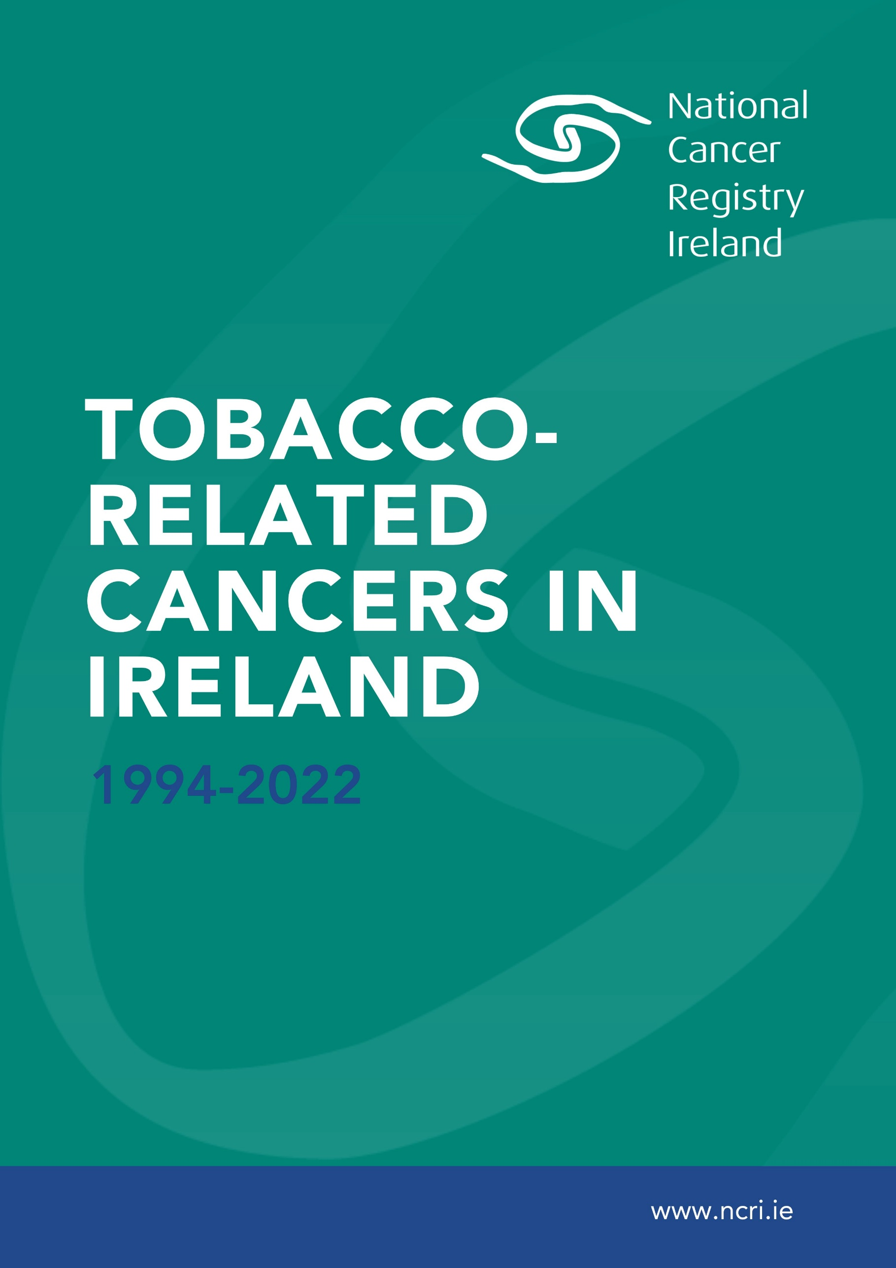

About the National Cancer Registry

The National Cancer Registry was established by the Minister for Health in 1991. It has been collecting comprehensive cancer information for the population of the Republic of Ireland since 1994. This information is used in research into the causes of cancer, in education and information programmes, and in the planning and management of cancer services to deliver the best cancer care to the whole population.

The mission of the National Cancer Registry of Ireland (NCRI) is to capture data and communicate information on cancer patients nationally to support the improvement of cancer outcomes in Ireland.

We collect information from all hospitals in Ireland on the number of persons diagnosed with cancer and the types of cancer they have. We also follow up the numbers dying from their cancer or from other causes. All the patient’s personal and private details are removed before summaries of this information are made available to public and health professionals through our annual cancer report and other reports on our website.

This report should be cited as:
O'Hare C, Finneran L, McDevitt J, George AM, Kavanagh P, Kabir Z, Sheridan A, Murray D, Redaniel MT (2025). Tobacco-Related Cancers in Ireland 1994-2022. Cork, Ireland: National Cancer Registry Ireland. Available at: URL [Accessed Day Month Year].

Published by:
National Cancer Registry
Building 6800,
Cork Airport Business Park,
Kinsale Road, Cork, Ireland.
T12 CDF7
Telephone: +353 21 4318014

Report at a glance
Who are we, and what do we do?  The National Cancer Registry of Ireland (NCRI) works on behalf of the Department of Health and collects information from all hospitals in Ireland on the number of persons diagnosed with cancer and the types of cancer they have. NCRI also follows up the numbers dying from their cancer or from other causes.  All patient personal and private information is removed before summary cancer statistics are prepared and made available to the public and health professionals through our annual cancer report and other reports on our website. |  | How are the numbers reported?  Collecting and checking of this information is performed by a combination of manual and electronic processes. Our staff collect cancer diagnosis information and then use an agreed system of coding (the International Classification of Diseases) to group the cancers into different types.  After a process of collating diverse information from Irish hospitals and assigning it to the correct person, reports are published following analysis of de-identified data.

What is in this report?  This report examines incidence, mortality, survival and population attributable fractions (PAFs) for tobacco-related cancers.  Findings are presented for:  - Incidence and incidence trends over time (1994-2022).  - Incidence by deprivation quintile (2014-2018).  - Mortality and mortality trends over time (1994-2022).  - Survival (1994-2022).  - Population attributable fraction (2022). |  |  |  | What is the purpose of this report?  Tobacco control is key to achieving national cancer control however, progress in reducing the prevalence of smoking in Ireland has slowed. Ireland has not met the ‘endgame’ target of achieving less than 5% smoking prevalence by 2025 and the absolute number of smokers remains high.  Examining the national burden of tobacco-related cancers in Ireland is important to assess the impact on cancer of tobacco control policies, to help policy makers and clinicians plan future services, and to ensure continued emphasis on the importance of tobacco control and its primacy to cancer control.  The PAF can be used to provide estimates of the benefits of reducing population-level exposure to tobacco-smoking.
What was found?  Incidence |  | - Tobacco-related cancers were, in general, more common among men, however, three tobacco-related cancers are female specific (breast, cervical and an uncommon type of ovarian cancer (mucinous)).  - Trends in incidence rates were stable or decreasing across most cancer types examined from 1994-2022.  - Considering all tobacco-related cancers combined, there was a clear socioeconomic gradient in cancer incidence in 2014-2018. Those living in areas of greater social disadvantage had a higher incidence of tobacco-related cancers compared with those living in more advantaged areas.

What was found?  Mortality |  | - Mortality across most tobacco-related cancers was higher among men than women.  - Trends in mortality rates were stable or decreasing across most cancer types examined.

What was found?  Survival |  | - Survival improved across most cancer types examined.

What was found?  Population attributable fraction |  | - In this report, the population attributable fraction (PAF) is the proportion of cancer cases caused by tobacco smoking.  - An estimated 3,756 cases, or 14.7% of invasive cancers cases (excluding non-melanoma skin cancer), would not have occurred in 2022 if there was no tobacco-smoking.  - Lung cancer accounted for the highest number of smoking-attributable cancer cases in both men and women, with 74.8% of cases in men (1,066/1,426) and 71.7% in women (944/1,316) attributable to smoking.
Summary of Population attributable fraction across types in 2022
  Population attributable fraction by cancer type in 2022
  Cancer Type | PAF (%)
  Lung | 73.3
  Larynx | 65.9
  Bladder & NMIBC | 47.5
  Oesophagus (adenocarcinoma) | 38.6
  Oesophagus (squamous cell carcinoma) | 38
  Pharynx | 37.6
  Sinonasal | 26
  Nasopharynx | 25.4
  Pancreas | 24.9
  Acute Myeloid Leukaemia | 20.7
  Cervix | 20.3
  Ovary (mucinous) | 20.3
  Oral cavity | 18.2
  Liver | 18
  Stomach | 14.8
  Kidney | 13.2
  Rectum | 8.3
  Colon & rectosigmoid junction | 5.4
  Breast | 3.6
What do these results mean? |  | - Tobacco smoking remains the leading preventable cause of cancer in Ireland.  - These findings underline the importance of continued and accelerated efforts to decrease tobacco smoking in Ireland to reduce future cancer incidence and mortality, and to improve cancer survival in Ireland.

List of Abbreviations
AML: Acute Myeloid Leukaemia
APC: Annual Percentage Change
CSO: Central Statistics Office
95%CI: 95% Confidence Interval
ED: Electoral Division
EHIS: European Health Interview Survey
ENDS: Electronic Nicotine Delivery System
EU: European Union
FCTC: Framework Convention on Tobacco Control
GBD: Global Burden of Disease
HSE: Health Service Executive
HPV: Human Papillomavirus
IARC: International Association for Research on Cancer
ICD: International Classification of Diseases
NA: Not Applicable
NCCP: National Cancer Control Programme
NCRI: National Cancer Registry Ireland
NMIBC: Non-muscle invasive bladder cancer
PAF: Population Attributable Fraction
SHS: Second Hand Smoke
WCRF: World Cancer Research Fund
WHO: World Health Organisation

Glossary
Glossary
Age-standardisation | Age-standardisation of a cancer incidence rate, for example, involves calculation of incidence while taking into account differences in the distribution of population characteristics such as age. Age-standardisation included computation of incidence for each age group, then adjusting (weighting) these to a ‘standard’, such as the 2013 European Standard Population. Age-standardisation allows comparison of rates over a range of years and between different regions and countries.
Deprivation | Social or socioeconomic deprivation, often represented by a proxy variable or index that incorporates measures such as unemployment, overcrowding and other relevant variables. This report uses the Pobal Haase-Pratschke 2016 indices of deprivation at electoral division (ED) level, i.e. an area-based measure of deprivation incorporating information from the national census in that year; this is assigned to populations and patients based on their place of residence (electoral division).
EASR | European age-standardised rate (standardised to 2013 European Standard Population).
ICD-10 | International Statistical Classification of Diseases and Related Health Problems (10th edition) (WHO 1992)
Incidence | Numbers and rates (usually expressed per 100,000 persons per year) of newly diagnosed disease. In this report, incidence refers to new cancers diagnosed during 2018-2022 and incidence is quoted separately for each sex.
PAF | Population attributable fraction is interpreted as the proportion of cases that would be prevented if exposure to a causal factor (i.e. smoking) in the entire population was adjusted to the level of the reference category (i.e. the level of ideal exposure to a risk factor, usually zero).

Contents
1 Introduction 14
1.1 Smoking Prevalence in Ireland 14
1.1.1 Tobacco-smoking and Gender 14
1.1.2 Tobacco-smoking and Socioeconomic Disadvantage 15
1.1.3 Electronic Nicotine Delivery Systems (ENDS) 15
1.2 Tobacco-smoking and cancer 15
1.3 Tobacco-smoking and cancer in Ireland 16
1.4 Policy context 16
1.4.1 Ireland is a tobacco ‘endgame’ country 17
1.5 Rationale 17
1.6 Aim 17
1.6.1 Objectives 17
2 Methods 18
2.1 Cancer types for inclusion 18
2.2 Incidence & Mortality 18
2.3 Survival 18
2.4 Deprivation 19
2.5 Population attributable fraction (PAF) 19
2.5.1 Data required for PAF calculation 19
2.5.2 PAF formula 22
3 Population Characteristics 23
4 Overall Trends in Tobacco-Related Cancers 24
4.1 Incidence 25
4.1.1 Trends over time 26
4.1.2 Variation by deprivation quintile 27
4.2 Mortality 27
4.2.1 Trends over time 28
4.3 Survival 29
4.4 Population Attributable Fraction 30
5 Oral cavity C00-06 32
5.1 Incidence 33
5.1.1 Trends over time 34
5.1.2 Variation by deprivation quintile 35
5.2 Mortality 35
5.2.1 Trends over time 36
5.3 Survival 37
5.4 Population Attributable Fraction 37
6 Pharynx C09-10, C12-14 38
6.1 Incidence 39
6.1.1 Trends over time 39
6.1.2 Variation by deprivation quintile 40
6.2 Mortality 40
6.2.1 Trends over time 41
6.3 Survival 42
6.4 Population Attributable Fraction 42
7 Nasopharynx C11 43
7.1 Incidence 44
7.1.1 Trends over time 44
7.1.2 Variation by deprivation quintile 45
7.2 Mortality 45
7.2.1 Trends over time 46
7.3 Survival 47
7.4 Population Attributable Fraction 47
8 Oesophagus C15 48
8.1 Oesophagus (adenocarcinoma) 48
8.1.1 Incidence 49
8.1.2 Mortality 51
8.1.3 Survival 51
8.1.4 Population Attributable Fraction 52
8.2 Oesophagus (squamous cell) 53
8.2.1 Incidence 54
8.2.2 Mortality 55
8.2.3 Survival 55
8.2.4 Population Attributable Fraction 56
9 Stomach C16 57
9.1 Incidence 58
9.1.1 Trends over time 59
9.1.2 Variation by deprivation quintile 60
9.2 Mortality 60
9.2.1 Trends over time 61
9.3 Survival 62
9.4 Population Attributable Fraction 62
10 Colorectal Cancer 63
10.1 Colon & Rectosigmoid junction C18-19 63
10.1.1 Incidence 64
10.1.2 Mortality 66
10.1.3 Survival 68
10.1.4 Population Attributable Fraction 68
10.2 Rectum C20 69
10.2.1 Incidence 70
10.2.2 Mortality 72
10.2.3 Survival 74
10.2.4 Population Attributable Fraction 74
11 Liver (primary) C22 75
11.1 Incidence 76
11.1.1 Trends over time 77
11.1.2 Variation by deprivation quintile 78
11.2 Mortality 78
11.2.1 Trends over time 79
11.3 Survival 80
11.4 Population Attributable Fraction 80
12 Pancreas C25 81
12.1 Incidence 82
12.1.1 Trends over time 82
12.1.2 Variation by deprivation quintile 83
12.2 Mortality 83
12.2.1 Trends over time 84
12.3 Survival 85
12.4 Population Attributable Fraction 85
13 Sino-nasal C30-31 86
13.1 Incidence 87
13.1.1 Trends over time 87
13.1.2 Variation by deprivation 88
13.2 Mortality 88
13.2.1 Trends over time 89
13.3 Survival 90
13.4 Population Attributable Fraction 90
14 Larynx C32 91
14.1 Incidence 92
14.1.1 Trends over time 92
14.1.2 Variation in incidence by deprivation quintile 93
14.2 Mortality 93
14.2.1 Trends over time 94
14.3 Survival 95
14.4 Population Attributable Fraction 95
15 Lung C33-34 96
15.1 Incidence 97
15.1.1 Trends over time 97
15.1.2 Variation by deprivation quintile 98
15.2 Mortality 98
15.2.1 Trends over time 99
15.3 Survival 100
15.4 Population Attributable Fraction 100
16 Breast (Female Breast Cancer) C50 101
16.1 Incidence 102
16.1.1 Trends over time 102
16.1.2 Variation by deprivation quintile 103
16.2 Mortality 103
16.2.1 Trends over time 104
16.3 Survival 105
16.4 Population Attributable Fraction 105
17 Cervix C53 106
17.1 Incidence 107
17.1.1 Trends over time 107
17.1.2 Variation by deprivation quintile 108
17.2 Mortality 108
17.2.1 Trends over time 109
17.3 Survival 110
17.4 Population Attributable Fraction 110
18 Ovary (mucinous) C56-57, C48 111
18.1 Incidence 112
18.1.1 Trends over time 112
18.1.2 Variation by Deprivation 113
18.2 Mortality 113
18.3 Survival 114
18.4 Population Attributable Fraction 114
19 Kidney C64-66, C68 115
19.1 Incidence 116
19.1.1 Trends over time 117
19.1.2 Variation by deprivation quintile 118
19.2 Mortality 118
19.2.1 Trends over time 119
19.3 Survival 120
19.4 Population Attributable Fraction 120
20 Bladder & Non-Muscle Invasive Bladder Cancer (C67, D090, D414) 121
20.1 Incidence 122
20.1.1 Trends over time 122
20.1.2 Variation by deprivation quintile 123
20.2 Mortality 123
20.2.1 Trends over time 124
20.3 Survival 125
20.4 Population Attributable Fraction 125
21 Acute myeloid leukaemia C92.0, C92.4-C92.6, C92.8, C93.0, C94.0, C94.2 126
21.1 Incidence 127
21.1.1 Trends over time 127
21.1.2 Variation by deprivation quintile 128
21.2 Mortality 128
21.3 Survival 128
21.4 Population Attributable Fraction 129
22 Discussion 130
22.1 Incidence and Mortality 130
22.2 Variation in incidence according to deprivation 132
22.3 Survival 132
22.4 Sex 133
22.5 Population attributable fraction 133
22.6 Strengths and limitations 133
22.7 Policy implications 134
23 Conclusion 136
24 References 137
Appendix 1 146

Introduction
Tobacco smoking remains the leading preventable cause of cancer accounting for 25% of all cancer deaths globally.(1) This report describes the burden of tobacco-related cancers in Ireland from 1994 to 2022. This is the first report to comprehensively describe trends over time in incidence, mortality and survival for tobacco-related cancers in Ireland. We also estimate the population attributable fraction (PAF) for these cancers in the Irish population in 2022.

Smoking Prevalence in Ireland
In Ireland there has been a marked decrease in the prevalence of smoking over recent decades.³ In 2024, smoking prevalence data from the national representative survey Healthy Ireland indicated that 17% of the Irish population aged 15+ years are current smokers (14% daily; 4% occasional).(2) By contrast, it is estimated that 38.2 % of the Irish population were smokers in 1980, falling to 32.3% by 1996 and decreasing further to just under one third of the population (29%) by 2007.(3) In 2023, 33% of the Irish population reported that they had previously smoked.(4)

According to data from the Eurostat Database (EHIS) from 2019, Ireland had the 8th lowest prevalence of daily smokers compared to other European countries.(5,6) According to these data in 2019 the estimated prevalence of daily smokers in Ireland was 14% - below the EU average of 18%.(5)

Ireland has a rapidly growing and ageing population with projections suggesting up to a doubling of cancer rates by 2045.(7) There was a 16% increase in the Irish population between 2014 and 2024.(8) The proportion of the population aged 65 years or over increased from 12.7% in 2014 to 15.5% in 2024.(8) The proportion aged 45-64 years also increased, from 23.3% in 2014 to 25.6% in 2024.(8) These demographic trends further underscore the need to accelerate progress on control of modifiable risk factors for cancer including tobacco-smoking.

Despite reducing smoking prevalence over the last decades, it is estimated that Ireland had 818,789 smokers in 2019 relative to 871,354 almost 30 years earlier in 1990.(9) Furthermore, in the last 5 years progress in reducing smoking prevalence has stalled. According to estimates from the Healthy Ireland survey, in 2019 smoking prevalence was 17% and remained at 17% in 2024.(2,10) While there have been clear declines over the longer term in smoking prevalence, population growth and population ageing mean that the absolute number of smokers remains high.(11)

Tobacco-smoking and Gender
The prevalence of smoking (daily and occasional) is higher in men than women (20% vs. 15% in 2024 according to Healthy Ireland data).(2) Compared to data available at EU level, daily smoking prevalence among males aged 15 and over in Ireland in 2019 was 16%, lower than the European average of 23%.(5) The prevalence of daily smoking among Irish women was also lower than the EU average (12% vs.14%). Previously, smoking rates among Irish women exceeded those in most EU countries.(5)

Prevalence trends indicate an approximate 4% decline for both sexes between 2015 and 2021.(12) Data from the GBD on longer term trends indicate that the percentage change in prevalence in smoking in Ireland since 1990 has been greater among men than among women.(9) This is in line with trends in the larger European region where declines in smoking prevalence among women have in general been slower. In Ireland women are at an earlier stage of the tobacco epidemic than men. The ‘Lopez curve’, used internationally to describe the stages of the tobacco epidemic, dictates that as uptake of tobacco smoking among women occurs later than among men, the peak in tobacco-related female morbidity and mortality will also occur later than for males.(13)

Tobacco-smoking and Socioeconomic Disadvantage
Tobacco smoking is the single leading cause of health inequalities.(14) Progress in reducing the prevalence of smoking in Ireland has not been uniform across socioeconomic groups. A 2024 report from the Royal College of Surgeons in Ireland and a 2022 HSE report on tobacco-control in Ireland both found that the prevalence of smoking was higher in those of lower socioeconomic position with evidence of increasing disparities over time.(12,15)

Adolescence is considered a critical risk period for smoking initiation.(16) Among Irish 15‑year‑olds, a decline in the proportion reporting tobacco use in the past 30 days (9.5% in 2014 vs. 7.0% in 2022) has been observed.(5) The prevalence of tobacco smoking among Irish 15-year-olds was substantially lower than their EU counterparts, but socioeconomic disparities persist.(5) The prevalence of smoking among school-aged children in the most socioeconomically disadvantaged quintile (defined by the ‘Family Affluence Scale’)(17) was significantly higher than among the most advantaged quintile (4.4% vs. 2.6%).(5)

Electronic Nicotine Delivery Systems (ENDS)
There have been rapid increases in the use of Electronic Nicotine Delivery Systems (ENDS - more commonly referred to as ‘vapes’ or e-cigarettes) among the Irish population.(18) Uptake has been particularly marked among young people and adolescent non-smokers.(19) The World Health Organisation (WHO) is clear – nicotine is addictive and harmful to health.(20) The full magnitude of harm associated with ENDS is unknown. IARC has not assessed the carcinogenicity of ENDS, however, known carcinogens (e.g. formaldehyde) have been identified in ENDS vapour.(21,22) In addition to any potential direct effect of ENDS on cancer risk, Irish and international evidence indicates that people who use ENDS are more likely to transition to the use of cigarettes or to dual use.(23) This risk may be particularly high among young people who were non-smokers.(20) While the use of ENDS devices and smoking is beyond the scope of this report, NCRI will continue to actively review the emerging evidence on any link between ENDS and cancer.

Tobacco-smoking and cancer
Tobacco smoke contains many carcinogens.(24) Carcinogenic chemicals generated by cigarette smoking accumulate over time to cause disease. The evidence-base for the number of cancers associated with tobacco-smoking and the number of carcinogens identified in tobacco-smoke continues to increase.(25–27) The International Association for Research on Cancer (IARC) Monographs published in 2012 evaluated the evidence on tobacco smoke and its carcinogenicity, concluding that there was ‘sufficient evidence’ that tobacco smoking causes numerous types of cancer in humans.(28) Those cancers with ‘sufficient evidence’ included: lung, oral cavity, pharynx, oesophagus, stomach, colorectum, liver, pancreas, nasal cavity and paranasal sinuses, larynx, uterine cervix, ovary (mucinous), urinary bladder, kidney and bone marrow (acute myeloid leukaemia).(28) While the IARC report described a ‘positive association’ between tobacco-smoking and breast cancer,(28) the Global Burden of Disease consortium,(29,30) World Cancer Research Fund,(31) and Cancer Research UK(32) have since included breast cancer when examining cancers considered ‘tobacco-related’.

Tobacco-smoking and cancer in Ireland
A 2020 NCRI report estimated that in Ireland the population attributable fraction (PAF) of cancer attributable to smoking was 13%.(33) Lung cancer was cited as having the highest PAF at 76%, although this estimate was considered conservative. Factors other than tobacco smoking are estimated to account for less than15% of cases of lung cancer in women and 10% in men in the US. Lung cancer is among the top four most common cancers in Ireland and is the cancer with the highest mortality in both men and women.(34) The 2020 NCRI report emphasised the importance of regularly reporting on the impact of potentially modifiable risk factors for cancer including tobacco-smoking.(33)

The National Cancer Control Programme (NCCP) National Survey on Cancer Awareness and Attitudes 2022 reported high levels of awareness of the risk of cancer associated with tobacco smoking among the Irish public.(35) For example, 98% agreed that tobacco smoking increases the risk of cancer, and a further 89% agreed that exposure to ‘second hand smoke’ can cause cancer. There was no difference between smokers and non-smokers in levels of awareness.(35) These findings, along with the current prevalence of smoking, emphasise that individual-level awareness of the risks associated with tobacco-smoking may not be sufficient to achieve behavioural change and reduce smoking prevalence.(16,36)

Policy context
The most effective strategy to reduce tobacco-related cancer burden is the implementation of comprehensive tobacco control policies.(37) Reducing smoking prevalence can have a direct impact on cancer incidence. There is most often a latency period of decades between tobacco smoking and cancer, and thus a lag between changes in smoking prevalence and changes in tobacco-related cancer incidence and mortality.(38–40) La Vecchia et al. estimated that the decline in lung cancer mortality among men in the European Union led to an estimated 1,156,000 fewer deaths from lung cancer between 1989 and 2021.(41) This reduction in mortality was due primarily to reductions in tobacco use.(41)

Ireland has led internationally on tobacco control policy. In 2004, Ireland was the first country in the world to introduce a national workplace smoking ban.(42) In 2005, Ireland ratified the WHO Framework Convention on Tobacco Control (FCTC) treaty and has consistently scored highly in evaluations of its implementation.(43) It has been estimated that tobacco control policies introduced in Ireland between 1998 and 2010 were associated with a 22% relative reduction in smoking prevalence in addition to 1,716 fewer deaths by 2010 and will eventually result in 50,000 fewer deaths by 2040.(44)

Ireland is a tobacco ‘endgame’ country
The tobacco endgame approach advocates for a radical shift in focus - shifting from policies which aim to bring the tobacco epidemic under control to those which seek to end the use of tobacco products.(45),(46) In 2013, the Irish government launched the ‘Tobacco Free Ireland’ policy which effectively aimed to establish Ireland as a tobacco-free society by aiming for a reduction in smoking prevalence to less than 5% by 2025.(47) This tobacco ‘endgame goal’ is also embedded into the National Cancer Strategy 2017-2026 and achieving this target is a key outcome from the strategy.(48)

Rationale
Tobacco control is key to achieving national cancer control. Despite policy and legislative support, and high levels of awareness among the public of the risks of cancer associated with tobacco smoking, progress in reducing the prevalence of smoking in Ireland has slowed. Ireland has not met the ‘endgame’ target of achieving less than 5% smoking prevalence by 2025(2) and the absolute number of smokers remains high.(9) Comprehensively examining the national burden of tobacco-related cancers in Ireland is important to assess the impact on cancer of tobacco control policies, to help policy makers and clinicians plan future services, and to ensure continued emphasis on the importance of tobacco control and its primacy to cancer control. In particular, the PAF can be used to provide estimates of the benefits of reducing population-level exposure to tobacco-smoking.(49)

Aim
This report aims to describe the burden of tobacco-related cancers in Ireland from 1994 to 2022.

Objectives
- Comprehensively describe trends over time in incidence, mortality and survival for tobacco-related cancers.
- Examine differences in the burden of tobacco-related cancers according to age, sex and area level deprivation.
- Estimate the population attributable fraction (PAF) of tobacco smoking on incident invasive cancer cases (excluding non-melanoma skin cancer) in Ireland in 2022.

Methods

Cancer types for inclusion
This report considers cancer types identified by IARC or WCRF as tobacco-related.(28,31) These, and the accompanying ICD codes, are presented in table 2.2.

Due to changes in coding practice over time (whereby some behaviour 1 & 2 bladder cancers were likely coded as C67) a broader definition of bladder cancer (C67 bladder & D090, D414 non-muscle invasive bladder cancer) has been used in this report to analyse incidence, survival and population attributable fractions. Mortality has been analysed using bladder (C67) only because CSO mortality data does not provide mortality figures at the tumour morphological level.

Incidence & Mortality
The number of cancer cases in Ireland was obtained from the National Cancer Registry Ireland (NCRI). Mortality data for Ireland were obtained from the Central Statistics Office Ireland.(50)

All age groups were included in this analysis. Incidence and mortality rates were calculated as the number of cases divided by the total midyear population.(50) These rates were standardised using the 2013 European Standard Population (ESP) and presented as age-standardised rates. Age-standardisation is one of the key methods to control for different age distributions among populations or over time. When comparing cancer incidence or mortality patterns between countries, regions or periods, variation in age and sex distribution presented as crude rates or case counts can be misleading, and age-standardisation is recommended. Age-standardised rates are reported separately by sex, because of differences, often substantial, in rates between males and females.

Joinpoint regression was used to assess trends (annual percentage change (APC)) in incidence and mortality rates for each cancer. Subsequently, to aid interpretation European age-standardised rates were plotted according to year (1994-2022) and by sex.

Survival
Five-year survival probabilities for cases diagnosed within 1994-1998, 1999-2003, 2004-2008, 2009-2013 and 2014-2018 were estimated using cohort analysis, whereas period analysis was used to estimate survival for 2019-2022. Cohort survival represents the survival rates of individuals diagnosed in the time period and followed up for the next 5-years. Period survival estimates the survival of patients diagnosed in the most recent period, even though they have not yet completed five-years follow-up. Period survival can be likened to life expectancy, where the projected lifespan of people born in a particular year is based on the mortality risk for that year. Similarly, period survival predicts the survival rates of patients diagnosed between 2019 and 2022.

Net survival estimates probability of a patient surviving a given time (from date of diagnosis to date of death/censor date) taking into account the underlying population life tables. It is the expected survival in the hypothetical situation in which cancer is the only possible cause of death, that is adjusted for other causes of death using a lifetable for the population of interest. It measures the effect of the excess mortality associated with a cancer diagnosis. Five-year net survival is a commonly quoted metric by population-based cancer registries which allows comparisons across time periods and countries. Calculation of net survival does not require cause-of-death information which is not always certain in death certificates. Calculations used the ‘strs’ command in Stata with ‘Pohar’ option and estimates have been constrained so that net survival does not exceed 100% in any follow-up interval.

Deprivation
Cancer patients were assigned, based on addresses geocoded to electoral division (ED) level, to deprivation strata derived from the 2016 Pobal Haase-Pratschke Deprivation Index at ED level.(51) This index is a proxy variable for relative affluence and deprivation. Scores on this index are based on information collected by the Central Statistics Office at household level in the relevant national census. The index is based on the combination of three dimensions of relative affluence and deprivation in each area including the demographic profile (e.g. percentage increase in population over the previous five years), social class composition (e.g. percentage of population with a primary school education only) and the labour market situation (e.g. male and female unemployment rate). Analyses for the diagnosis period examined, 2014-2018, compares cancer incidence across deprivation strata based on the 2016 index. The 2022 index is not currently linked to the NCRI data and so the 2019-2022 diagnosis period could not be examined in this report.

For this report, deprivation quintiles were assigned at the electoral division (ED) level by ranking EDs from least to most deprived and dividing them into five groups of equal population size. This classification was based on the total population (all ages and both sexes combined) for the relevant year. This assignment of cases to quintiles was done for practical reasons, to ensure that each deprivation category had broadly comparable numerators and denominators and to avoid having too many categories.

Population attributable fraction (PAF)

Data required for PAF calculation
The PAF is interpreted as the proportion of cases that would be prevented if exposure to a causal factor (i.e. smoking) in the entire population was adjusted to the level of the reference category (i.e. the level of ideal exposure to a risk factor, usually zero).

Calculating PAF as percentages and attributable cases requires information on the population prevalence of each risk factor, the relative risk associated with each risk factor, and the incidence of each cancer type in the population. Cancer incidence data for 2022 was obtained for the Irish population from the NCRI which records all incident cancers in Ireland. All age groups were included in the analysis. Results were calculated for males, females and total (male & female combined).

Literature was reviewed to identify the most suitable Irish-based population smoking prevalence data. When calculating PAFs, the amount of time between exposure to the risk factor and cancer outcome (time lag) was considered. A 10-year lag was considered reasonable based on methodology used by similar national studies in other jurisdictions. As smoking prevalence data were not available for 2012, data from the nearest timeframe available were used. The Healthy Ireland survey of 2015 was used for current and ex-smoker prevalence estimates. The Healthy Ireland survey of 2016 was used to estimate exposure to second hand smoke. Table 2.1 notes the smoking exposure information used in the PAF calculations.

Table 2.1: Smoking exposure from the 2015 and 2016 Healthy Ireland surveys
 | Smoking |  |  | Second hand smoke (SHS)
 | Sample Size | % current smoker (n) | % ex-smoker (n) | Sample size | % exposed (n exposed)
Male | 3,262 | 25.7 (868) | 32.1 (1082) | 3,157 | 19.2 (638)
Female | 3,908 | 22.0 (774) | 27.5 (964) | 4,034 | 15.2 (535)

Relative risks were taken from recent published literature. They were reviewed to determine the most relevant for this analysis. Table 2.2 lists the relative risks and sources used for each cancer type in the analysis.

Table 2.2: Relative risks and their sources
Cancer | ICD | Male |  | Female |  | SHS |  | Source
Cancer | ICD | Current | Ex | Current | Ex | Male | Female | Source
Lung | C33-34 | 8.96 | 3.85 | 8.96 | 3.85 | 1.23 | 1.37 | Brown et al., 2018(52)
Oral cavity | C00-06 | 1.91 | 1 | 1.91 | 1 |  |  | Berstad et al., 2025(53)
Nasopharynx | C11 | 1.95 | 1.39 | 1.95 | 1.39 |  |  | Berstad et al., 2025(53)
Pharynx | C09-10, C12-14 | 3.43 | 1 | 3.43 | 1 |  |  | Berstad et al., 2025(53)
Sino-nasal | C30-31 | 1.95 | 1.39 | 1.95 | 1.39 |  |  | Tyberg et al., 2022(54)
Larynx | C32 | 7.01 | 2.37 | 7.01 | 2.37 |  |  | Berstad et al., 2025(53)
Oesophagus (adenocarcinoma) | C15 | 2.1 | 2.18 | 1.74 | 2.18 |  |  | Berstad et al., 2025(53)
Oesophagus (squamous cell) | C15 | 4.45 | 1.62 | 1.57 | 1.62 |  |  | Berstad et al., 2025(53)
Stomach | C16 | 1.62 | 1.34 | 1.2 | 1 |  |  | Berstad et al., 2025(53)
Pancreas | C25 | 2.2 | 1.15 | 2.2 | 1.15 |  |  | Berstad et al., 2025(53)
Liver (primary) | C22 | 1.61 | 1.17 | 1.86 | 1.17 |  |  | Berstad et al., 2025(53)
Colon & Rectosigmoid junction | C18-19 | 1.05 | 1.15 | 1.05 | 1.15 |  |  | Berstad et al., 2025(53)
Rectum | C20 | 1.16 | 1.17 | 1.16 | 1.17 |  |  | Berstad et al., 2025(53)
Breast | C50 |  |  | 1.07 | 1.08 |  |  | RCP report Royal College of Physicians, UK, 2021(55)
Kidney | C64-66, C68 | 1.35 | 1.22 | 1.35 | 1.22 |  |  | Berstad et al., 2025(53)
Bladder (& Non-Muscle Invasive Bladder) | C67, D090, D414 | 3.44 | 1.92 | 3.56 | 2.04 |  |  | Berstad et al., 2025(53)
Cervix | C53 |  |  | 1.83 | 1.26 |  |  | Berstad et al., 2025(53)
Ovary (mucinous) | C56-57, C48 |  |  | 1.83 | 1.26 |  |  | Berstad et al., 2025(53)
Acute myeloid leukaemia (AML) | C92.0, C92.4-C92.6, C92.8, C93.0, C94.0, C94.2 | 1.52 | 1.45 | 1.52 | 1.45 |  |  | Cancer Research UK(56); Calamesta et al., 2016(57)

PAF formula
Population attributable fractions (PAFs) were calculated using the standard formula described by Parkin et al.(58):
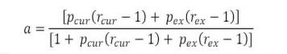
where a is the smoking population attributable fraction, p_{cur} is the proportion of current smokers, p_{ex} is the proportion of ex-smokers, r_{cur} is the relative risk for current smokers and r_{ex} is the relative risk for ex-smokers.

Secondly, the PAF for exposure to SHS for never smokers was derived using the following 2-step formula:
Where, b is the exposure to SHS PAF for each disease, p_{shs} is the proportion of non-smoking population exposed to SHS, r_{shs} is the relative risk for people exposed to SHS, NSB is the burden to non-smokers and T is the total number.

PAFs were calculated and different PAF types were combined in Stata and are expressed in this report as percentages. Using this approach, the number of cancer cases that could be attributed to smoking was estimated by applying the smoking PAFs to the NCRI cancer incidence data. The PAF for exposure to SHS was applied to the NSB to estimate the number of cancer cases due to exposure to SHS.

Population Characteristics
Table 3.1 presents total case numbers by cancer type across the full 1994-2022 period and median age at diagnosis and sex by cancer type. A breakdown of cases by 5-year time periods can be found in Appendix 1. There were 305,914 cases of tobacco-related cancer between 1994 and 2022. An estimated 168,521 deaths occurred due to tobacco-related cancers between 1994 and 2022.

Table 3.1: Cases numbers and median age at diagnosis by sex and tumour type, 1994-2022
Cancer type | Number of cases |  |  | Median age at diagnosis, years (IQR)
Cancer type | Total | Male | Female | Male | Female
All tobacco-related | 305,914 | 136,268 | 169,646 | 69 (61-77) | 65 (53-76)
C00-06 oral cavity | 6,078 | 4,163 | 1,915 | 64 (55-72) | 66 (56-76)
C09-10, C12-14 pharynx | 3,512 | 2,691 | 821 | 62 (55-70) | 63 (54-72)
C11 nasopharynx | 468 | 355 | 113 | 56 (45-65) | 55 (44-70)
C15 oesophagus adenocarcinoma | 5,212 | 4,152 | 1,060 | 68 (59-76) | 74 (65-81)
C15 oesophagus, squamous cell carcinoma | 4,467 | 2,227 | 2,240 | 69 (61-76) | 74 (64-81)
C16 stomach | 15,068 | 9,486 | 5,582 | 71 (62-78) | 73 (63-81)
C18-19 colon & rectosigmoid junction | 47,422 | 25,884 | 21,538 | 70 (62-78) | 72 (61-80)
C20 rectum | 18,150 | 11,857 | 6,293 | 68 (60-76) | 68 (58-78)
C22 liver | 5,701 | 3,867 | 1,834 | 69 (61-77) | 72 (62-80)
C25 pancreas | 13,671 | 6,982 | 6,689 | 71 (62-78) | 74 (65-82)
C30-31 sino-nasal | 729 | 424 | 305 | 65 (54-74.5) | 67 (51-76)
C32 larynx | 4,326 | 3646 | 680 | 65 (58-73) | 65 (58-74)
C33-34 lung | 60,635 | 35,042 | 25,593 | 71 (63-77) | 71 (63-78)
C50 breast | 75,090 |  | 75,090 |  | 59 (50-71)
C53 cervix | 7,170 |  | 7,170 |  | 45 (37-58)
C56-57, C48 ovary-mucinous | 431 |  | 431 |  | 55 (43-67)
C64-66, C68 kidney | 15,079 | 9,622 | 5,457 | 66 (56-75) | 68 (57-77)
C67, D090, D414 bladder & NMIBC | 19,524 | 14,102 | 5,422 | 72 (63-79) | 72 (62-80)
C920, C924-C926, C928, C930, C940, C942 AML | 3,181 | 1,768 | 1,413 | 66 (51-76) | 63 (43-76)

Overall Trends in Tobacco-Related Cancers
This section provides an overview of trends across all tobacco-related cancers combined and provides the PAF for tobacco smoking for cancer incidence in Ireland in 2022 across all cancer types (excluding NMSC).

Key points
Incidence
- Incidence was stable for males from 1994 to 2015 before a decrease of -2.6% (95%CI -3.4; -1.7) per year from 2015 to 2022.
- Incidence for females increased from 1994 to 2010, before stabilising from 2010 to 2022.
- The age-standardised incidence rate of tobacco-related cancers in 2014-2018 increased from the less deprived to the more deprived population quintiles.
Mortality
- Age-standardised mortality rates for males and females decreased from 1994 to 2022.
Survival
- 5-year net survival was 49% for cases diagnosed during 2019-2022.
Population attributable fraction
- The estimated total number of all invasive cancers excluding NMSC cases attributable to smoking in Ireland in 2022 was 3,756 (PAF 14.7%).

Incidence
Between 1994 and 2022, 305,914 cases of tobacco-related cancers were reported (136,268 males, 169,646 females). The median age at diagnosis was 69 years (IQR: 61-77) for males and 65 years (IQR: 53-76) for females. The age-standardised incidence rate of tobacco-related cancers during the period 1994-2022 was 356.3 cases per 100,000 males and 350.6 cases per 100,000 females per year. Figure 4.1 breaks this down further by sex and age group.

Figure 4.1: Incidence rate (per 100,000) for tobacco-related cancers combined by age group,1994-2022
Total | Males | Females
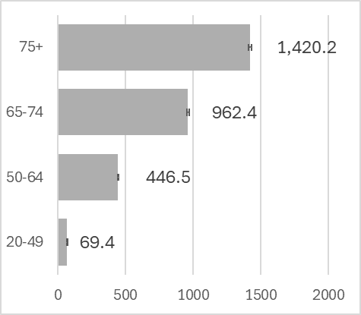 | 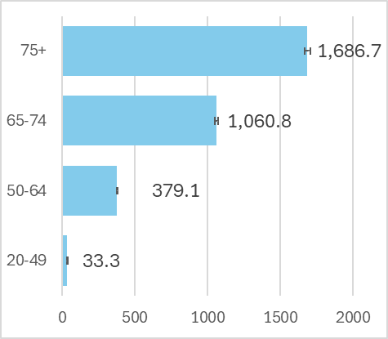 | 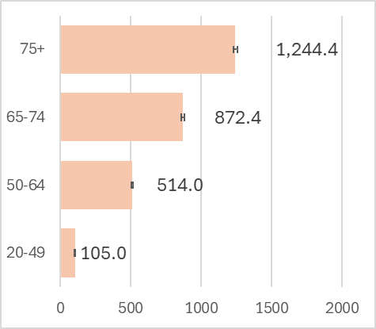

Trends over time
Figure 4.2 shows the incidence of tobacco-related cancers from 1994 to 2022. Incidence was stable for males from 1994 to 2015 (0.2% per year (95%CI 0.0; 0.4)), before a decrease of -2.6% per year from 2015 to 2022 (95%CI -3.4; -1.7). Incidence for females increased by 1.5% annually from 1994 to 2010 (95%CI 1.0; 1.9), before stabilising from 2010 to 2022 (-0.4 % per year (95%CI -1.0; 0.2)).

Figure 4.2: Age-standardised incidence rate per 100,000, 1994-2022 tobacco-related cancers
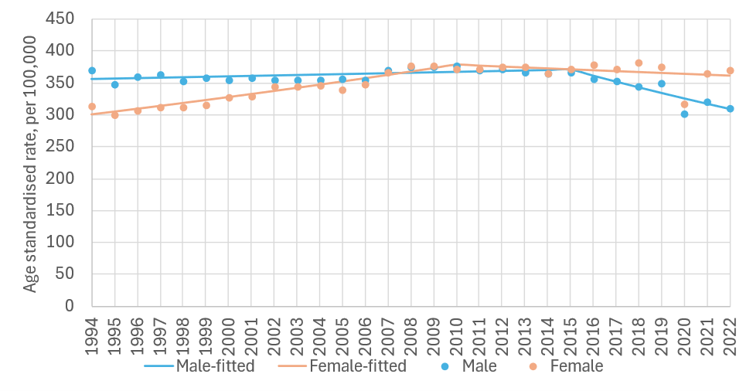
sex | period | APC | 95%CI | trend | sex | period | APC | 95%CI | trend
M | 1994-2015 | 0.2 | 0.0, 0.4 | flat | F | 1994-2010 | 1.5 | 1.0, 1.9 | up
 | 2015-2022 | -2.6 | -3.4, -1.7 | down |  | 2010-2022 | -0.4 | -1.0, 0.2 | flat

APC%: average annual percentage change in rate over period and 95% confidence interval (95%CI) based on annual data points fitted with Joinpoint regression. Trend: ‘up’=significant increase, ‘down’=significant decrease, ‘flat’=no change (static), at the 95% level.

Variation by deprivation quintile
Age-standardised incidence rates of tobacco-related cancers in 2014-2018 ranged from 355.9 to 415.4 cases per 100,000 in the least and in the most deprived quintiles, respectively (Figure 4.3). Similar trends were observed when the rates were stratified into males and females.

Figure 4.3: Incidence rate (per 100,000) for tobacco-related cancer by deprivation quintile, 2014-2018
Total | Males | Females
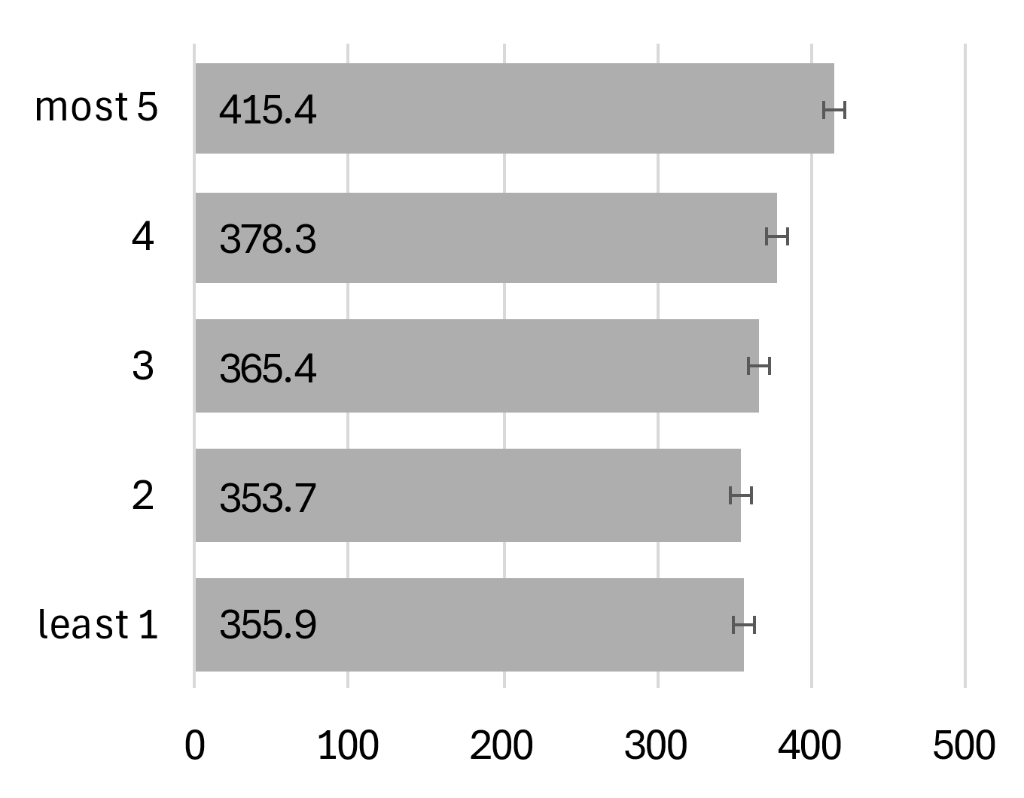 | 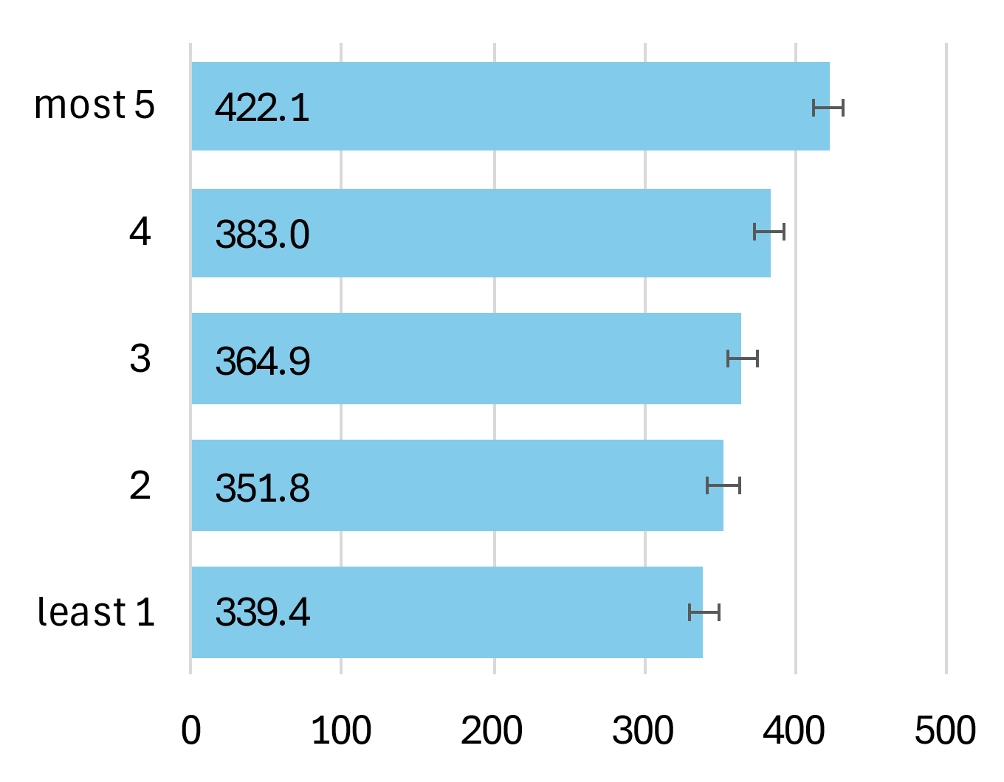 | 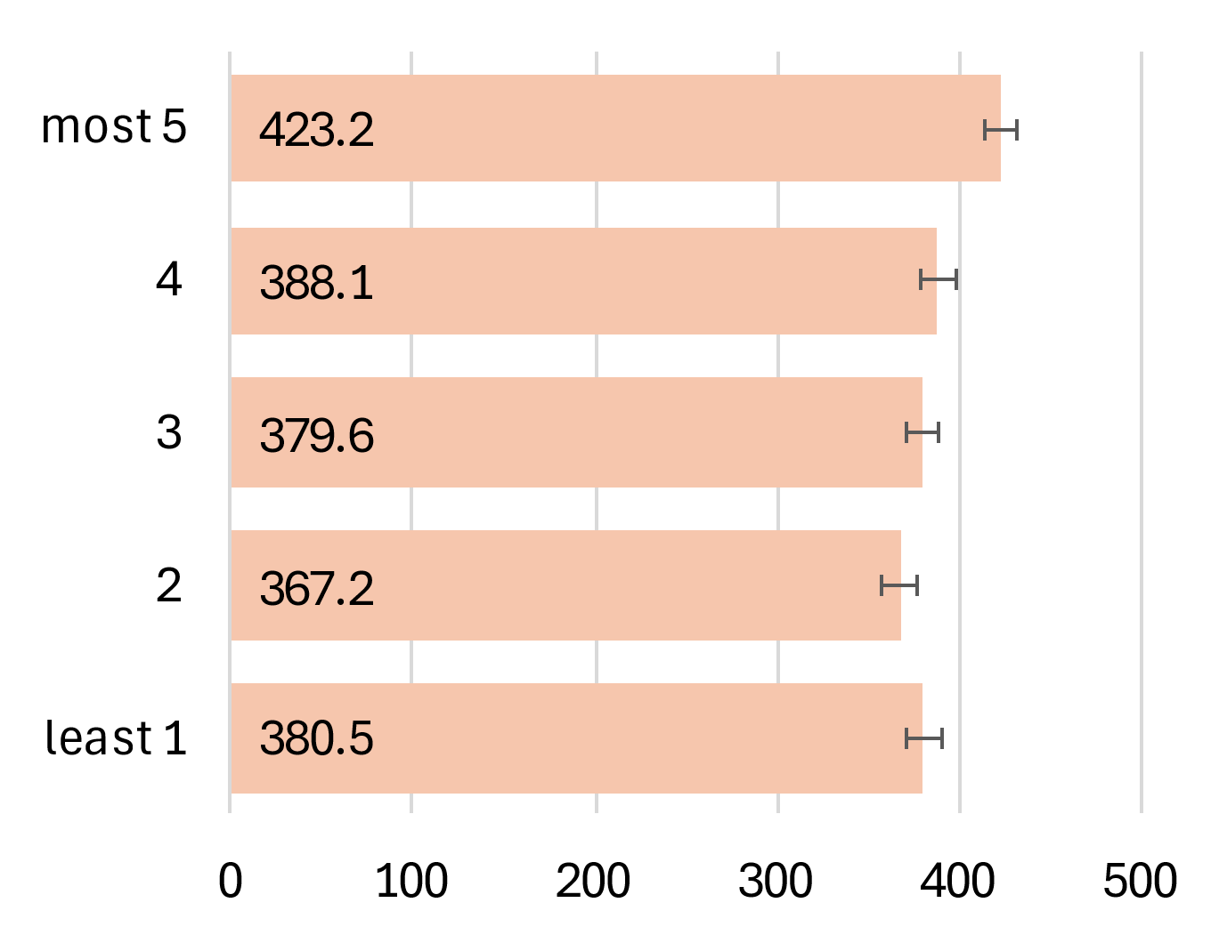

Mortality
The age-standardised mortality rate of tobacco-related cancers during the period 1994-2022 was 213.0 deaths per 100,000 in males and 162.0 deaths per 100,000 in females per year. Figure 4.4 breaks this down further by sex and age group. Mortality was higher among older cases regardless of sex.

Figure 4.4: Mortality rate (per 100,000) for any tobacco-related cancer by age group, 1994-2022
Total | Males | Females
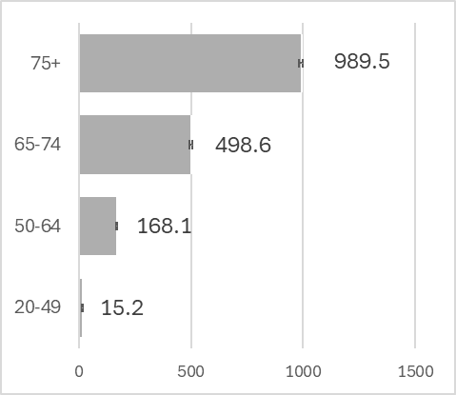 | 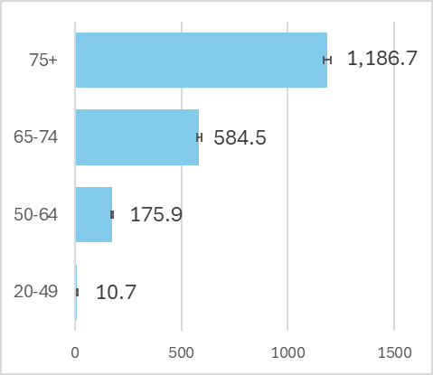 | 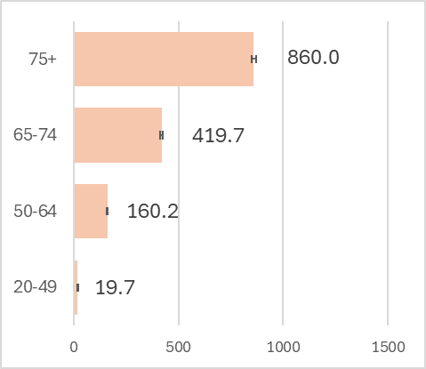

Trends over time
Figure 4.5 shows the mortality rates of tobacco-related cancers from 1994 to 2022. In males, there was a decline in mortality of -1.1% per year (95%CI -1.3; -0.9) from 1994 to 2014. The mortality rate further decreased by -2.7% per year (95%CI -3.4; -2.0) between 2014-2022. In females there was a -0.5% decline in mortality per year (95%CI -0.8; -0.3) in 1994 to 2014. The mortality rate continued to decrease from 2014-2022 at a rate of -1.8% per year (95%CI -2.6; -1.0)).

Figure 4.5 Age-standardised mortality rate 1994-2022, tobacco-related cancer
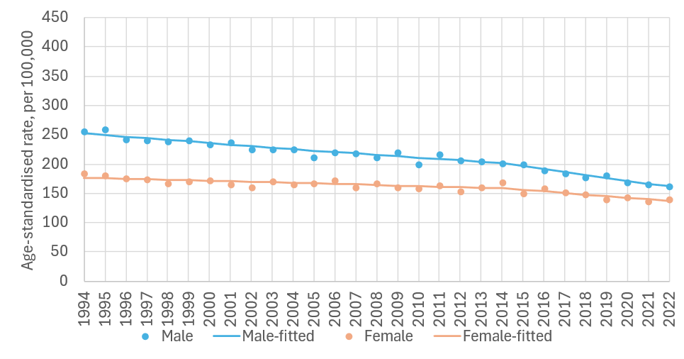
sex | period | APC% | 95%CI | trend | sex | period | APC% | 95%CI | Trend
M | 1994-2014 | -1.1 | -1.3, -0.9 | down | F | 1994-2014 | -0.5 | -0.8, -0.3 | down
 | 2014-2022 | -2.7 | -3.4, -2.0 | down |  | 2014-2022 | -1.8 | -2.6, -1.0 | down

APC%: average annual percentage change in rate over period and 95% confidence interval (95%CI) based on annual data points fitted with Joinpoint regression. Trend: ‘up’=significant increase, ‘down’=significant decrease, ‘flat’=no change (static), at the 95% level.

Survival
The overall 5-year net survival was 49% for cases diagnosed with a tobacco-related cancer during 2019-2022 (Figure 4.6). Five-year net survival for 2019-2022 was slightly higher for females (51%) than for males (47%).

Figure 4.6: Age-standardised 5-year net survival (%) for tobacco-related cancer over six consecutive diagnosis periods
Total | Males | Females
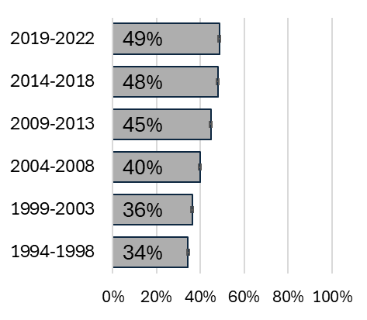 | 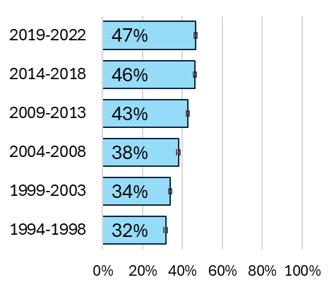 | 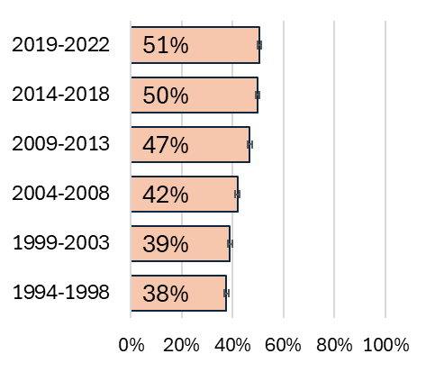

Population Attributable Fraction
In 2022, 25,540 cases of invasive cancers excluding NMSC were recorded (13,654 males, 11,886 females). The estimated total number of cancer cases attributable to smoking in Ireland in 2022 was 3,756 (PAF 14.7%). Table 4.1 presents the difference between males and females.

Table 4.1: Population attributable fraction and attributable cases for tobacco-related cancers in 2022
 | Total | Males | Females
PAF (%) | 14.7 | 16.0 | 13.3
Total cases | 25,540 | 13,654 | 11,886
Attributable cases | 3,756 | 2179 | 1578

Table 4.2 presents the PAF and number of cases attributable to smoking for each cancer type. Figure 4.7 presents a heat map of the PAF for each cancer type (darker shading reflects a higher PAF). Figure 4.7 additionally presents the PAF across cancer types by sex. Lung, laryngeal and bladder were the cancer types with the greatest proportion of cases attributable to tobacco smoking with PAFs of 73.3% (lung), 65.9% (larynx) and 47.5% (bladder & NMIBC).

Table 4.2: Population attributable fractions and attributable cases by cancer type
Cancer Types | PAF (%) | Attributable cases
C00-06 oral cavity | 18.2 | 60
C09-10, C12-14 pharynx | 37.6 | 80
C11 nasopharynx | 25.4 | 4
C15 oesophagus adenocarcinoma | 38.6 | 123
C15 squamous cell carcinoma | 38 | 75
C16 stomach | 14.8 | 91
C18-19 colon & rectosigmoid junction | 5.4 | 107
C20 rectum | 8.3 | 68
C22 liver | 18 | 61
C25 pancreas | 24.9 | 156
C30-31 sino-nasal | 26 | 6
C32 larynx | 65.9 | 121
C33-34 lung | 73.3 | 2,010
C50 breast | 3.6 | 147
C53 cervix | 20.3 | 52
C56-57, C48 ovary-mucinous | 20.3 | 5
C64-66, C68 kidney | 13.2 | 105
C67,D090,D414 bladder & NMIBC | 47.5 | 456
C920, C924-C926, C928, C930, C940, C942 AML | 20.7 | 29

Figure 4.7: Heat map of population attributable fractions by cancer type and sex
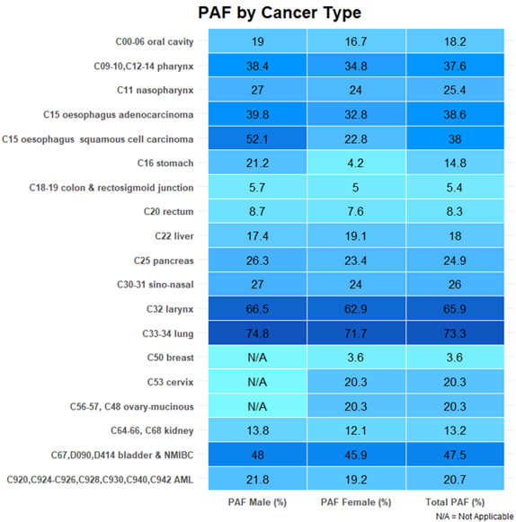

Oral cavity C00-06
Key points
Incidence
- Incidence decreased sharply for males from 1994 to 2001, before a period of steady increase again from 2001 to 2022.
- Incidence rates increased steadily among females from 1994-2022.
- Age-standardised incidence rates of oral cavity cancer in 2014-2018 ranged 5.7-10.3 cases per 100,000 from the least to the most deprived quintiles.
Mortality
- Age-standardised mortality rates for males decreased from 1994 to 2022
- There were no significant trends observed in mortality rates from 1994-2022 among females.
Survival
- 5-year net survival was 58% for cases diagnosed during 2019-2022.
Population attributable fraction
- The estimated total number of oral cavity cancer cases attributable to smoking in Ireland in 2022 was 60 (PAF 18%).

Incidence
Between 1994-2022, a total of 6,078 cases of oral cavity cancer were reported (1,915 Males, 4,163 Females). The median age at diagnosis was 64 years (IQR: 55-72) for males and 66 years (IQR: 56-76) for females. The age-standardised incidence rate of oral cavity cancer during the period 1994-2022 was 9.8 cases per 100,000 males and 3.9 cases per 100,000 females per year. Figure 5.1 breaks this down further by sex and age group.

Figure 5.1: Incidence rate (per 100,000) for oral cavity cancer by age group,1994-2022
Total | Males | Females
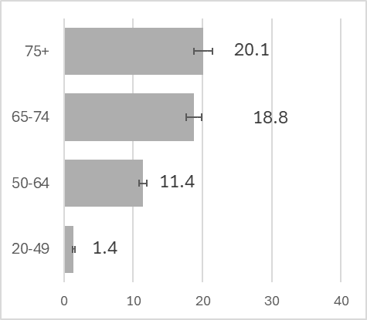 | 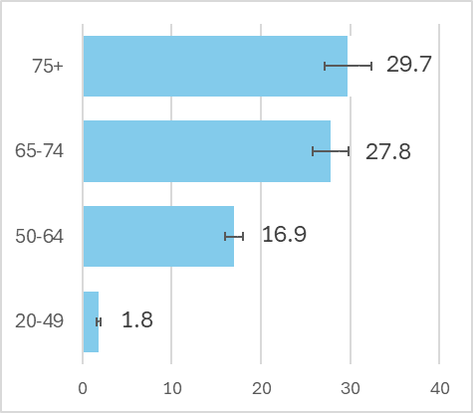 | 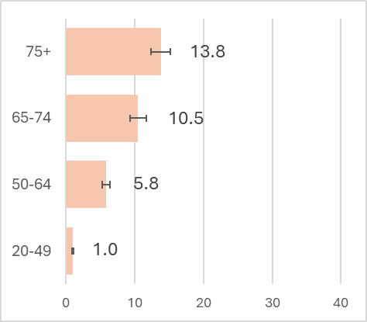

Trends over time
Figure 5.2 shows the incidence of oral cavity cancer from 1994 to 2022. Incidence decreased sharply by -7.7% per year (95%CI -10.7; -4.6) for males from 1994 to 2001), before a period of steady increase from 2001 to 2022 (1.3 % increase per year (95%CI 0.7; 1.8)). Across the period rates increased steadily among females by 1.6% per year (95%CI 1.0; 2.3).

Figure 5.2: Age-standardised incidence rate 1994-2022, oral cavity
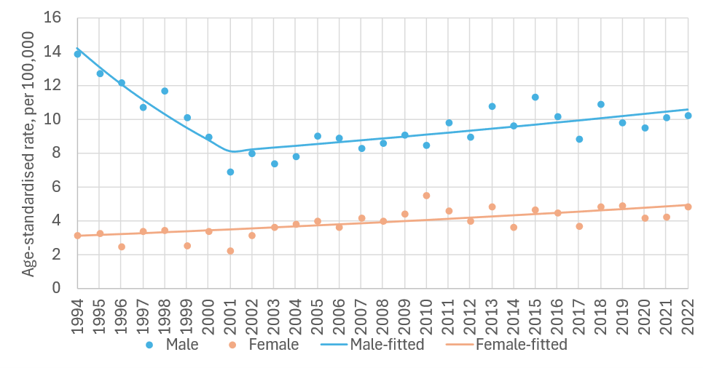
sex | period | APC% | 95%CI | trend | sex | period | APC% | 95%CI | trend
M | 1994-2001 | -7.7 | -10.7, -4.6 | down | F | 1994-2022 | 1.6 | 1.0, 2.3 | up
 | 2001-2022 | 1.3 | 0.7, 1.8 | up

APC%: average annual percentage change in rate over period and 95% confidence interval (95%CI) based on annual data points fitted with Joinpoint regression. Trend: ‘up’=significant increase, ‘down’=significant decrease, ‘flat’=no change (static), at the 95% level.

Variation by deprivation quintile
Age-standardised incidence rates of oral cavity cancer in 2014-2018 ranged between 5.7 to 10.2 cases per 100,000 from the least to the most deprived quintiles (Figure 5.3). There was a difference in rates of oral cavity cancer between the most and least deprived quintiles for males (8.4 for least deprived and 14.7 for most deprived). Although smaller, a difference in rates between the most and least deprived quintiles was also seen in females (3.4 for least deprived and 6.2 for most deprived).

Figure 5.3: Incidence rate (per 100,000) for oral cavity cancer by deprivation quintile, 2014-2018
Total | Males | Females
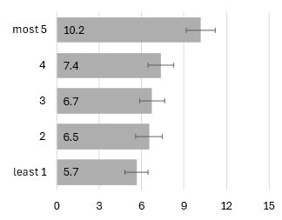 | 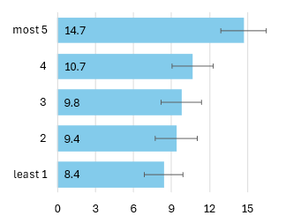 | 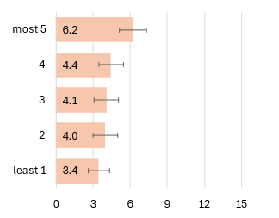

Mortality
The age-standardised mortality rate of oral cavity cancer during the period 1994-2022 was 3.6 deaths per 100,000 males and 1.4 deaths per 100,000 females per year. Figure 5.4 breaks this down further by sex and age group. Mortality was higher among older age groups regardless of sex.

Figure 5.4: Mortality rate (per 100,000) for oral cavity cancer by age group, 1994-2022
Total | Males | Females
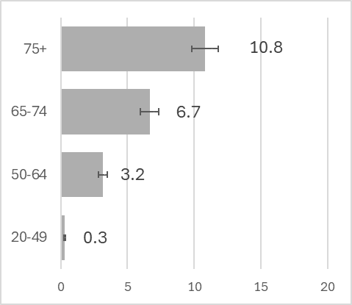 | 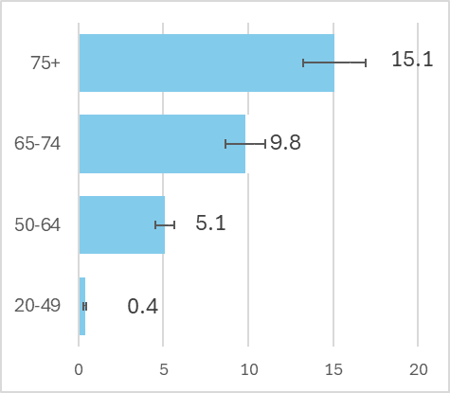 | 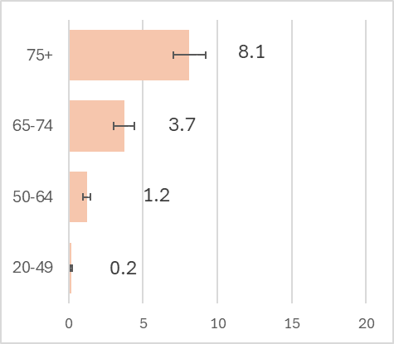

Trends over time
Figure 5.5 shows the age-standardised mortality rates for cancer of the oral cavity from 1994 to 2022 in males and females. In males there was a decline of -2.2% per year (95%CI -3.0; -1.3) in the mortality rate from 1994 to 2022. Among females, the mortality rate remained stable over time (-0.1% per year (95%CI -1.1;0.9)).

Figure 5.5: Age-standardised mortality rate 1994-2022, oral cavity
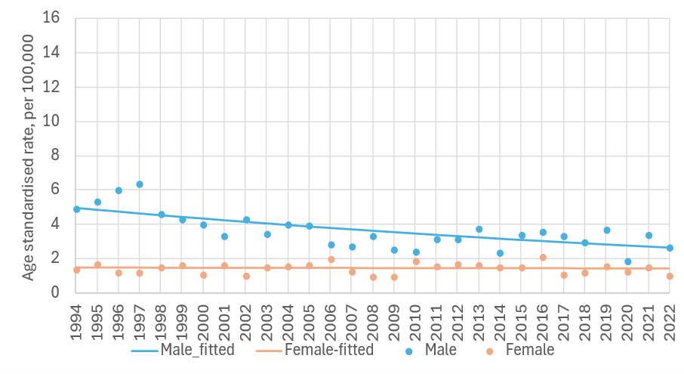
sex | period | APC% | 95%CI | trend | sex | period | APC% | 95%CI | trend
M | 1994-2022 | -2.2 | -3.0, -1.3 | down | F | 1994-2022 | -0.1 | -1.1, 0.9 | flat

APC%: average annual percentage change in rate over period and 95% confidence interval (95%CI) based on annual data points fitted with Joinpoint regression. Trend: ‘up’=significant increase, ‘down’=significant decrease, ‘flat’=no change (static), at the 95% level.

Survival
Overall, 5-year net survival was 58% for cases diagnosed during 2019-2022 (Figure 5.6). Five-year net survival for 2019-2022 was higher for females (64%) than for males (57%). This was in line with the survival estimates for the 2014-2018 and 2009-2013 periods.

Figure 5.6: Age-standardised 5-year net survival (%) for oral cavity cancer over six consecutive diagnosis periods
Total | Males | Females
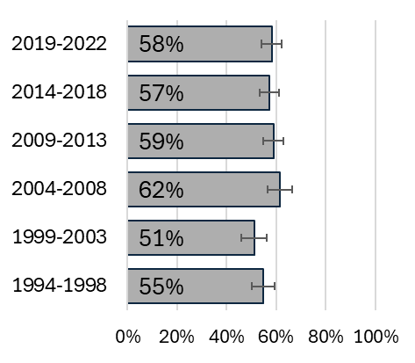 | 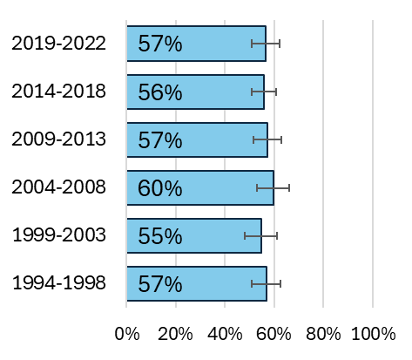 | 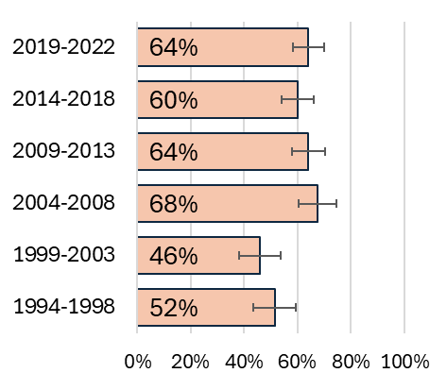

Population Attributable Fraction
In 2022, 328 cases of oral cavity cancer were recorded (218 males, 110 females). The estimated total number of cases attributable to smoking in Ireland in 2022 was 60 (PAF 18.2%). Table 5.1 presents the difference between male and female oral cavity cancer incidence related to smoking. Males had a higher PAF than females, 19.0% vs 16.7%.

Table 5.1: Population attributable fraction and attributable cases for oral cavity cancer in 2022
 | Total | Males | Females
PAF (%) | 18.2 | 19.0 | 16.7
Total cases | 328 | 218 | 110
Attributable cases | 60 | 41 | 18

Pharynx C09-10, C12-14
Key points
Incidence
- Incidence rates remained stable for males from 1994 to 2001, before a period of steady increase from 2001 to 2022.
- Between 1994 and 2022, the incidence rate increased steadily among females.
Mortality
- Mortality rates remained stable for both males and females from 1994 to 2022.
Survival
- 5-year net survival was 47% for cases diagnosed during 2019-2022.
Population attributable fraction
- The estimated total number of pharyngeal cancer cases attributable to smoking in Ireland in 2022 was 80 (PAF 37.6%).

Incidence
Between 1994 and 2022, 3,512 cases of pharyngeal cancer were reported (2,691 males, 821 females). The median age at diagnosis was 62 years (IQR: 55-70) for males and 63 years (IQR: 54-72) for females. Age-standardised incidence rates of pharyngeal cancer during the period 1994-2022 were 5.9 cases per 100,000 males and 1.7 cases per 100,000 females per year. Figure 6.1 breaks this down further by sex and age group.

Figure 6.1: Incidence rate (per 100,000) for pharyngeal cancer by age group,1994-2022
Total | Males | Females
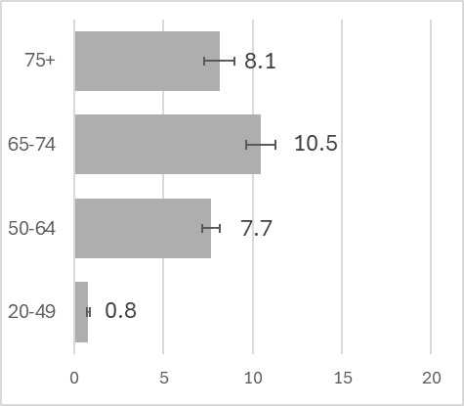 | 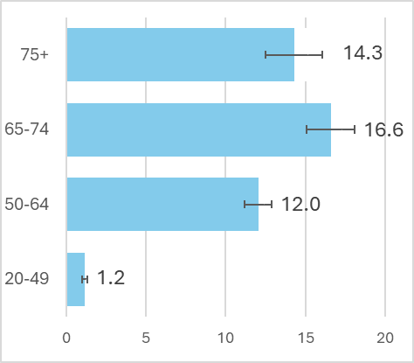 | 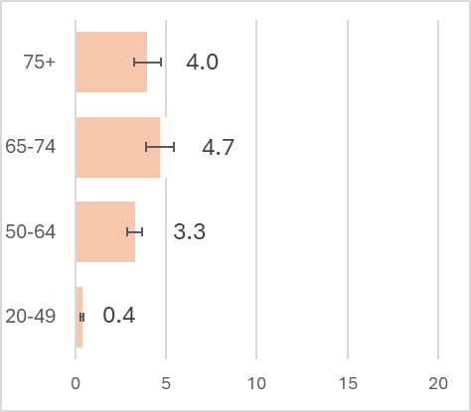

Trends over time
Figure 6.2 shows the incidence of pharyngeal cancer from 1994 to 2022. Incidence remained stable for males from 1994 to 2001 before a period of steady increase from 2001 to 2022 (2.7 % increase per year (95%CI 2.0; 3.4)). Between 1994 and 2001, incidence increased steadily among females by 1.4% per year (95%CI 0.5; 2.3).

Figure 6.2: Age-standardised incidence rate 1994-2022, pharynx
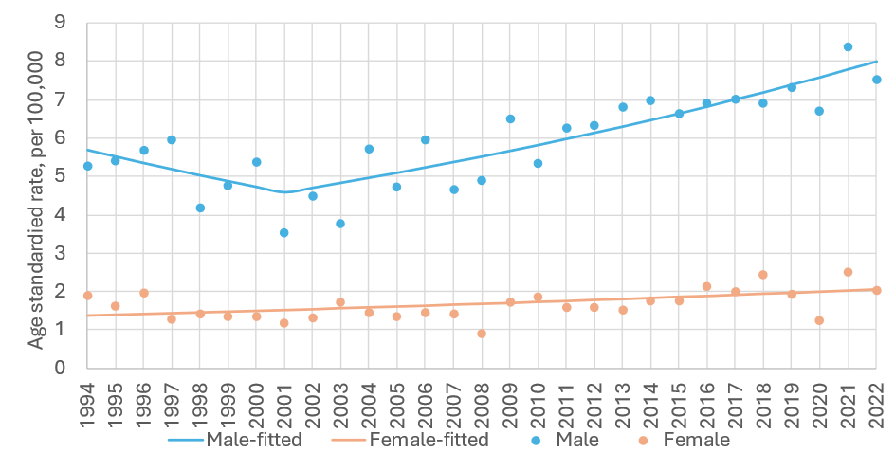
sex | period | APC% | 95%CI | trend | sex | period | APC% | 95%CI | trend
M | 1994-2001 | -3.0 | -7.5, 1.7 | Flat | F | 1994-2022 | 1.4 | 0.5, 2.3 | up
 | 2001-2022 | 2.7 | 2.0, 3.4 | up

APC%: average annual percentage change in rate over period and 95% confidence interval (95%CI) based on annual data points fitted with Joinpoint regression. Trend: ‘up’=significant increase, ‘down’=significant decrease, ‘flat’=no change (static), at the 95% level.

Variation by deprivation quintile
Age-standardised incidence of pharyngeal cancer in 2014-2018 ranged between 4.2 and 5.2 cases per 100,000 from the least to the most deprived quintiles (Figure 6.3). There was a small difference in the rate of pharyngeal cancer between the most and least deprived quintiles for males (6.8 for least deprived and 8.6 for most deprived). For females, the rate of pharyngeal cancer was similar across deprivation levels (2.0 for least deprived and 2.0 for most deprived).

Figure 6.3: Incidence rate (per 100,000) for pharyngeal cancer by deprivation quintile, 2014-2018
Total | Males | Females
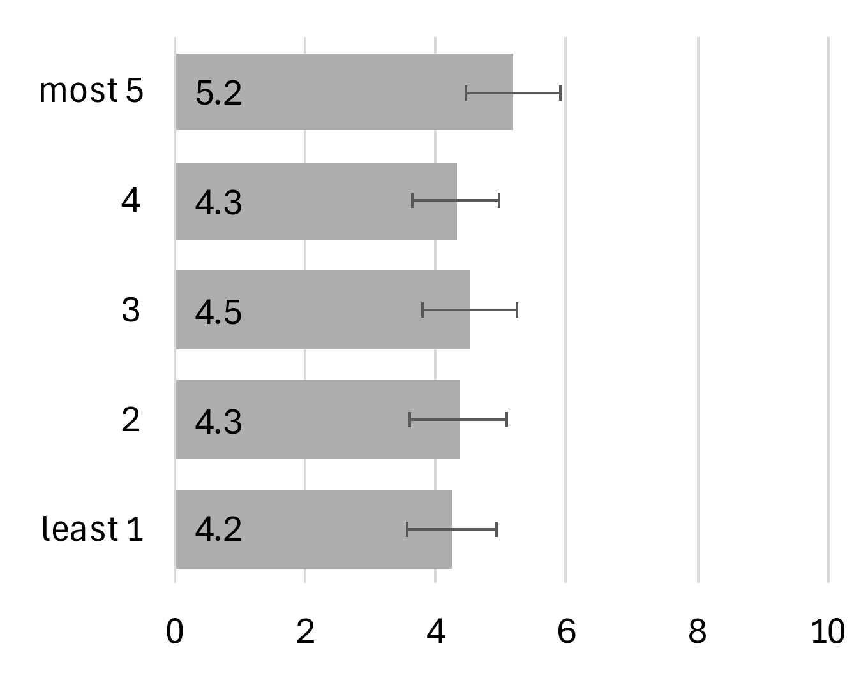 | 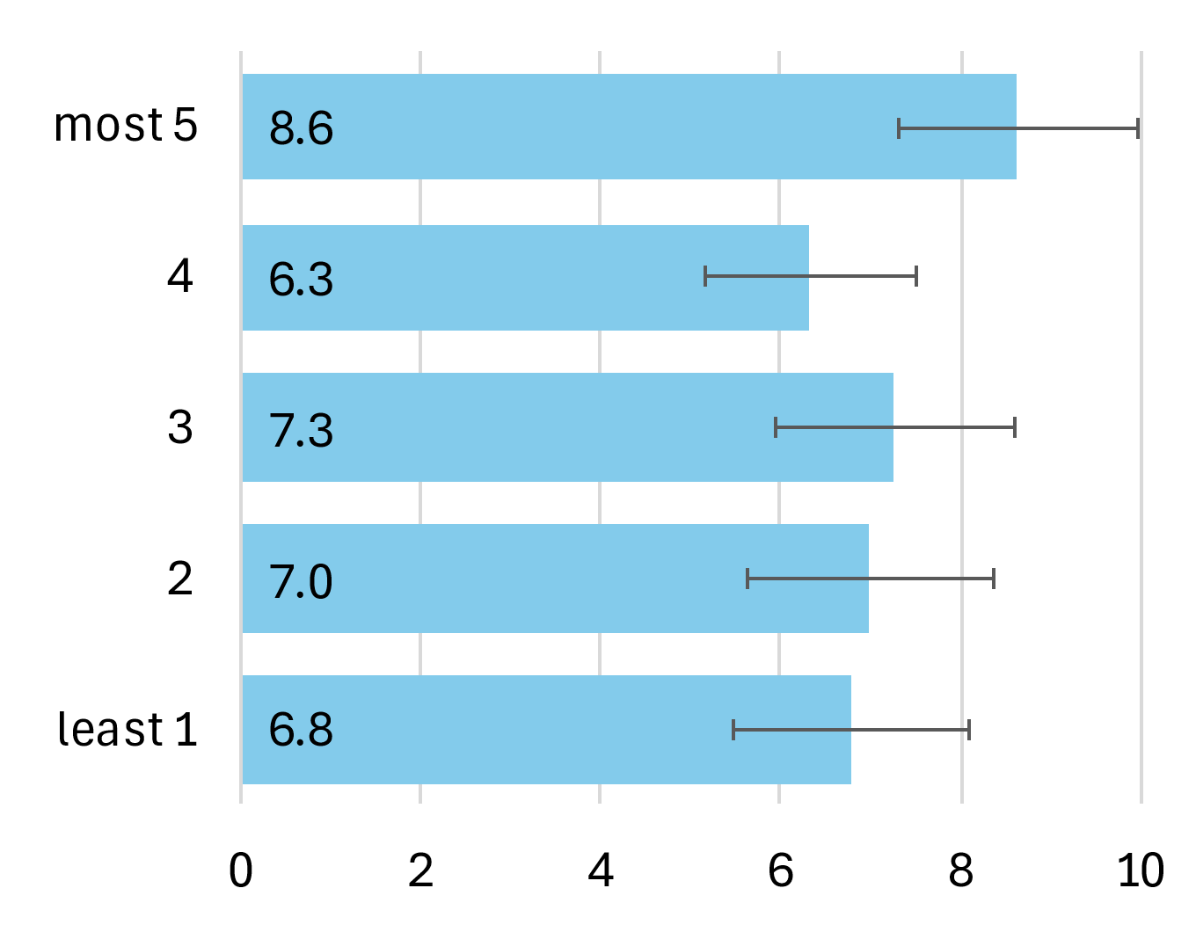 | 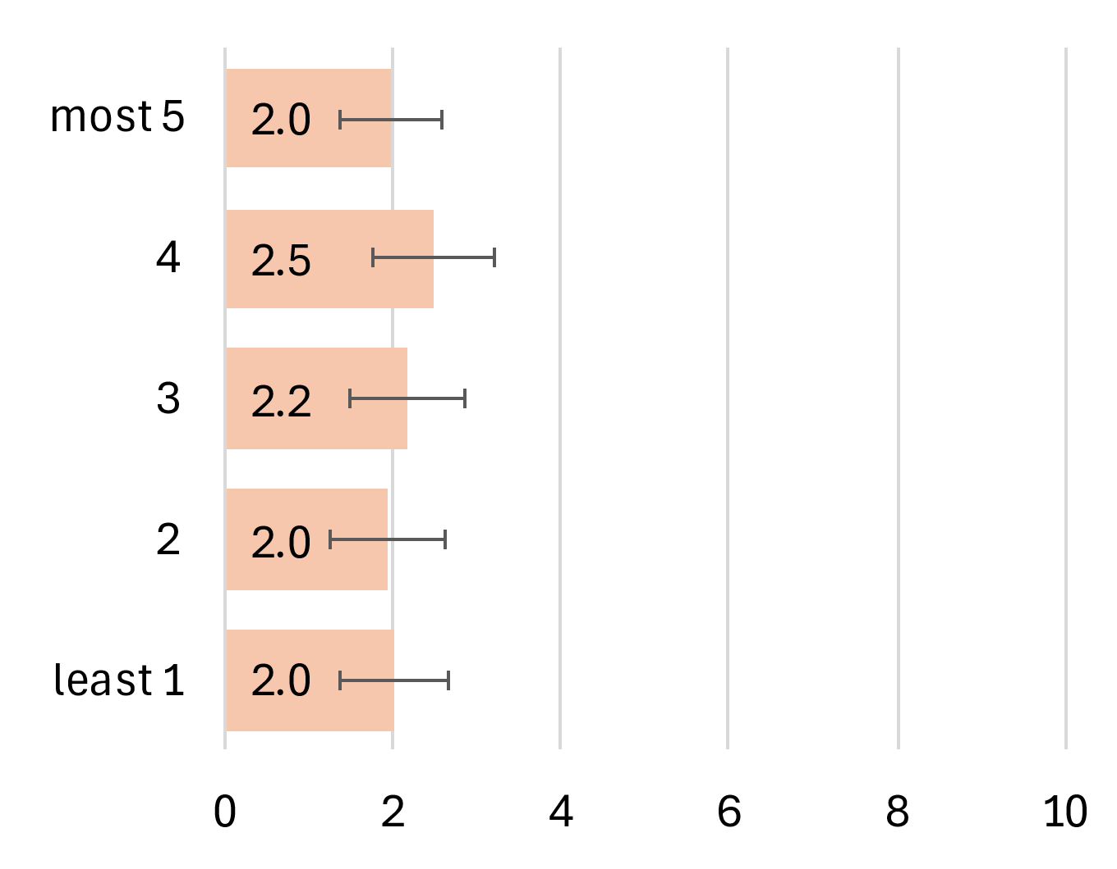

Mortality
The age-standardised mortality rate of pharyngeal cancer during the period 1994-2022 was 3.2 deaths per 100,000 males and 0.9 deaths per 100,000 females per year. Figure 6.4 breaks this down further by sex and age group. Mortality rates were higher among older age groups regardless of sex.

Figure 6.4: Mortality rate (per 100,000) for pharyngeal cancer by age group, 1994-2022
Total | Males | Females
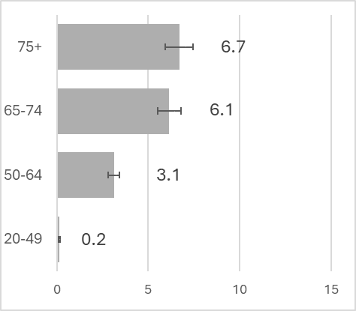 | 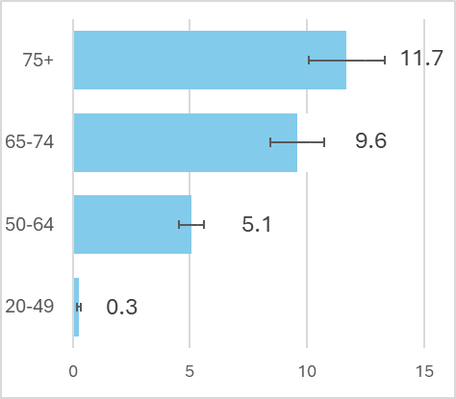 | 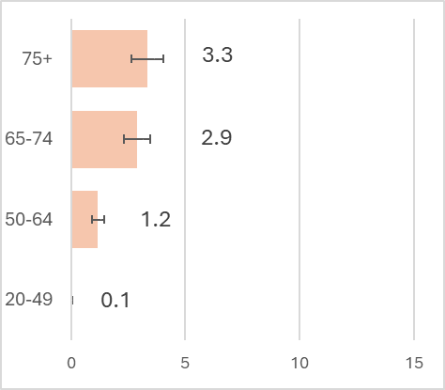

Trends over time
Figure 6.5 displays age-standardised mortality for pharyngeal cancer from 1994 to 2022 for males and females. No significant change in trend was observed for males or females during this period.

Figure 6.5: Age-standardised mortality rate 1994-2022, pharyngeal cancer
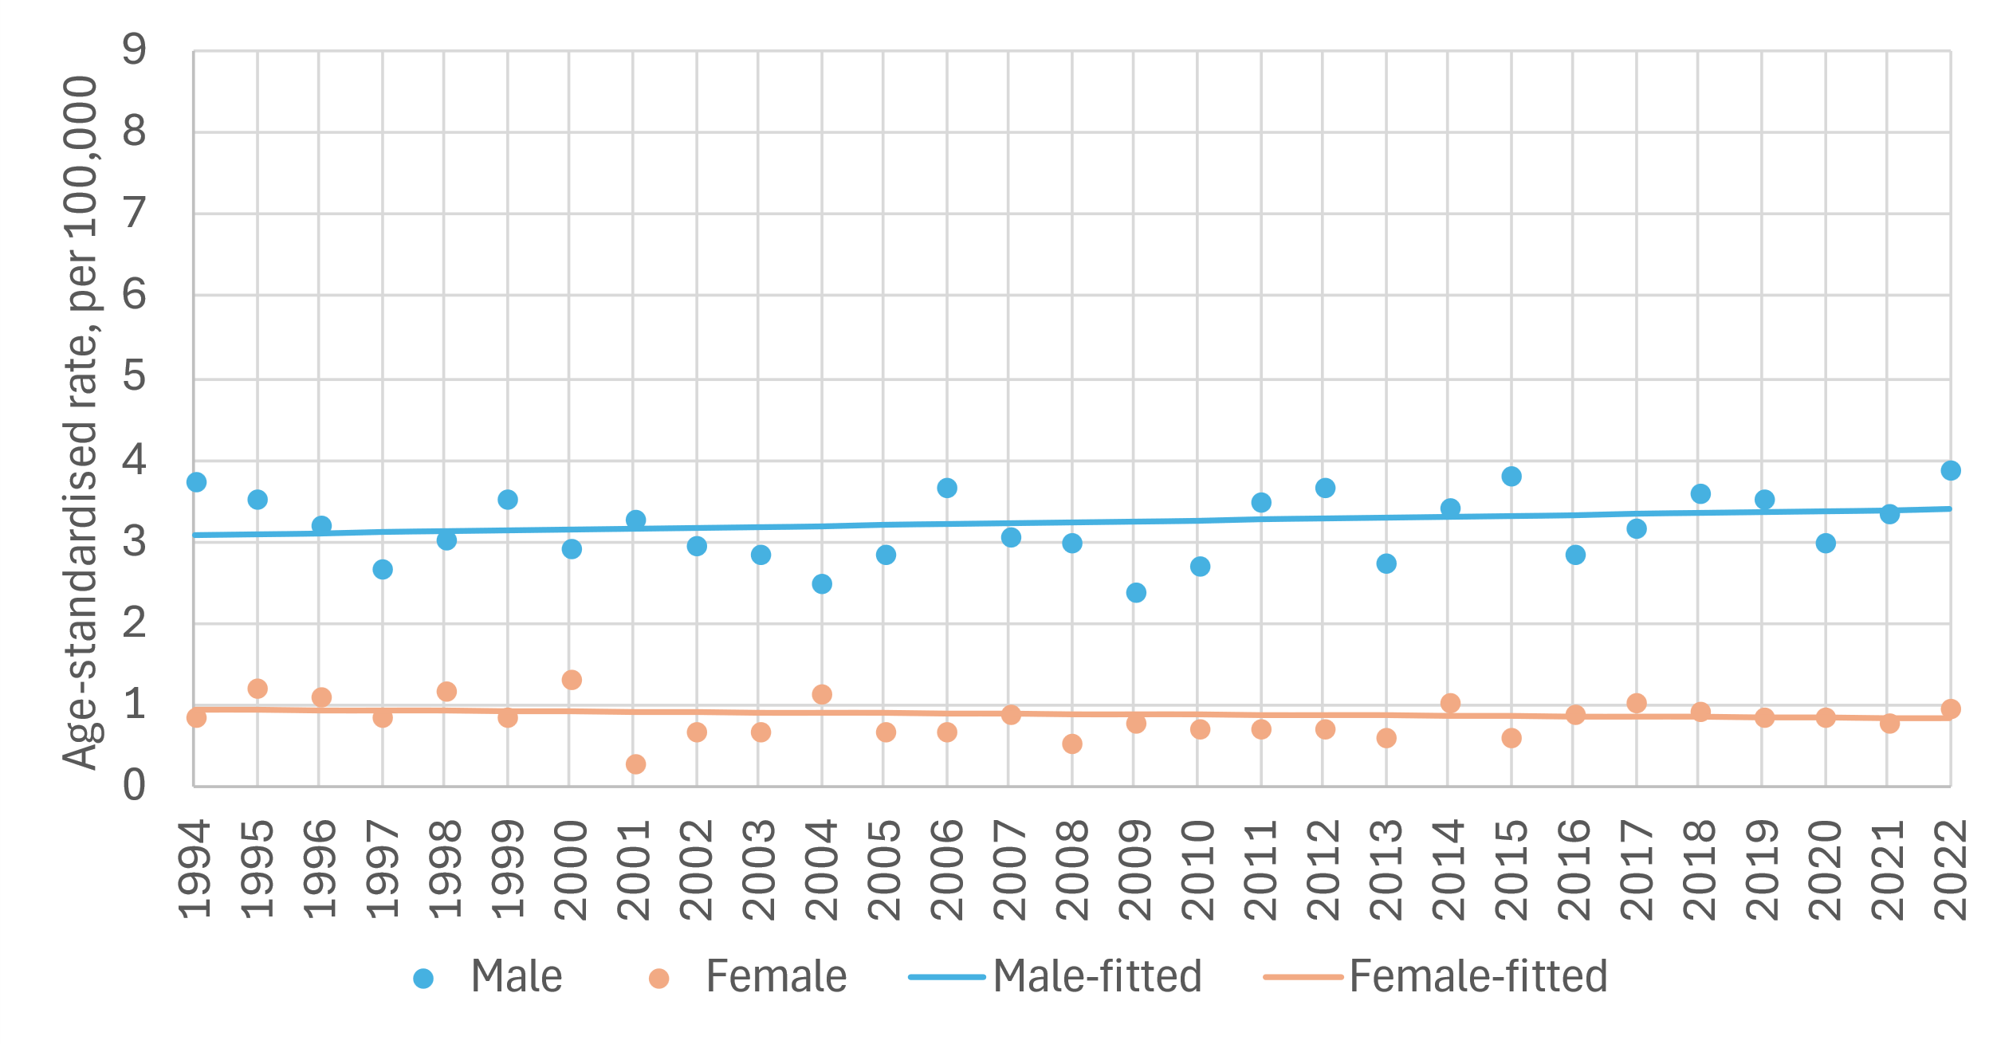
sex | period | APC% | 95%CI | trend | sex | period | APC% | 95%CI | trend
M | 1994-2022 | 0.4 | -0.2, 0.9 | flat | F | 1994-2022 | -0.4 | -1.5, 0.6 | flat

APC%: average annual percentage change in rate over period and 95% confidence interval (95%CI) based on annual data points fitted with Joinpoint regression. Trend: ‘up’=significant increase, ‘down’=significant decrease, ‘flat’=no change (static), at the 95% level.

Survival
Overall, 5-year net survival was 47% for cases diagnosed during 2019-2022 (Figure 6.6). Five-year net survival for 2019-2022 was similar for females (47%) and for males (48%).

Figure 6.6: Age-standardised 5-year net survival (%) for pharyngeal cancer over six consecutive diagnosis periods
Total | Males | Females
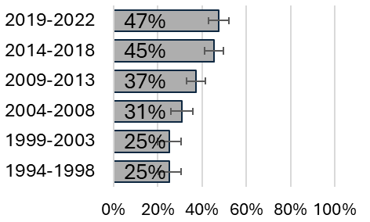 | 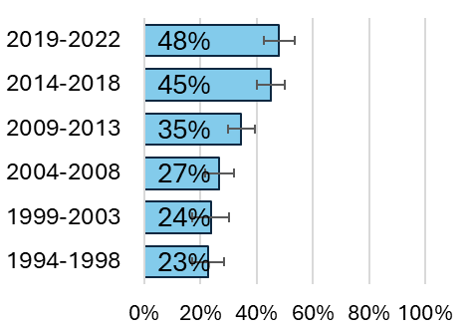 | 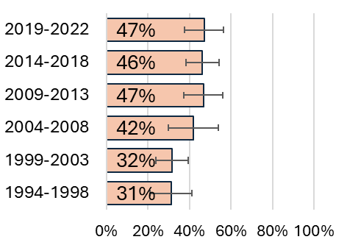

Population Attributable Fraction
In 2022, 213 cases of pharyngeal cancer were recorded (165 males, 48 females). The estimated total number of pharyngeal cancers attributable to smoking in Ireland in 2022 was 80 (PAF 37.6%). Table 6.1 presents the difference between male and female pharyngeal cancer incidence related to smoking. Males had higher PAF than females, 38.4% vs 34.8%.

Table 6.1: Population attributable fraction and attributable cases for cancer of the pharynx in 2022
 | Total | Males | Females
PAF (%) | 37.6 | 38.4 | 34.8
Total cases | 213 | 165 | 48
Attributable cases | 80 | 63 | 17

Nasopharynx C11
  - Key points
  - Incidence
- Incidence rates remained stable during the period 1994 to 2022 among males while incidence increased among females.
- Incidence rates in the diagnosis period 2014-2018 were similar across deprivation quintiles.
Mortality
- In males, no significant change in mortality rates was observed from 1994-2022. Due to small numbers, including the absence of cases reported for certain years, trends in mortality rates could not be estimated for females.
  - Survival
- Overall, 5-year net survival was 60% for cases diagnosed during 2019-2022.
  - Population attributable fraction
- The estimated total number of nasopharyngeal cancer cases attributable to smoking in Ireland in 2022 was 4 (PAF 25.4%).

Incidence
Between 1994 and 2022, 468 cases of nasopharyngeal cancer were reported (355 males, 113 females). The median age at diagnosis was 56 years (IQR: 45-65) for males and 55 years (IQR: 44-70) for females. Age-standardised incidence rates of nasopharyngeal cancer during the period 1994-2022 were 0.7 cases per 100,000 males and 0.2 cases per 100,000 females per year. Figure 7.1 breaks this down further by sex and age group.

Figure 7.1: Incidence rate (per 100,000) for nasopharyngeal cancer by age group,1994-2022
Total | Males | Females
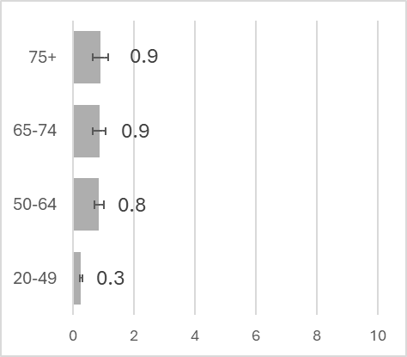 | 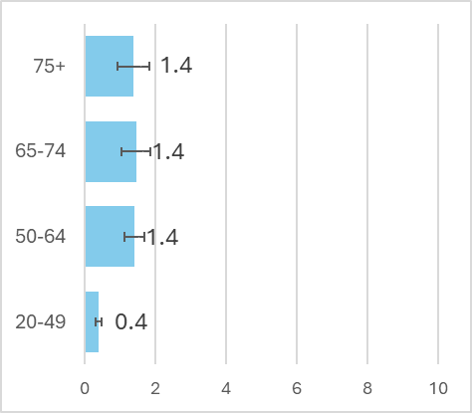 | 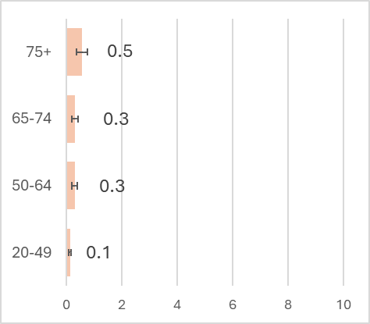

Trends over time
Figure 7.2 shows the incidence of nasopharyngeal from 1994 to 2022. Across the period incidence remained stable among males but increased steadily among females by 3.0% per year (95%CI 1.0; 5.2).

Figure 7.2: Age-standardised incidence rate 1994-2022, nasopharyngeal cancer
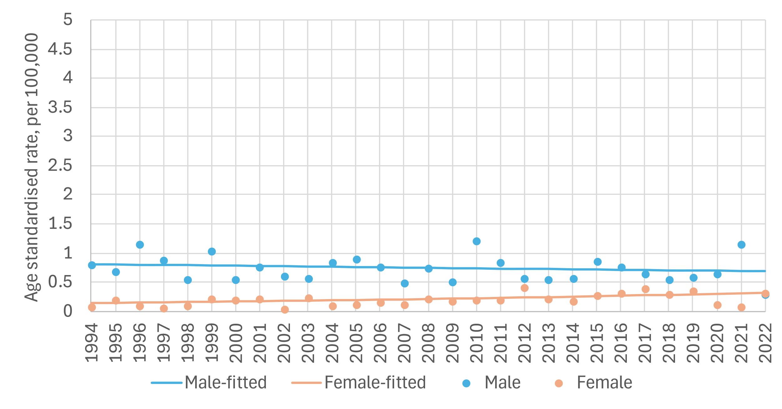
sex | period | APC% | 95%CI | trend | sex | period | APC% | 95%CI | trend
M | 1994-2022 | -0.6 | -2.0, 0.8 | flat | F | 1994-2022 | 3 | 1.0, 5.2 | up

APC%: average annual percentage change in rate over period and 95% confidence interval (95%CI) based on annual data points fitted with Joinpoint regression. Trend: ‘up’=significant increase, ‘down’=significant decrease, ‘flat’=no change (static), at the 95% level.

Variation by deprivation quintile
Age-standardised incidence rates of nasopharyngeal cancer in 2014-2018 ranged from 0.4-0.6 cases per 100,000 from the least to the most deprived quintiles (Figure 7.3). Very little difference was observed in rates of nasopharyngeal cancer between the most and least deprived quintiles for males (0.6 for least deprived and 0.8 for most deprived) and females (0.3 for least deprived and 0.4 for most deprived).

Figure 7.3: Incidence rate (per 100,000) for nasopharyngeal cancer by deprivation quintile, 2014-2018
Total | Males | Females
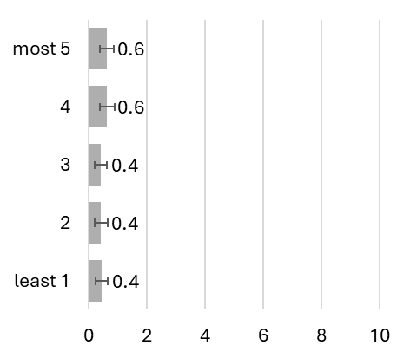 | 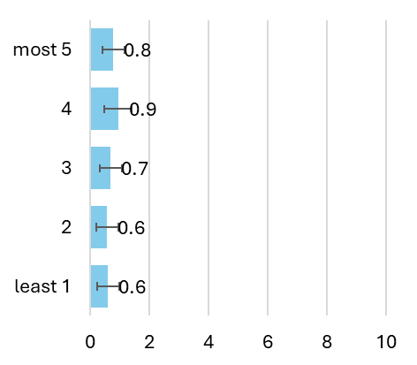 | 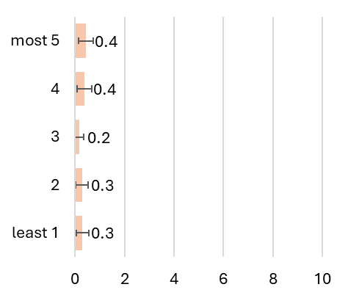

Mortality
Age-standardised mortality rates of nasopharyngeal cancer during the period 1994-2022 were 0.4 deaths per 100,000 males and 0.1 deaths per 100,000 females per year. Figure 7.4 breaks this down further by sex and age group. Mortality rates tended to be higher in older age groups regardless of sex.

Figure 7.4: Mortality rate (per 100,000) for nasopharyngeal cancer by age group, 1994-2022
Total | Males | Females
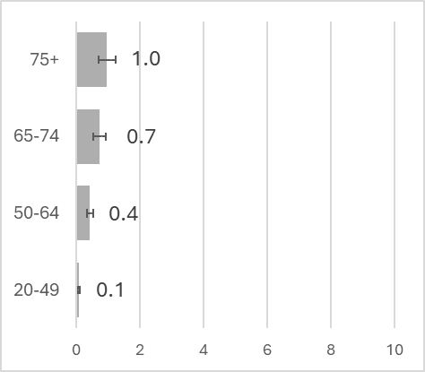 | 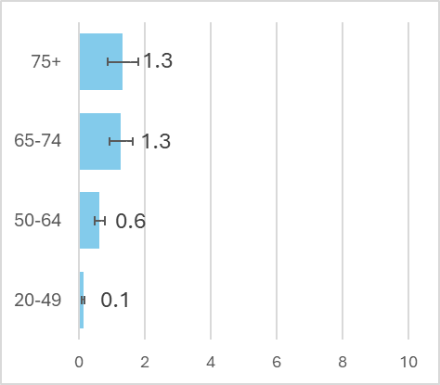 | 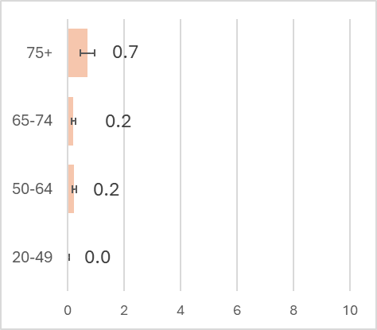

Trends over time
Figure 7.5 shows the age-standardised mortality rate for nasopharyngeal cancer from 1994 to 2022 in males. In males, mortality rates (APC) were stable from 1994 to 2022. Due to small numbers, including the absence of cases reported for certain years, trends in mortality rates could not be estimated for females.

Figure 7.5 Age-standardised mortality rate 1994-2022, nasopharyngeal cancer
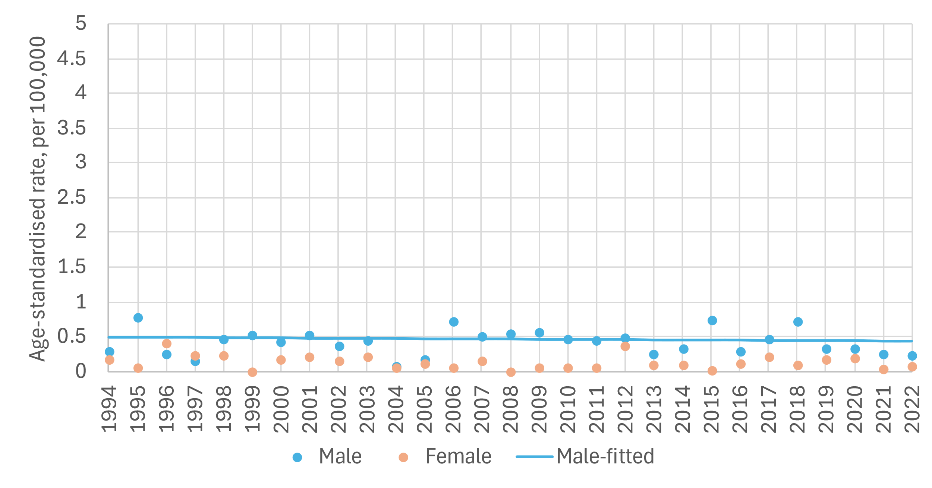
sex | period | APC% | 95%CI | trend | sex | period | APC% | 95%CI | trend
M | 1994-2022 | -0.5 | -2.4, 1.4 | flat | F | 1994-2022 | NA | NA | NA

APC%: average annual percentage change in rate over period and 95% confidence interval (95%CI) based on annual data points fitted with Joinpoint regression. Trend: ‘up’=significant increase, ‘down’=significant decrease, ‘flat’=no change (static), at the 95% level.

Survival
Overall, 5-year net survival was 60% for cases diagnosed during 2019-2022 (Figure 7.6). Five-year net survival was 64% for 2019-2022 for males and 71% for 2014-2018 for females. It was not possible to calculate five-year net survival for several periods for females because of an insufficient number of cases (Figure 7.6).

Figure 7.6: Age-standardised 5-year net survival (%) for nasopharyngeal cancer over six consecutive diagnosis periods
Total | Males | Females
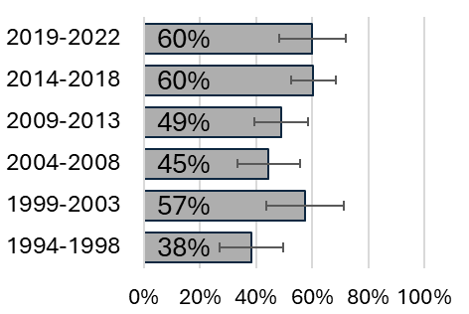 | 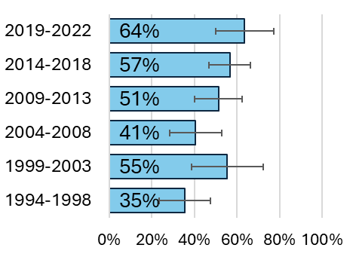 | 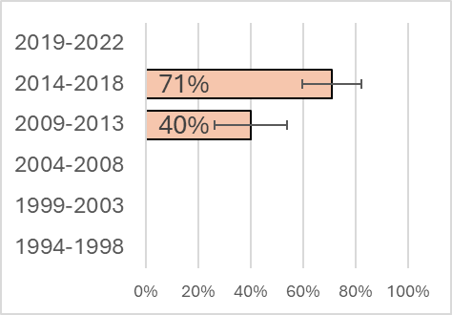

Population Attributable Fraction
In 2022, 15 cases of nasopharyngeal cancer were recorded (7 males, 8 females). The estimated total number of nasopharyngeal cancer cases attributable to smoking in Ireland in 2022 was 4 (PAF 25.4%). Table 7.1 presents the difference between male and female nasopharyngeal cancer incidence related to smoking. Males had a higher PAF than females, 27.0% vs 24.0%.

Table 7.1: Population attributable fraction and attributable cases of nasopharyngeal cancer in 2022
 | Total | Males | Females
PAF (%) | 25.4 | 27.0 | 24.0
Total cases | 15 | 7 | 8
Attributable cases | 4 | 2 | 2

Oesophagus C15

Oesophagus (adenocarcinoma)
Key points
Incidence
- Incidence rates increased in males from 1994 to 2004. There was no significant change in incidence among males from 2004 to 2022.
- Across the period 1994 to 2022 incidence rates increased steadily among females.
- Incidence rates in the diagnosis period 2014-2018 were similar across deprivation quintiles.
Mortality
CSO mortality data does not provide mortality figures at the tumour morphological level therefore mortality trends are not presented.
Survival
- 5-year net survival was 25% for cases diagnosed during 2019-2022.
Population attributable fraction
- The estimated total number of cases of oesophageal adenocarcinoma attributable to smoking in Ireland in 2022 was 123 (PAF 38.6%).

Incidence
Between 1994-2022, 5,212 cases of oesophageal adenocarcinoma were reported (4,152 males, 1,060 females). The median age at diagnosis was 68 years (IQR: 59-76) for males and 74 years (IQR: 65-81) for females. Age-standardised incidence rates of oesophageal adenocarcinoma during the period 1994-2022 were 10.3 cases per 100,000 males and 2.3 cases per 100,000 females per year. Figure 8.1 breaks this down further by sex and age group.

Figure 8.1: Incidence rate (per 100,000) for oesophageal adenocarcinoma by age group,1994-2022
Total | Males | Females
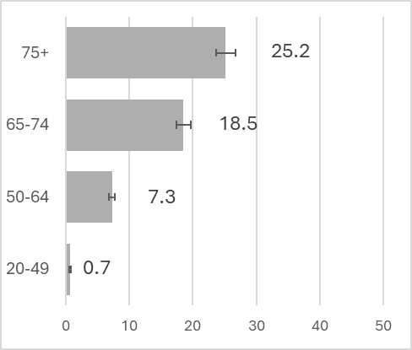 | 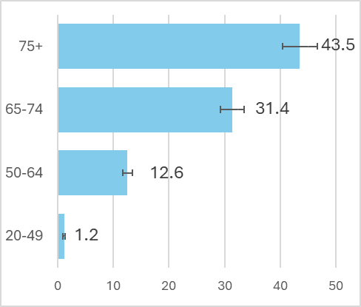 | 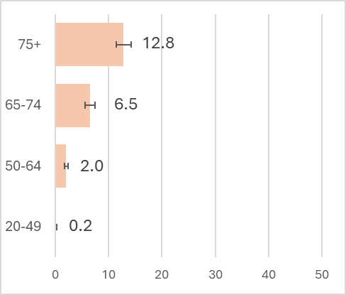

Trends over time
Figure 8.2 shows the incidence of oesophageal adenocarcinoma from 1994 to 2022. Incidence increased for males from 1994 to 2004 by 3.6% per year (95%CI 0.9; 6.3), before a steady period from 2004 to 2022 (0.6 % increase per year; 95%CI -0.2; 1.3). Across the period, rates increased steadily among females by 0.7% per year (95%CI 0.1; 1.4).

Figure 8.2: Age-standardised incidence rate 1994-2022, oesophagus (adenocarcinoma)
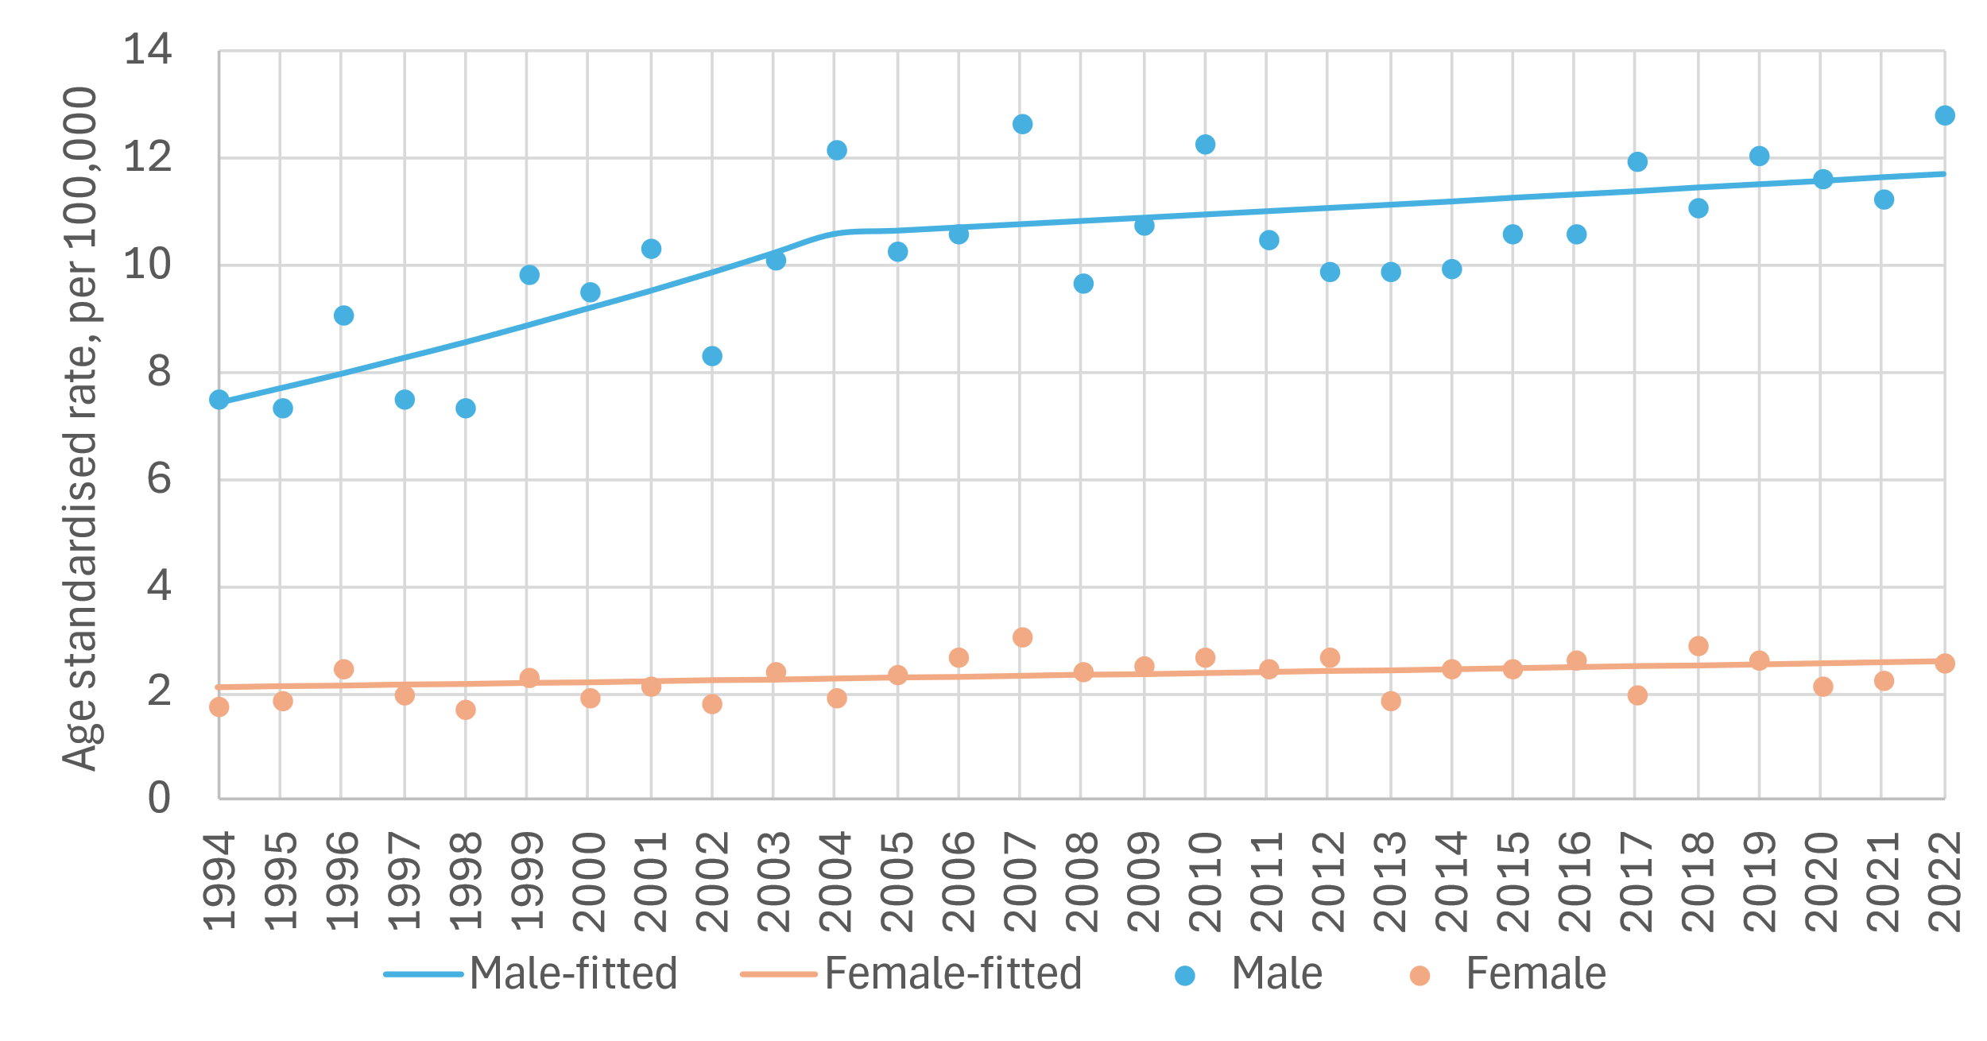
sex | period | APC% | 95%CI | trend | sex | period | APC% | 95%CI | trend
M | 1994-2004 | 3.6 | 0.9, 6.3 | up | F | 1994-2022 | 0.7 | 0.1, 1.4 | up
 | 2004-2022 | 0.6 | -0.2, 1.3 | flat

APC%: average annual percentage change in rate over period and 95% confidence interval (95%CI) based on annual data points fitted with Joinpoint regression. Trend: ‘up’=significant increase, ‘down’=significant decrease, ‘flat’=no change (static), at the 95% level.

Variation by deprivation quintile
Age-standardised incidence rates of oesophageal adenocarcinoma in 2014-2018 ranged from 5.6 to 7.2 cases per 100,000 in the least to the most deprived quintiles (Figure 8.3). Little difference was observed in rates of oesophageal adenocarcinoma between the most and least deprived quintiles for males (10.0 for least deprived and 11.5 for most deprived). There was also little observed difference in incidence between the most and least deprived quintiles in females (2.3 for least deprived and 3.5 for most deprived).

Figure 8.3: Incidence rate (per 100,000) for oesophageal (adenocarcinoma) cancer by deprivation quintile, 2014-2018
Total | Males | Females
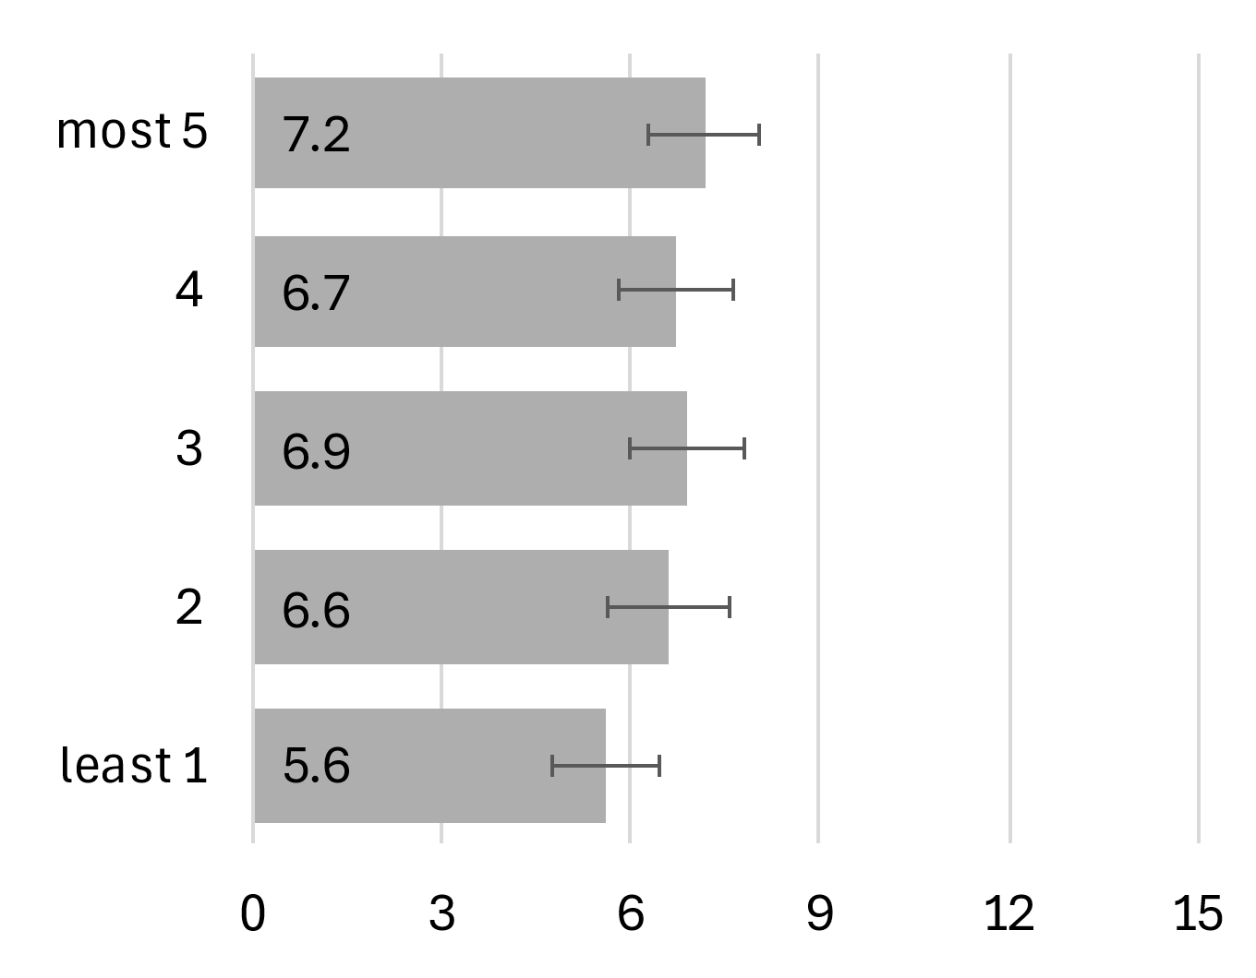 | 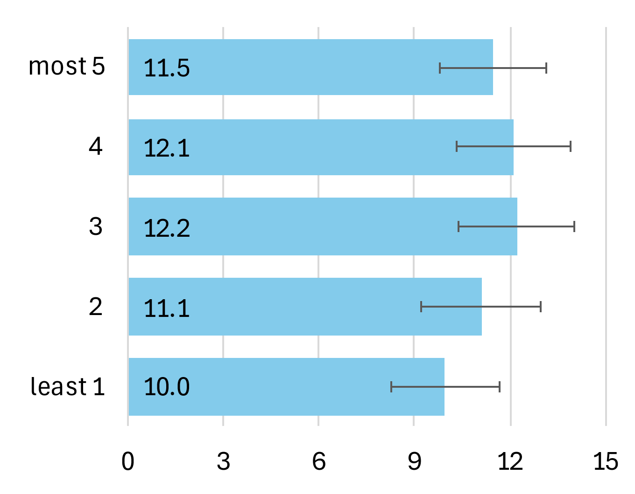 | 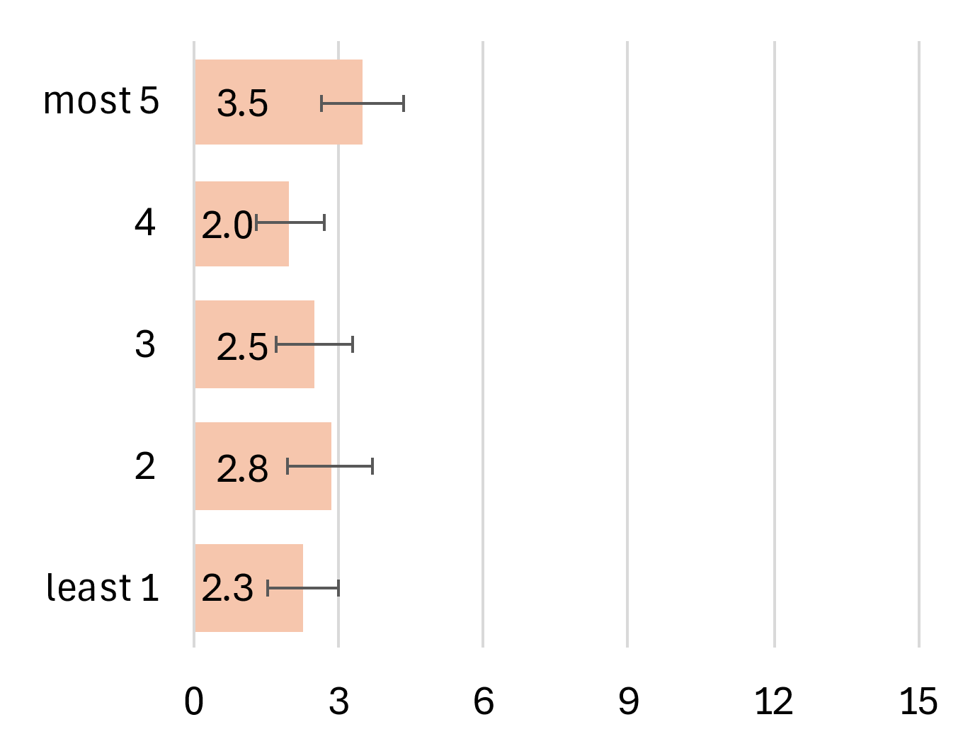

Mortality
CSO mortality data does not provide mortality figures at the tumour morphological level therefore mortality trends are not presented.

Survival
For oesophageal adenocarcinoma cancer in Ireland overall 5-year net survival was 25% for cases diagnosed during 2019-2022 (Figure 8.4). Five-year net survival for 2019-2022
was higher for females (32%) than for males (24%).

Figure 8.4: Age-standardised 5-year net survival (%) for oesophageal adenocarcinoma over six consecutive diagnosis periods
Total | Males | Females
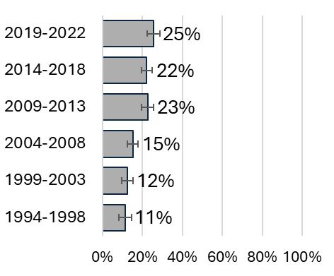 | 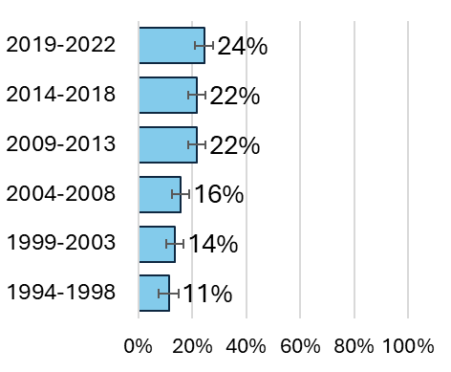 | 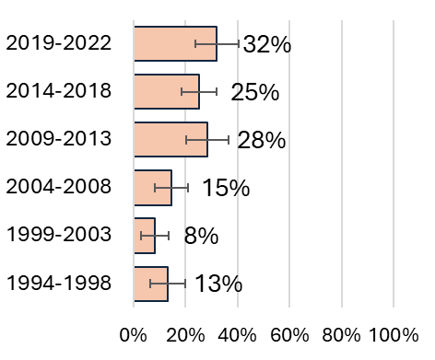

Population Attributable Fraction
In 2022, 319 cases of oesophageal adenocarcinoma were recorded (262 males, 57 females). The estimated total number of cases of oesophageal adenocarcinoma attributable to smoking in Ireland in 2022 was 123 (PAF 38.6%). Table 8.1 presents the difference between male and female oesophageal adenocarcinoma incidence related to smoking. Males had a higher PAF than females, 39.8% vs 32.8%.

Table 8.1: Population attributable fraction and attributable cases of oesophageal adenocarcinoma in 2022
 | Total | Males | Females
PAF (%) | 38.6 | 39.8 | 32.8
Total cases | 319 | 262 | 57
Attributable cases | 123 | 104 | 19

Oesophagus (squamous cell)
  - Incidence
- Across the period 1994-2022 there was no significant change in incidence rates in males.
- Across the period 1994-2022, incidence rates decreased steadily by -0.8% per year (95%CI -1.3; -0.4) in females.
- Incidence rates in the diagnosis period 2014-2018 were similar across deprivation quintiles.
  - Survival
- 5-year net survival was 22% for cases diagnosed during 2019-2022.
Mortality
- CSO mortality data does not provide mortality figures at the tumour morphological level therefore mortality trends are not presented.
  - Population attributable fraction
- The estimated total number of cases of oesophageal squamous cell carcinoma attributable to smoking in Ireland in 2022 was 75 (PAF 38%).

Incidence
Between 1994-2022, 4,467 cases of oesophageal squamous cell carcinoma were reported (2,227 males, 2,240 females). The median age at diagnosis was 69 years (IQR: 61-76) for males and 74 years (IQR: 64-81) for females. Age-standardised incidence rates of oesophageal squamous cell carcinoma during the period 1994-2022 were 5.7 cases per 100,000 males and 5.0 cases per 100,000 females per year. Figure 8.5 breaks this down further by sex and age group.

Figure 8.5: Incidence rate (per 100,000) for oesophageal squamous cell carcinoma by age group,1994-2022
Total | Males | Females
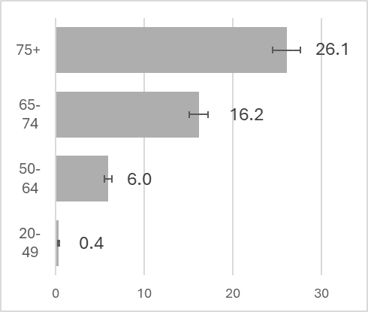 | 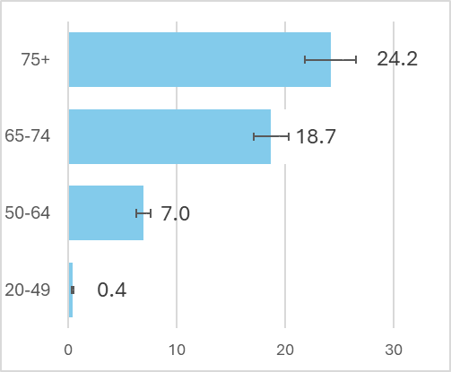 | 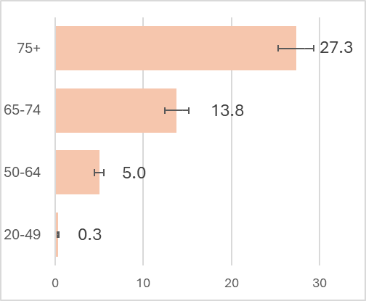

Trends over time
Figure 8.6 shows the incidence of oesophageal squamous cell carcinoma from 1994 to 2022. Across the period, no significant decrease in rates for males was observed. Rates decreased steadily among females by -0.8% per year (95%CI -1.3; -0.4).

Figure 8.6: Age-standardised incidence rate 1994-2022, oesophageal squamous cell carcinoma
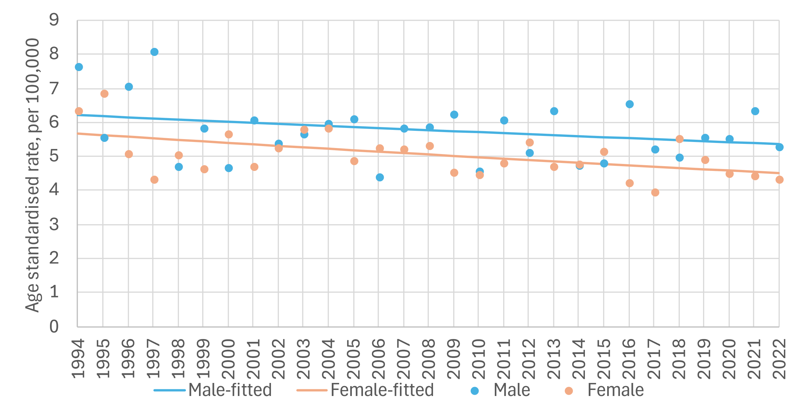
sex | period | APC% | 95%CI | trend | sex | Period | APC% | 95%CI | trend
M | 1994-2022 | -0.5 | -1.1, 0.1 | flat | F | 1994-2022 | -0.8 | -1.3, -0.4 | down

APC%: average annual percentage change in rate over period and 95% confidence interval (95%CI) based on annual data points fitted with Joinpoint regression. Trend: ‘up’=significant increase, ‘down’=significant decrease, ‘flat’=no change (static), at the 95% level.

Variation by deprivation quintile
Age-standardised incidence rates of oesophageal squamous cell carcinoma in 2014-2018 ranged from 5.4 to 6.7 cases per 100,000 in the least to the most deprived quintiles (Figure 8.7). There was a difference in incidence between the most and least deprived quintiles for males (5.2 for least deprived and 8.4 for most deprived). There was little difference in rates between the most and least deprived quintiles among females (5.9 for least deprived and 5.2 for most deprived).

Figure 8.7: Incidence rate (per 100,000) for oesophageal squamous cell carcinoma cancer by deprivation quintile, 2014-2018
Total | Males | Females
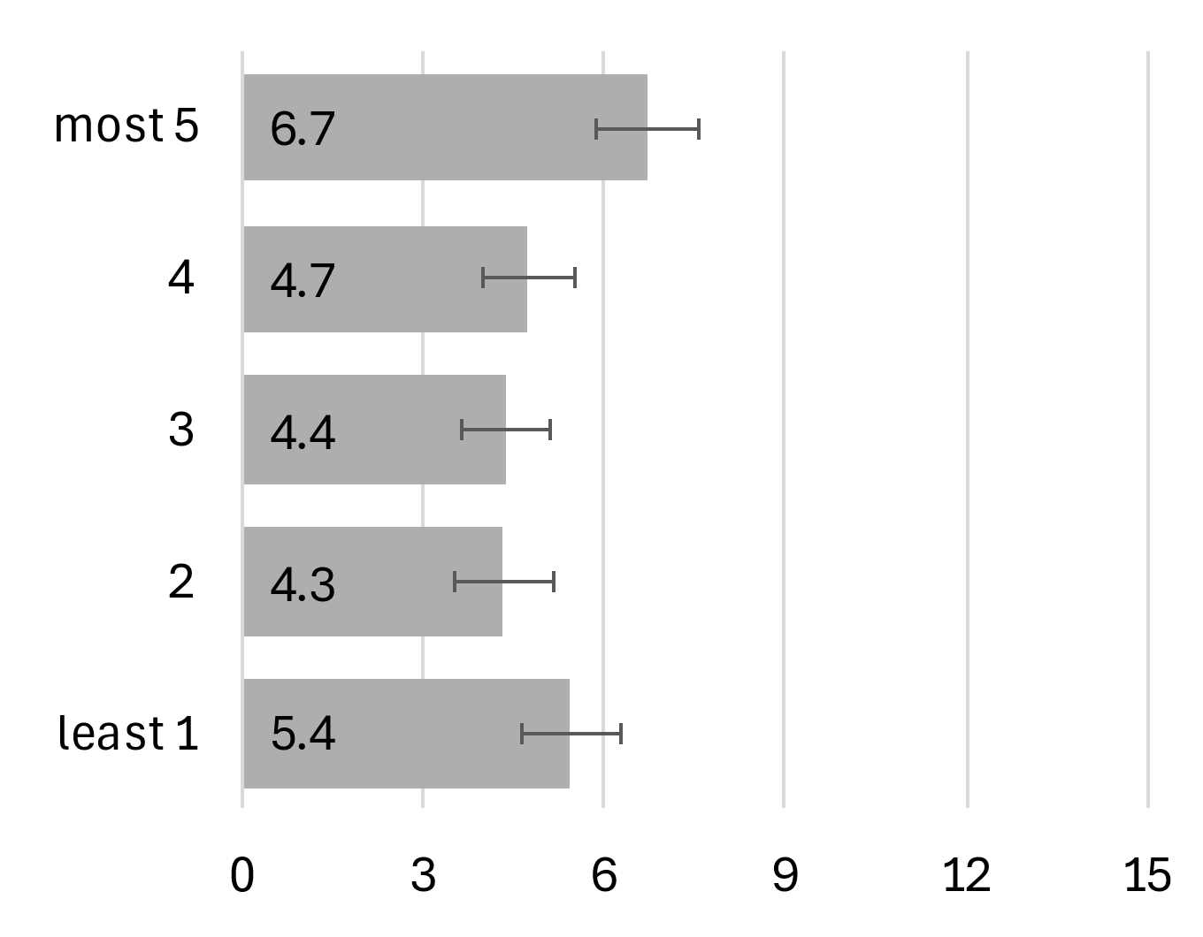 | 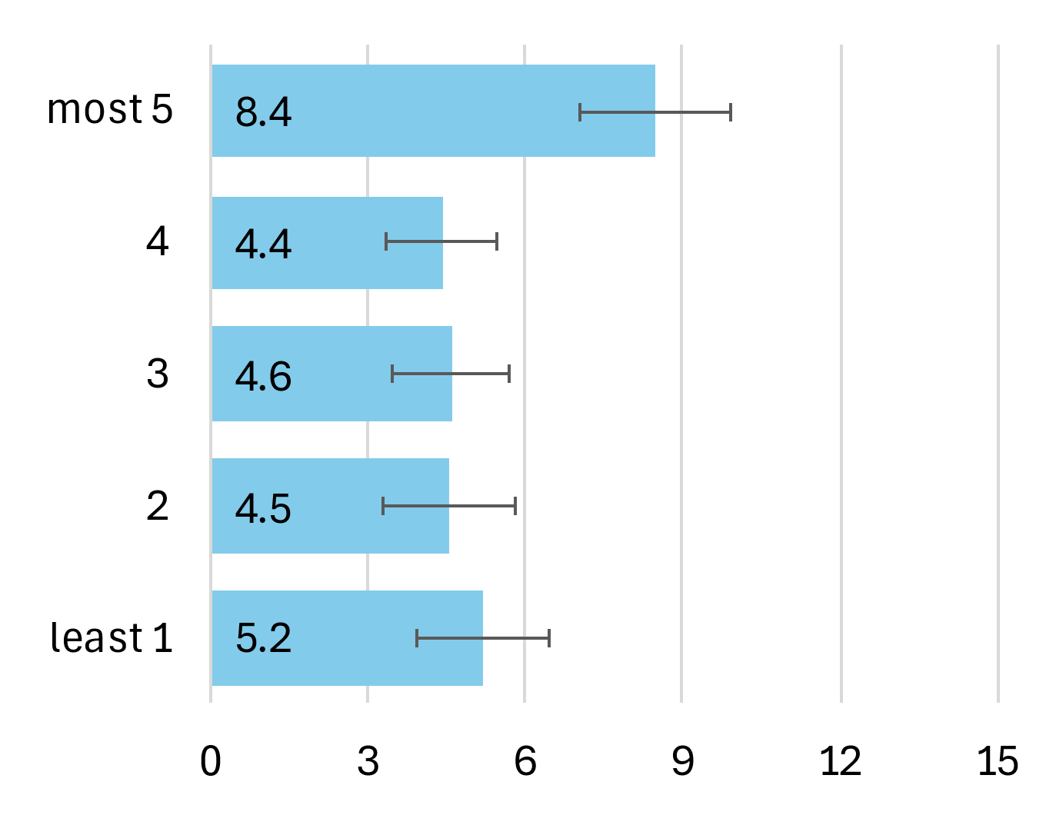 | 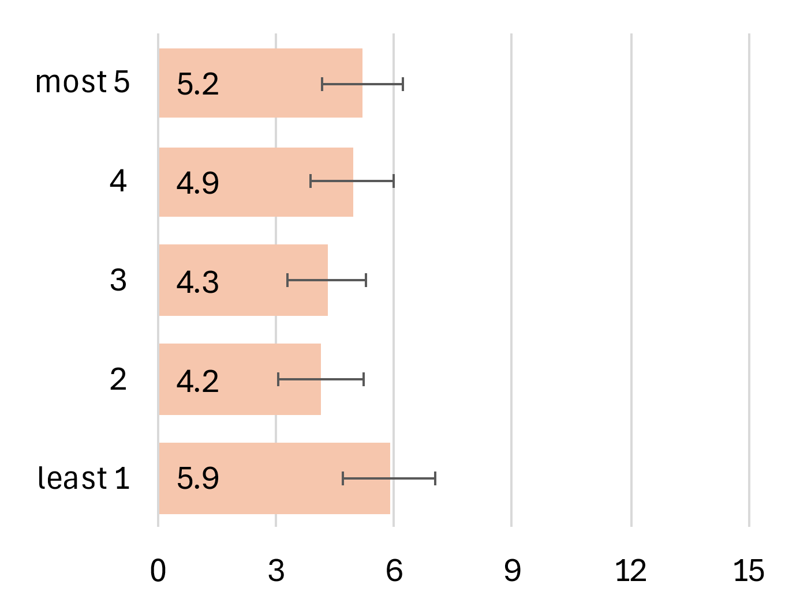

Mortality
CSO mortality data does not provide mortality figures at the tumour morphological level therefore mortality trends are not presented.

Survival
For oesophageal squamous cell carcinoma, overall, 5-year net survival was 22% for cases diagnosed during 2019-2022 (Figure 8.8). It was not possible to calculate five-year age-standardised net survival for females for 2019-2022 due to an insufficient number of cases (Figure 8.8).

Figure 8.8: Age-standardised 5-year net survival (%) for squamous cell carcinoma cancer over six consecutive diagnosis periods
Total | Males | Females
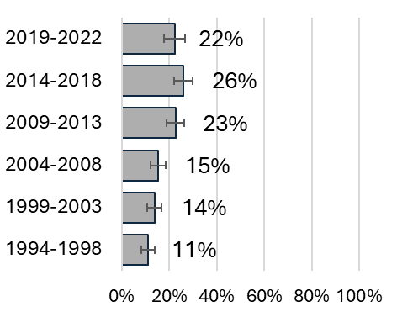 | 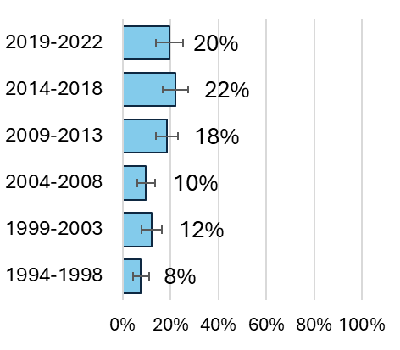 | 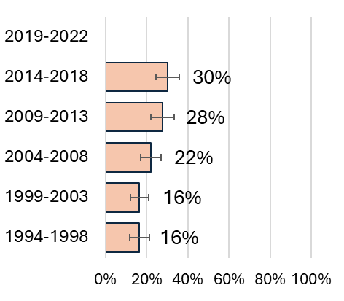

Population Attributable Fraction
In 2022, 196 cases of oesophageal squamous cell carcinoma were recorded (102 males, 94 females). The estimated total number of cases of oesophageal squamous cell carcinoma attributable to smoking in Ireland in 2022 was 75 (PAF 38%). Table 8.2 presents the difference between male and female oesophageal squamous cell carcinoma incidence related to smoking. Males had a higher PAF than females, 52.1% vs 22.8%.

Table 8.2: Population attributable fraction and attributable cases of oesophageal squamous cell carcinoma in 2022
 | Total | Males | Females
PAF (%) | 38 | 52.1 | 22.8
Total cases | 196 | 102 | 94
Attributable cases | 75 | 53 | 21

Stomach C16
  - Key points
  - Incidence
- Incidence rates decreased for males from 1994 to 2002 and then remained stable from 2001 to 2014 before decreasing again from 2014 to 2022.
- Across the period 1994 to 2022 incidence decreased steadily among females.
- Age-standardised incidence rates of stomach cancer in 2014-2018 ranged from 13.3 to 20.2 cases per 100,000 in the least to the most deprived quintiles.
Mortality
- In males there was a decline in mortality rates from 1994 to 2022.
- A similar decline was seen in mortality rates in females from 1994 to 2022.
  - Survival
- 5-year net survival was 37% for cases diagnosed during 2019-2022.
  - Population attributable fraction
- The estimated total number of cases of stomach cancer attributable to smoking in Ireland in 2022 was 91 (PAF 14.8%).

Incidence
Between 1994-2022, 15,068 cases of stomach cancer were reported (9,486 males, 5,582 females). The median age at diagnosis was 71 years (IQR 62-78) for males and 73 (IQR 63-81) for females. Age-standardised incidence rates of stomach cancer during the period 1994-2022 were 26.0 cases per 100,000 males and 12.6 cases per 100,000 females per year. Figure 9.1 breaks this down further by sex and age group.

Figure 9.1: Incidence rate (per 100,000) for stomach cancer by age group,1994-2022
Total | Males | Females
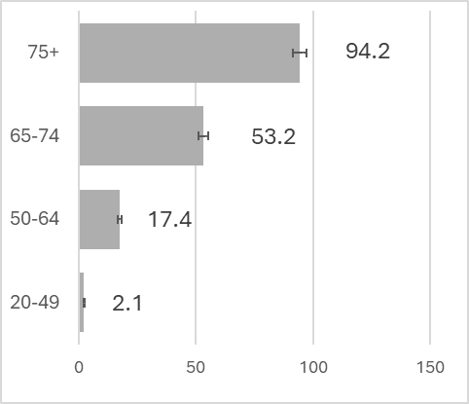 | 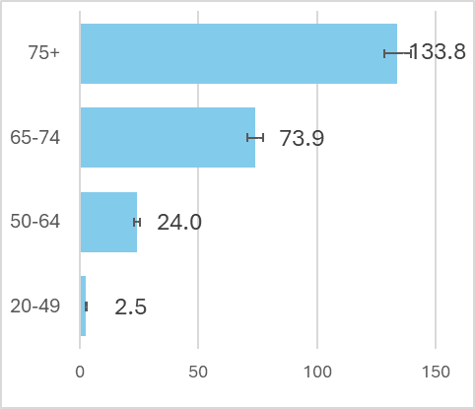 | 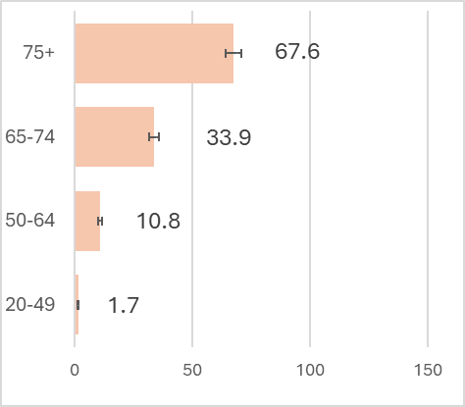

Trends over time
Figure 9.2 shows the incidence of stomach cancer from 1994 to 2022. Incidence decreased for males from 1994 to 2002 (-2.8 % decrease per year (95%CI -4.4; -1.2)) then remained stable from 2001 to 2014 (-0.3 % per year (95%CI -1.3; 0.6)) before decreasing again from 2014 to 2022 (-3.9 % decrease per year (95%CI -5.2; -2.5)). Across the period incidence declined steadily among females by -1.5% per year (95%CI -1.8; -1.2).

Figure 9.2: Age-standardised incidence rate 1994-2022, stomach
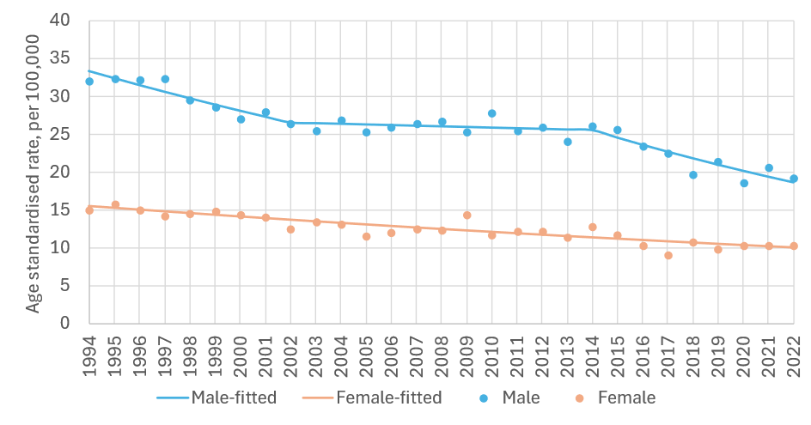
sex | period | APC% | 95%CI | trend | sex | period | APC% | 95%CI | trend
M | 1994-2002 | -2.8 | -4.4, -1.2 | down | F | 1994-2022 | -1.5 | -1.8, '-1.2 | down
 | 2002-2014 | -0.3 | -1.3, 0.6 | flat
 | 2014-2022 | -3.9 | -5.2, -2.5 | down

APC%: average annual percentage change in rate over period and 95% confidence interval (95%CI) based on annual data points fitted with Joinpoint regression. Trend: ‘up’=significant increase, ‘down’=significant decrease, ‘flat’=no change (static), at the 95% level.

Variation by deprivation quintile
Age-standardised incidence rates of stomach cancer in 2014-2018 ranged from 13.4 to 20.2 cases per 100,000 in the least to the most deprived quintiles (Figure 9.3). There was a difference in rates of stomach cancer between the most and least deprived quintiles for males (19.4 for least deprived and 28.0 for most deprived). Although smaller, a difference in rates between the most and least deprived quintiles was also seen in females (8.6 for least deprived and 13.9 for most deprived).

Figure 9.3: Incidence rate (per 100,000) for stomach cancer by deprivation quintile, 2014-2018
Total | Males | Females
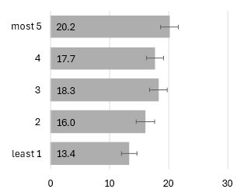 | 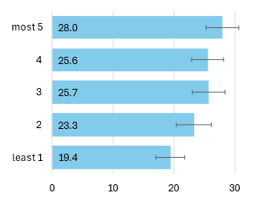 | 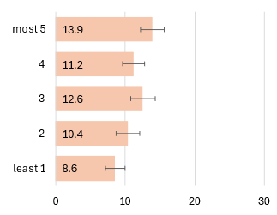

Mortality
Age-standardised mortality rates of stomach cancer during the period 1994-2022 were 17.8 deaths per 100,000 males and 8.9 deaths per 100,000 females per year. Figure 9.4 breaks this down further by sex and age group. Mortality rates increased with increasing age among both males and females.

Figure 9.4: Mortality rate (per 100,000) for stomach cancer by age group, 1994-2022
Total | Males | Females
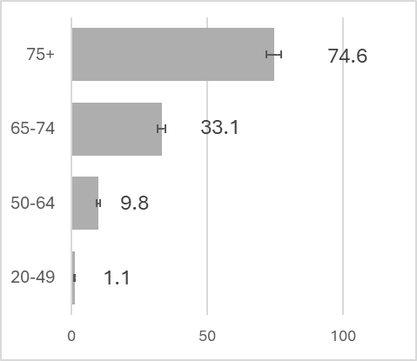 | 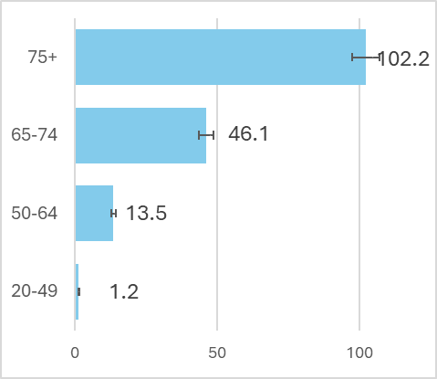 | 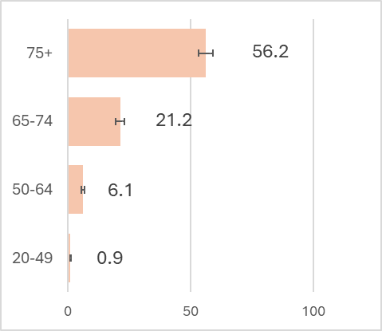

Trends over time
Figure 9.5 shows the age-standardised mortality rates for stomach cancer from 1994 to 2022 for males and females. In males there was a decline in mortality (APC) from 1994 to 2022 (-3.1% per year (95%CI -3.4; -2.8)). A similar decline was seen in females from 1994 to 2022 (-3.4% per year (95%CI -3.8; -3.0)).

Figure 9.5: Age-standardised mortality rate 1994-2022, stomach
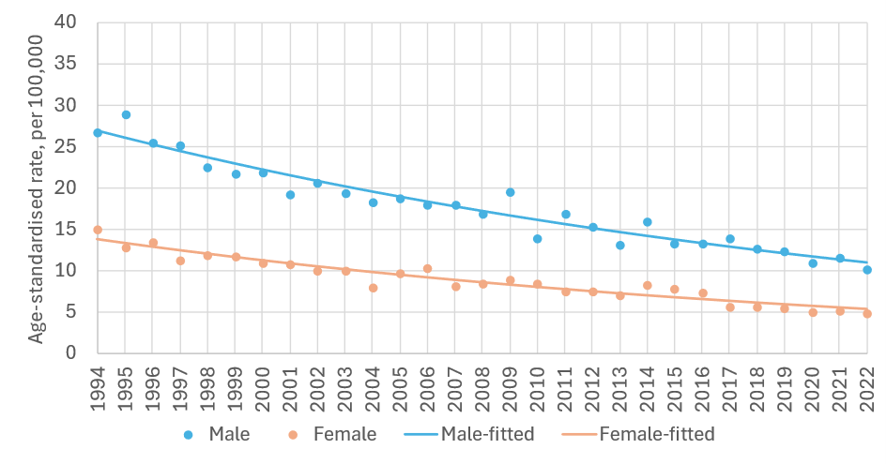
sex | period | APC% | 95%CI | trend | sex | period | APC% | 95%CI | trend
M | 1994-2022 | -3.1 | -3.4, -2.8 | down | F | 1994-2022 | -3.4 | -3.8, -3.0 | down

APC%: average annual percentage change in rate over period and 95% confidence interval (95%CI) based on annual data points fitted with Joinpoint regression. Trend: ‘up’=significant increase, ‘down’=significant decrease, ‘flat’=no change (static), at the 95% level.

Survival
For stomach cancer in Ireland overall 5-year net survival was 37% for cases diagnosed during 2019-2022 (Figure 9.6). Five-year net survival for 2019-2022 was higher for females (45%) than for males (33%) and tended to improve across periods.

Figure 9.6: Age-standardised 5-year net survival (%) for stomach cancer over six consecutive diagnosis periods
Total | Males | Females
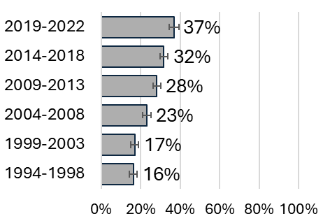 | 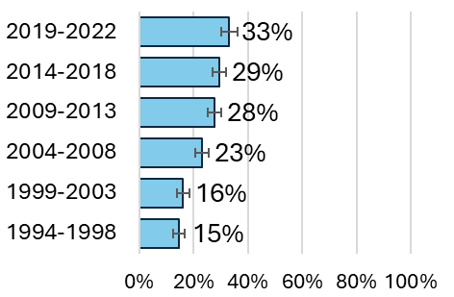 | 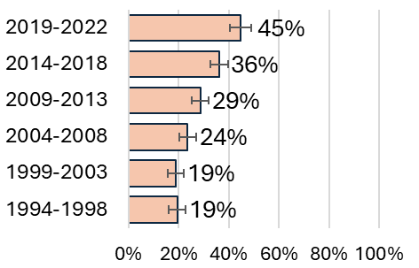

Population Attributable Fraction
612 (382 males, 230 females) stomach cancer cases were recorded in 2022. The estimated total number of stomach cancer cases attributable to smoking in Ireland in 2022 was 91 (PAF 14.8%). Table 9.1 presents the difference between male and female stomach cancer incidence related to smoking. Males had a higher PAF than females, 21.2% vs 4.2%.

Table 9.1: Population attributable fraction and attributable cases for stomach cancer in 2022
 | Total | Males | Females
PAF (%) | 14.8 | 21.2 | 4.2
Total cases | 612 | 382 | 230
Attributable cases | 91 | 81 | 10

Colorectal Cancer

Colon & Rectosigmoid junction C18-19
Key points
Incidence
- Incidence rates increased for males from 1994 to 2013 before a period of steady decrease from 2013 to 2022.
- Incidence rates were stable for females from 1994 to 2010 before a period of steady decrease from 2010 to 2022.
- From 2014-2018, little difference was observed in incidence rates of colon and RSJ cancer between the most and least deprived quintiles.
Mortality
- In males, mortality rates decreased from 1994 to 2022
- In females, mortality rates decreased from 1994 to 2005, before stabilising 2005-2010. Mortality declined again from 2010 to 2022
Survival
- 5-year net survival was 65% for cases diagnosed during 2019-2022.
Population attributable fraction
- The estimated total number of colon and RSJ cancer cases attributable to smoking in Ireland in 2022 was 107 (PAF 5.4%).

Incidence
Between 1994-2022, 47,422 cases of colon and RSJ cancer were reported (25,884 males, 21,538 females). The median age at diagnosis was 70 years (IQR: 62-78) for males and 72 (IQR: 61-80) for females. Age-standardised incidence rates of cancer of the colon and RSJ during the period 1994-2022 were 69.4 cases per 100,000 males and 47.3 cases per 100,000 females per year. Figure 10.1 breaks this down further by sex and age group.

Figure 10.1: Incidence rate (per 100,000) for colon and rectosigmoid junction cancer by age group,1994-2022
Total | Males | Females
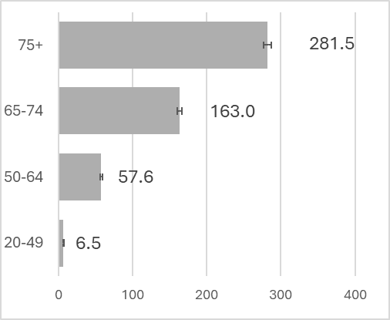 | 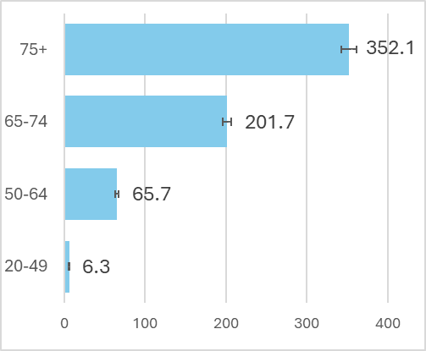 | 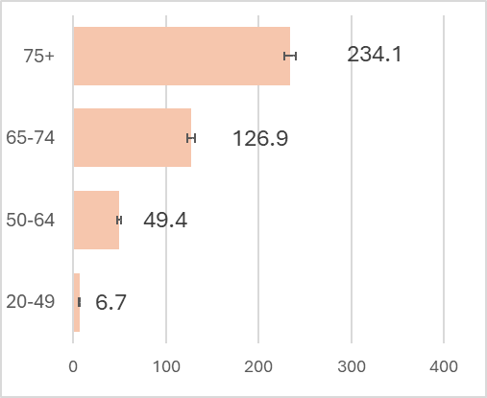

Trends over time
Figure 10.2 shows the incidence of colon and RSJ cancer from 1994 to 2022. Incidence increased for males from 1994 to 2013 (0.5% increase per year (95%CI 0.1; 1.0)), before a period of steady decrease from 2013 to 2022 (-3.8% decrease per year (95%CI -4.9; -2.7)). Incidence was stable for females from 1994 to 2010 before a period of steady decrease from 2010 to 2022 (-1.9% decrease per year (95%CI -2.7; -1.1)).

Figure 10.2: Age-standardised incidence rate 1994-2022, colon and rectosigmoid junction
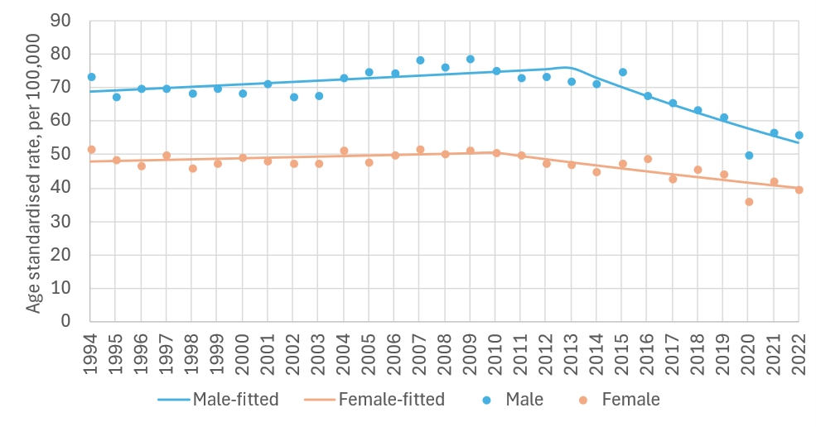
sex | period | APC% | 95%CI | trend | sex | period | APC% | 95%CI | trend
M | 1994-2013 | 0.5 | 0.1, 1.0 | up | F | 1994-2010 | 0.3 | -0.2, 0.9 | flat
 | 2013-2022 | -3.8 | -4.9, -2.7 | down |  | 2010-2022 | -1.9 | -2.7, -1.1 | down

APC%: average annual percentage change in rate over period and 95% confidence interval (95%CI) based on annual data points fitted with Joinpoint regression. Trend: ‘up’=significant increase, ‘down’=significant decrease, ‘flat’=no change (static), at the 95% level.

Variation by deprivation quintile
Age-standardised incidence rates of colon and RSJ cancer in 2014-2018 ranged 57.5-61.1 cases per 100,000 in the least to the most deprived quintiles (Figure 10.3). Very little difference was seen in rates of colon and RSJ cancer between the most and least deprived quintiles for males (68.6 for least deprived and 76.5 for most deprived). Similarly, little difference in rates between the most and least deprived quintiles was evident in females (49.3 for least deprived and 49.1 for most deprived).

Figure 10.3: Incidence rate (per 100,000) for colon and rectosigmoid junction cancer by deprivation quintile, 2014-2018
Total | Males | Females
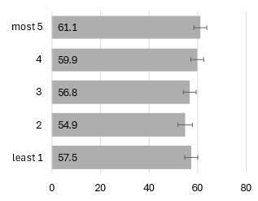 | 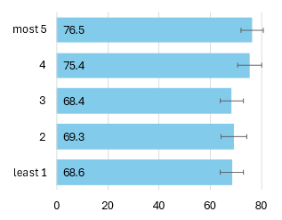 | 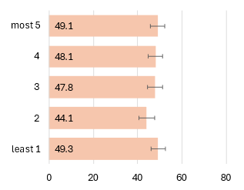

Mortality
Age-standardised mortality rates of colon and RSJ cancer during the period 1994-2022 were 43.3 deaths per 100,000 males and 21.9 deaths per 100,000 females per year. Figure 10.4 breaks this down further by sex and age group. Mortality rates were higher among older age groups regardless of sex.

Figure 10.4: Mortality rate (per 100,000) for colon and rectosigmoid junction cancer by age group, 1994-2022
Total | Males | Females
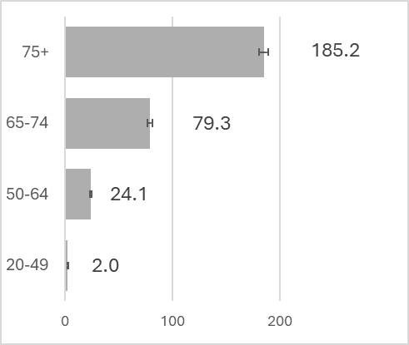 | 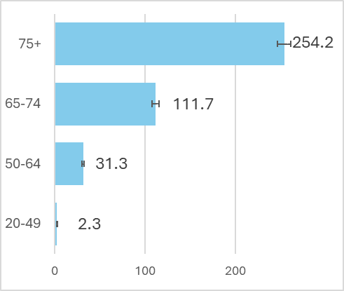 | 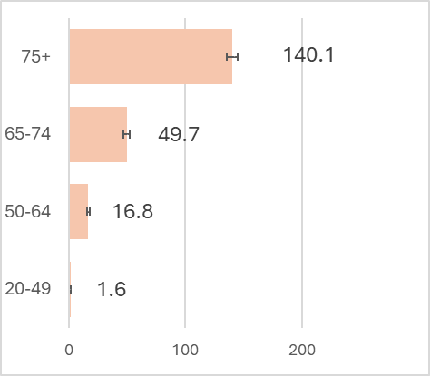

Trends over time
Figure 10.5 shows age-standardised mortality rates for colon and RSJ cancer from 1994 to 2022 for males and females. In males, there was a slight decrease in mortality rates (APC) from 1994 to 2001 (-0.3% per year (95%CI -3.3;2.7)). Mortality rates then decreased from 2001 to 2022 (-3.5% per year (95%CI -4.1; -3.0)). In females, mortality rates (APC) decreased from 1994 to 2005 (-3.1% per year (95%CI -4.2, -1.9)), before stabilising 2005-2010 (2.5% per year (95%CI -3.3, 8.5)). Mortality declined again from 2010 to 2022 (-2.2% per year (95%CI -3.1; -1.2)).

Figure 10.5: Age-standardised mortality rate 1994-2022, colon and rectosigmoid junction
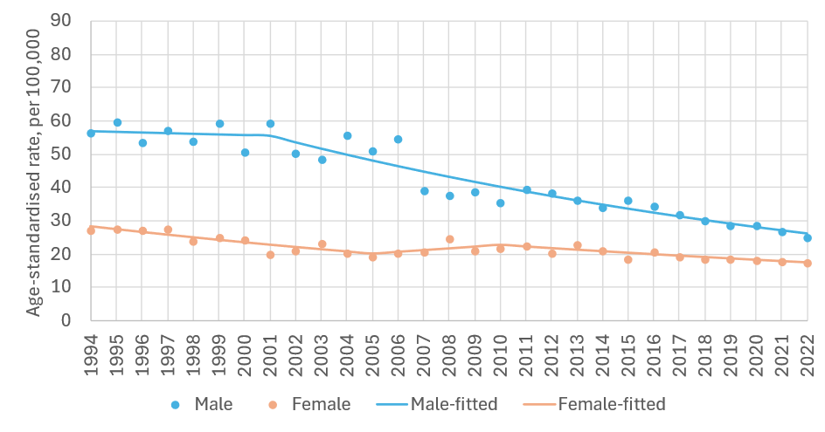
sex | period | APC% | 95%CI | trend | sex | period | APC% | 95%CI | trend
M | 1994-2001 | -0.3 | -3.3,2.7 | flat | F | 1994-2005 | -3.1 | -4.2, -1.9 | down
 | 2001-2022 | -3.5 | -4.1, -3.0 | down |  | 2005-2010 | 2.5 | -3.3, 8.5 | flat
 |  |  |  |  |  | 2010-2022 | -2.2 | -3.1, -1.2 | down

APC%: average annual percentage change in rate over period and 95% confidence interval (95%CI) based on annual data points fitted with Joinpoint regression. Trend: ‘up’=significant increase, ‘down’=significant decrease, ‘flat’=no change (static), at the 95% level.

Survival
Overall, 5-year net survival was 65% for cases diagnosed during 2019-2022 (Figure 10.6). Five-year net survival for 2019-2022 was 65% for both males and females during the 2019-2022 period.

Figure 10.6: Age-standardised 5-year net survival (%) for colon and rectosigmoid junction cancer over six consecutive diagnosis periods
Total | Males | Females
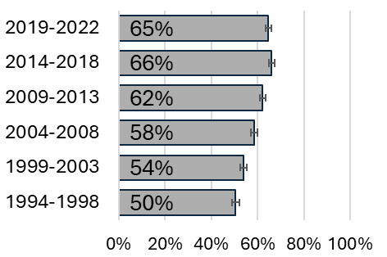 | 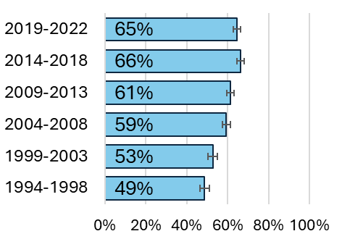 | 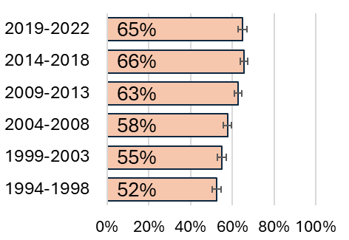

Population Attributable Fraction
In 2022, 1,977 cases were recorded (1,097 males, 880 females). The estimated total number of cases attributable to smoking in Ireland in 2022 was 107 (PAF 5.4%). Table 10.1 presents the difference between male and female incidence related to smoking. Males had a slightly higher PAF than females, 5.7 % vs 5.0%.

Table 10.1: Population attributable fraction and attributable cases for colon & rectosigmoid junction cancer in 2022
 | Total | Males | Females
PAF (%) | 5.4 | 5.7 | 5.0
Total cases | 1,977 | 1,097 | 880
Attributable cases | 107 | 63 | 44

Rectum C20
Key points
Incidence
- Incidence rated remained stable for males from 1994 to 2001 before a period of steady decrease from 2001 to 2022.
- Across the period 1994-2022 incidence rates decreased steadily among females.
- Incidence rates in the diagnosis period 2014-2018 were similar across deprivation quintiles.
Mortality
- Among males and females mortality rates decreased from 2007-2022.
Survival
- 5-year net survival was 67% for cases diagnosed during 2019-2022.
Population attributable fraction
- The estimated total number of rectal cancer cases attributable to smoking in Ireland in 2022 was 68 (PAF 8.3%).

Incidence
Between 1994-2022, 18,150 cases of rectal cancer were reported (11,857 males, 6,293 females). The median age at diagnosis was 68 years (IQR: 60-76) for males and 68 (IQR: 58-78) for females. Age-standardised incidence rates of rectal cancer during the period 1994-2022 were 30.6 cases per 100,000 males and 13.6 cases per 100,000 females per year. Figure 10.7 breaks this down further by sex and age group.

Figure 10.7: Incidence rate (per 100,000) for rectal cancer by age group,1994-2022
Total | Males | Females
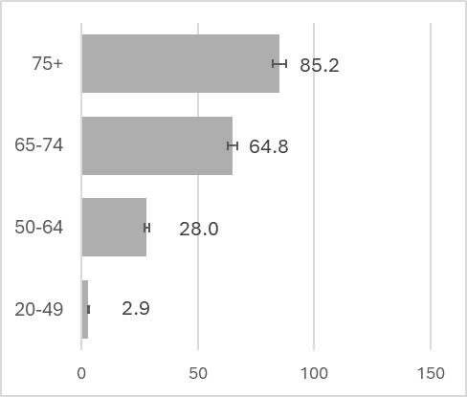 | 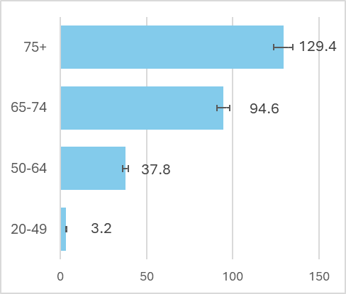 | 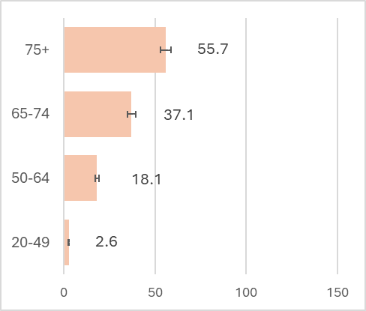

Trends over time
Figure 10.8 shows the incidence of rectal cancer from 1994 to 2022. Incidence remained stable for males from 1994 to 2001 before a period of steady decrease from 2001 to 2022 (-1.6 % decrease per year (95%CI -2.1; -1.2)). Across the period incidence decreased steadily among females by -0.7% per year (95%CI -1.1; -0.3).

Figure 10.8: Age-standardised incidence rate 1994-2022, rectum
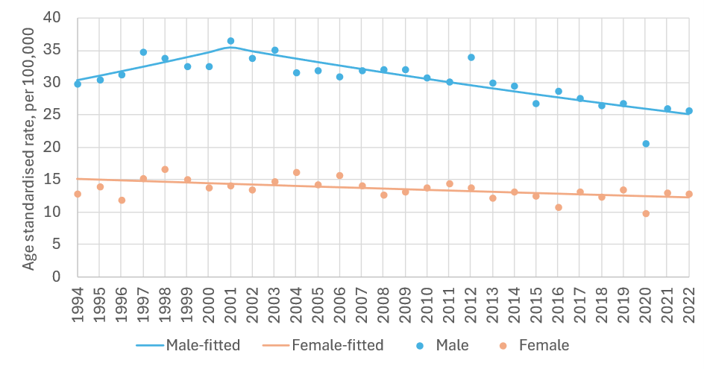
sex | period | APC% | 95%CI | trend | sex | period | APC% | 95%CI | trend
M | 1994-2001 | 2.2 | -0.7, 5.2 | flat | F | 1994-2022 | -0.7 | -1.1, -0.3 | down
 | 2001-2022 | -1.6 | -2.1, -1.2 | down

APC%: average annual percentage change in rate over period and 95% confidence interval (95%CI) based on annual data points fitted with Joinpoint regression. Trend: ‘up’=significant increase, ‘down’=significant decrease, ‘flat’=no change (static), at the 95% level.

Variation by deprivation quintile
Age-standardised incidence rates of rectal cancer in 2014-2018 ranged 20.2-20.9 cases per 100,000 in the least to the most deprived quintiles (Figure 10.9). Very little difference was evident in rates of rectal cancer between the most and least deprived quintiles for males (28.8 for least deprived and 30.2 for most deprived). Similarly, very little difference was seen in rates between the most and least deprived quintiles in females (13.5 for least deprived and 13.0 for most deprived).

Figure 10.9: Incidence rate (per 100,000) for rectal cancer by deprivation quintile, 2014-2018
Total | Males | Females
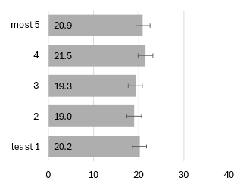 | 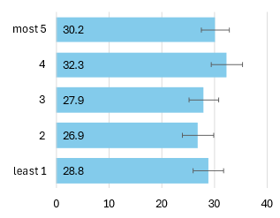 | 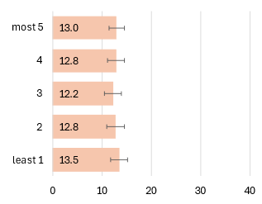

Mortality
Age-standardised mortality rates of rectal cancer during the period 2007 to 2022 were 4.4 deaths per 100,000 males and 5.5 deaths per 100,000 females per year. Figure 10.10 breaks this down further by sex and age group. Mortality increased with increasing age in both males and females.

Figure 10.10: Mortality rate (per 100,000) rectal cancer by age group, 2007-2022
Total | Males | Females
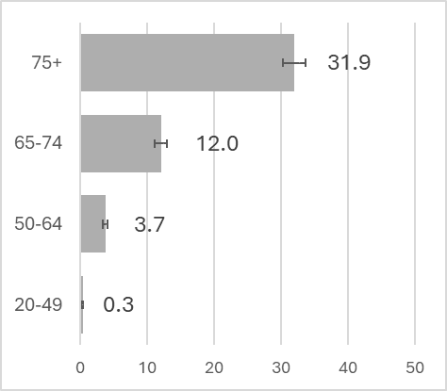 | 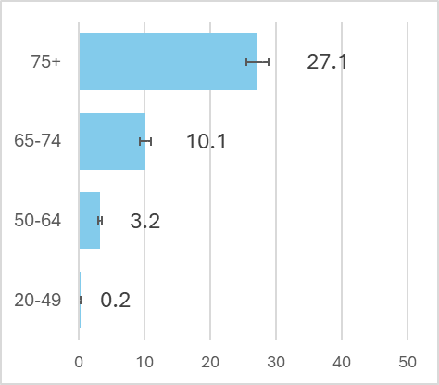 | 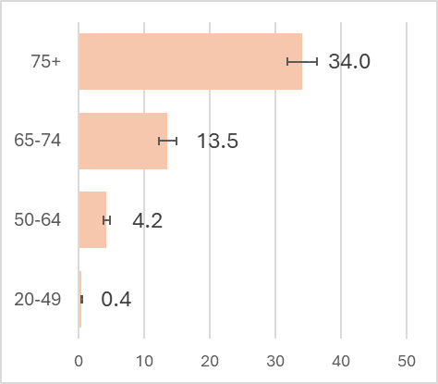

Trends over time
Figure 10.11 shows the age-standardised mortality rates for rectal cancer from 2007 to 2022 among males and females. In females, mortality (APC) decreased from 2007 to 2022 (-3.1% per year (95%CI -4.3, -1.9)). Mortality rate for males decreased from 2007 to 2022 ( -3.2% per year (95%CI -4.3, -2.0)).

Figure 10.11: Age-standardised mortality rate 2007-2022, rectum
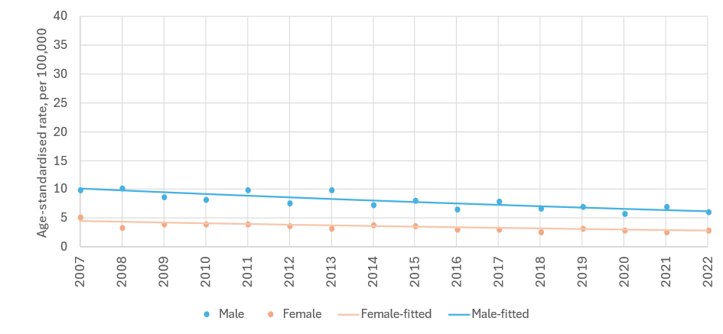
sex | period | APC% | 95%CI | trend | sex | period | APC% | 95%CI | trend
M | 2007-2022 | -3.2 | -4.3, -2.0 | down | F | 2007-2022 | -3.1 | -4.3, -1.9 | down

APC%: average annual percentage change in rate over period and 95% confidence interval (95%CI) based on annual data points fitted with Joinpoint regression. Trend: ‘up’=significant increase, ‘down’=significant decrease, ‘flat’=no change (static), at the 95% level.

Survival
For rectal cancer in Ireland overall 5-year net survival was 67% for cases diagnosed during 2019-2022 (Figure 10.12). Five-year net survival for 2019-2022 was similar for females (66%) and males (67%).

Figure 10.12: Age-standardised 5-year net survival (%) for rectal cancer over six consecutive diagnosis periods
Total | Males | Females
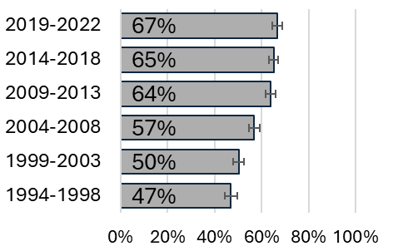 | 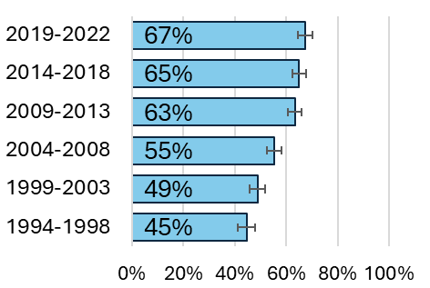 | 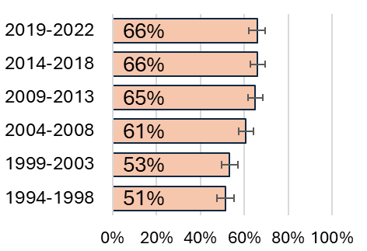

Population Attributable Fraction
In 2022, 819 cases of rectal cancer were recorded (528 males, 291 females). The estimated total number of cases attributable to smoking in Ireland in 2022 was 68 (PAF 8.3%). Table 10.2 presents the difference between male and female rectal cancer incidence related to smoking. Males had a higher PAF than females, 8.7% vs 7.6%.

Table 10.2: Population attributable fraction and attributable cases for rectal cancer in 2022
 | Total | Males | Females
PAF (%) | 8.3 | 8.7 | 7.6
Total cases | 819 | 528 | 291
Attributable cases | 68 | 46 | 22

Liver (primary) C22
Key points
Incidence
- Incidence rates increased among males from 1994 to 2017 before a period of decline from 2017 to 2022.
- Incidence rates increased among females from 1994 to 2022.
- Incidence rates in the diagnosis period 2014-2018 were similar across deprivation quintiles.
Mortality
- Age-standardised mortality rates increased for both males and females from 1994 to 2022.
Survival
- 5-year net survival was 16% for cases diagnosed during 2019-2022.
Population attributable fraction
- The estimated total number of liver cancer cases attributable to smoking in Ireland in 2022 was 61 (PAF 18.0%).

Incidence
Between 1994-2022, 5,701 cases of liver cancer have been reported (3,867 males, 1,834 females). The median age at diagnosis was 69 years (IQR: 61-77) for males and 72 (IQR: 62-80) for females. Age-standardised incidence rates of liver cancer during the period 1994-2022 were 9.2 cases per 100,000 males and 3.8 cases per 100,000 females. Figure 11.1 breaks this down further by sex and age group.

Figure 11.1 Incidence rate (per 100,000) for liver cancer by age group,1994-2022
Total | Males | Females
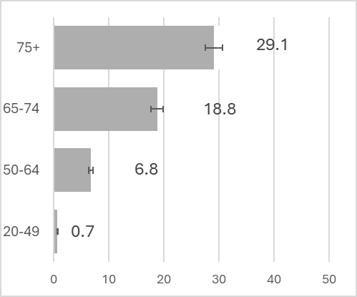 | 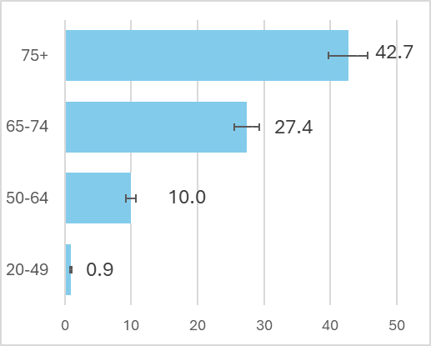 | 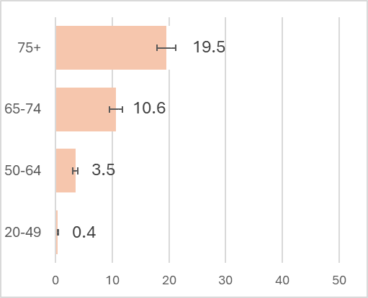

Trends over time
Figure 11.2 shows the incidence of liver cancer from 1994 to 2022. Incidence increased for males from 1994 to 2017 (6.2 % increase per year (95%CI -5.4; 6.9)), before a period of steady decrease from 2017 to 2022 (-6.7% decrease per year (95%CI -10.6; -2.7)). Incidence increased among females from 1994 to 2007 (7.9% increase per year (95%CI -4.6; 11.3)), before continuing to increase from 2007 to 2022 at a rate of 2.2% per year (95%CI 0.7; 3.7).

Figure 11.2: Age-standardised incidence rate 1994-2022, liver
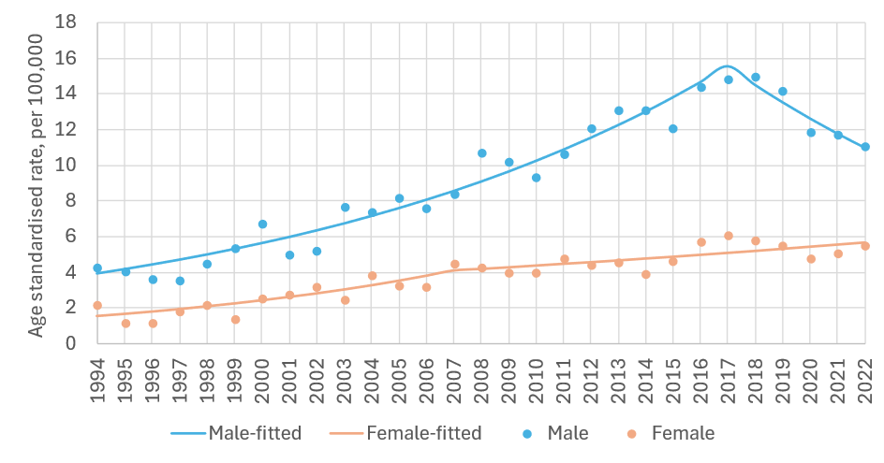
sex | period | APC% | 95%CI | trend | sex | period | APC% | 95%CI | trend
M | 1994-2017 | 6.2 | 5.4, 6.9 | up | F | 1994-2007 | 7.9 | 4.6, 11.3 | up
 | 2017-2022 | -6.7 | -10.6, -2.7 | down |  | 2007-2022 | 2.2 | 0.7, 3.7 | up

APC%: average annual percentage change in rate over period and 95% confidence interval (95%CI) based on annual data points fitted with Joinpoint regression. Trend: ‘up’=significant increase, ‘down’=significant decrease, ‘flat’=no change (static), at the 95% level.

Variation by deprivation quintile
Age-standardised incidence rates of liver cancer in 2014-2018 ranged from 9.5-10.6 cases per 100,000 from the least to the most deprived quintiles (Figure 11.3). Little difference was seen in rates of liver cancer between the most and least deprived quintiles for males (15.0 for least deprived and 16.1 for most deprived). Similarly, very little difference was seen in rates between the most and least deprived quintiles in females (5.1 for least deprived and 5.7 for most deprived).

Figure 11.3: Incidence rate (per 100,000) for liver cancer by deprivation quintile, 2014-2018
Total | Males | Females
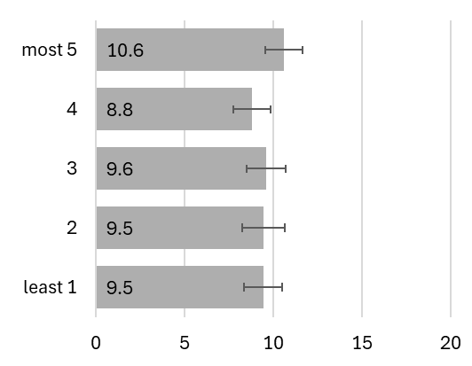 | 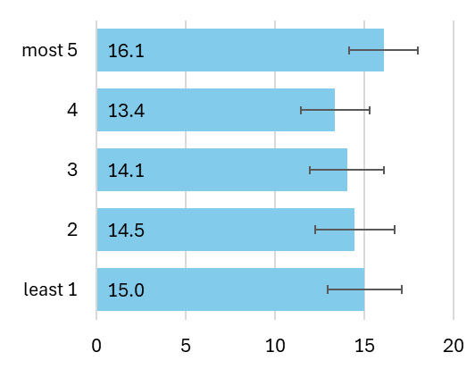 | 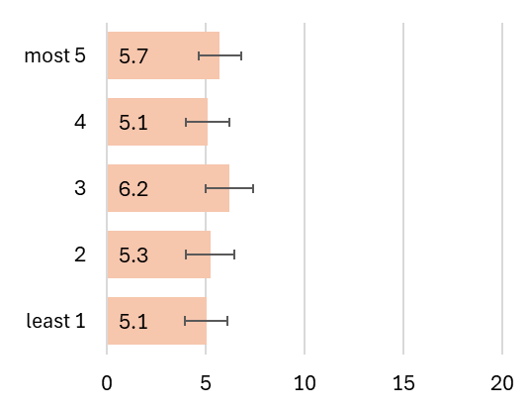

Mortality
Age-standardised mortality rates of liver cancer during the period 1994-2022 were 10.8 deaths per 100,000 males and 6.2 deaths per 100,000 females per year. Figure 11.4 breaks this down further by sex and age group. Older patients had a higher mortality rate regardless of sex.

Figure 11.4: Mortality rate (per 100,000) for liver cancer by age group, 1994-2022
Total | Males | Females
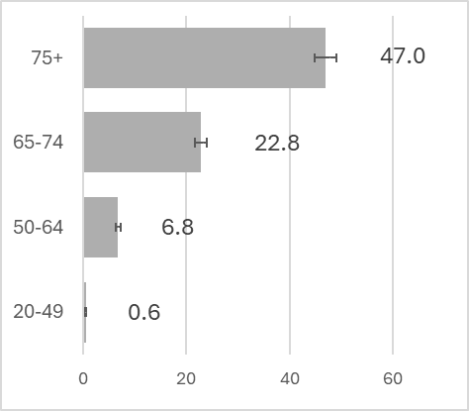 | 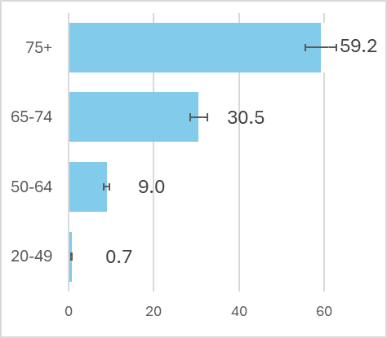 | 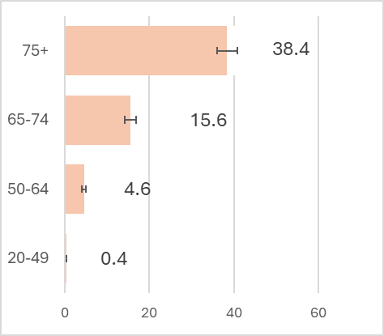

Trends over time
Figure 11.5 displays age-standardised mortality rates for liver cancer from 1994 to 2022 for males and females. In males, there was an increase in mortality from 1994 to 2022 (2.8% per year (95%CI 2.3;3.2)). In females there was also an increase in mortality from 1994 to 2022 (2.6% per year (95%CI 2.0;3.1)).

Figure 11.5: Age-standardised mortality rate 1994-2022, liver
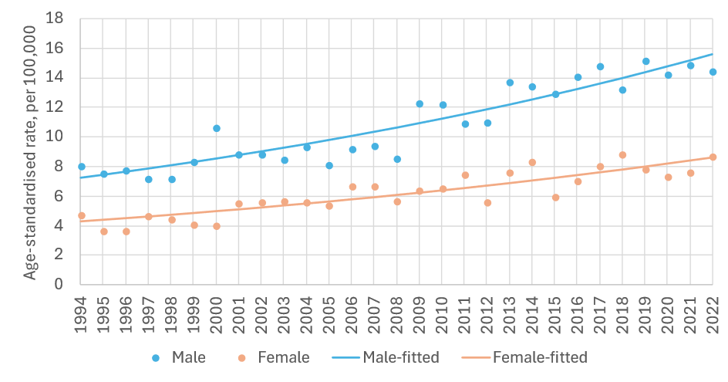
sex | period | APC% | 95%CI | trend | sex | period | APC% | 95%CI | trend
M | 1994-2022 | 2.8 | 2.3, 3.2 | Up | F | 1994-2022 | 2.6 | 2.0, 3.1 | up

APC%: average annual percentage change in rate over period and 95% confidence interval (95%CI) based on annual data points fitted with Joinpoint regression. Trend: ‘up’=significant increase, ‘down’=significant decrease, ‘flat’=no change (static), at the 95% level.

Survival
Overall, 5-year net survival was 16% for cases diagnosed during 2019-2022 (Figure 11.6). Five-year net survival for 2019-2022 was similar for females (16%) and males (17%).

Figure 11.6: Age-standardised 5-year net survival (%) for liver cancer over six consecutive diagnosis periods
Total | Males | Females
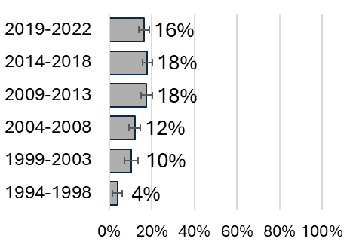 | 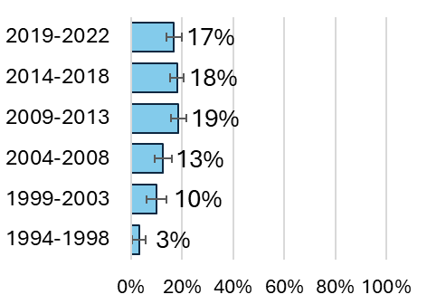 | 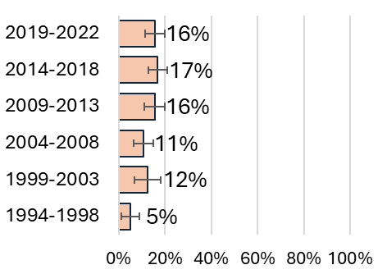

Population Attributable Fraction
In 2022, 343 cases of liver cancer were recorded (220 males, 123 females). The estimated total number of liver cancer cases attributable to smoking in Ireland in 2022 was 61 (PAF 18.0%). Table 11.1 presents the difference between male and female liver cancer incidence related to smoking. Females had a higher PAF than males, 19.1% vs 17.4%.

Table 11.1: Population attributable fraction and attributable cases for liver cancer in 2022
 | Total | Males | Females
PAF (%) | 18.0 | 17.4 | 19.1
Total cases | 343 | 220 | 123
Attributable cases | 61 | 38 | 23

Pancreas C25
Key points
Incidence
- There were no significant trends observed in incidence rates from 1994-2022 among males and females.
- Incidence rates in the diagnosis period 2014-2018 were similar across deprivation quintiles.
Mortality
- Age-standardised mortality rates decreased for males from 1994 to 2022 and were stable for females.
Survival
- 5-year net survival was 15% for cases diagnosed during 2019-2022.
Population attributable fraction
- The estimated total number of pancreatic cancer cases attributable to smoking in Ireland in 2022 was 156 (PAF 24.9%).

Incidence
Between 1994-2022, 13,671 cases of pancreatic cancer were reported (6,982 males, 6,689 females). The median age at diagnosis was 71 years (IQR: 62-78) for males and 74 (IQR: 65-82) for females. Age-standardised incidence rates of pancreatic cancer during the period 1994-2022 were 18.8 cases per 100,000 males and 14.9 cases per 100,000 females per year. Figure 12.1 breaks this down further by sex and age group.

Figure 12.1: Incidence rate (per 100,000) for pancreatic cancer by age group,1994-2022
Total | Males | Females
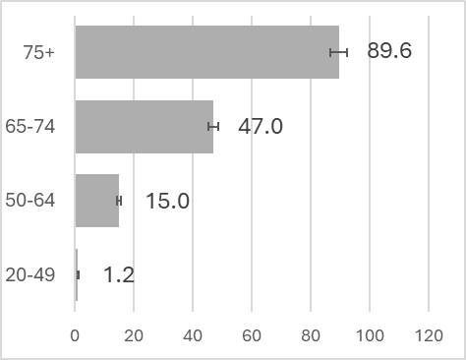 | 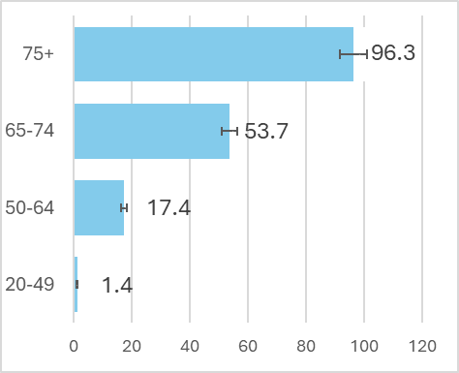 | 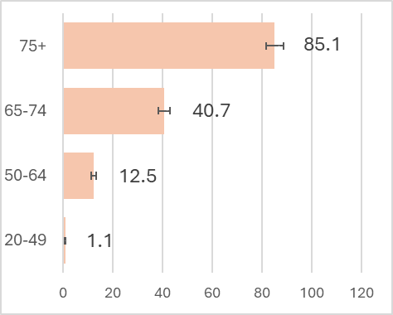

Trends over time
Figure 12.2 shows the incidence of pancreatic cancer from 1994 to 2022. Across the period rates remained steady among males and among females.

Figure 12.2: Age-standardised incidence rate 1994-2022, pancreas
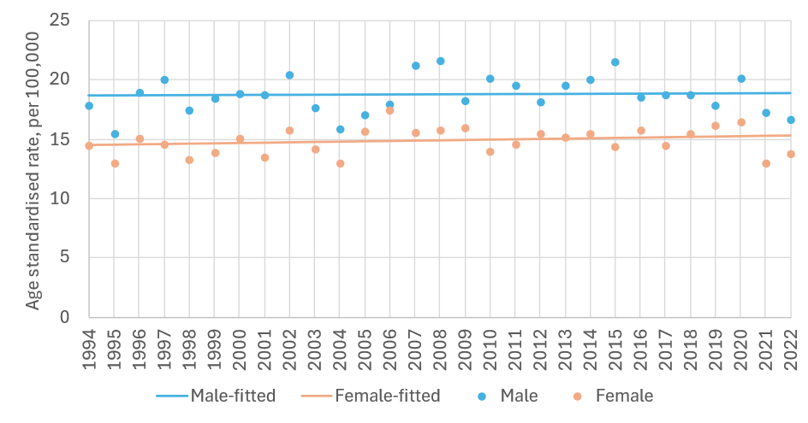
sex | period | APC% | 95%CI | trend | sex | period | APC% | 95%CI | trend
M | 1994-2022 | 0 | -0.3, 0.4 | flat | F | 1994-2022 | 0.2 | -0.2, 0.5 | flat

APC%: average annual percentage change in rate over period and 95% confidence interval (95%CI) based on annual data points fitted with Joinpoint regression. Trend: ‘up’=significant increase, ‘down’=significant decrease, ‘flat’=no change (static), at the 95% level.

Variation by deprivation quintile
Age-standardised incidence rates of pancreatic cancer in 2014-2018 ranged 17.1-19.2 cases per 100,000 from the least to the most deprived quintiles (Figure 12.3). Little difference was seen in rates of pancreatic cancer between the most and least deprived quintiles for males (20.4 for least deprived and 21.1 for most deprived). Some evidence of a difference in rates between the most and least deprived quintiles was seen in females (14.4 for least deprived and 17.7 for most deprived).

Figure 12.3: Incidence rate (per 100,000) for pancreatic cancer by deprivation quintile, 2014-2018
Total | Males | Females
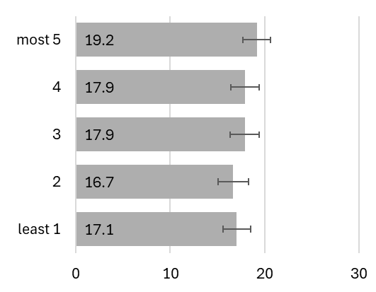 | 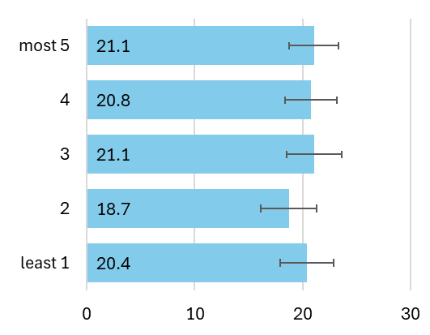 | 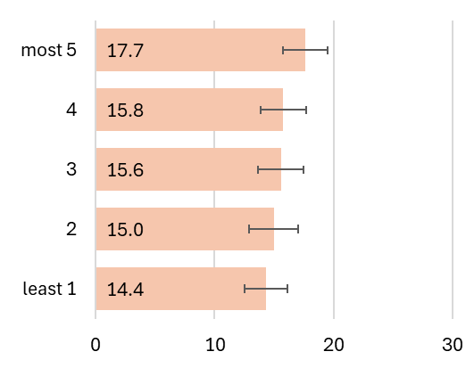

Mortality
Age-standardised mortality rates of pancreatic cancer during the period 1994-2022 were 18.7 deaths per 100,000 males and 14.5 deaths per 100,000 females per year. Figure 12.4 breaks this down further by sex and age group. Older patients had a higher mortality rate regardless of sex.

Figure 12.4: Mortality rate (per 100,000) for pancreatic cancer by age group, 1994-2022
Total | Males | Females
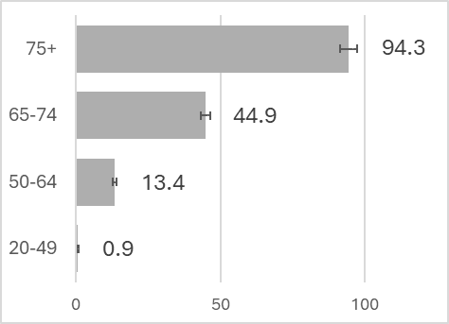 | 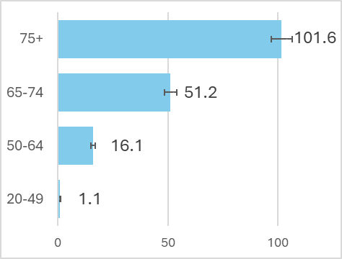 | 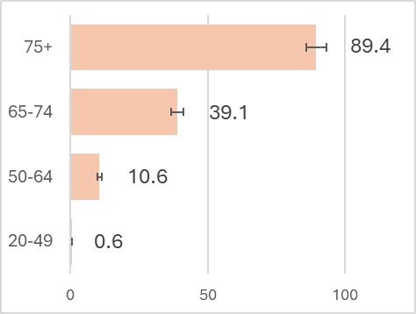

Trends over time
Figure 12.5 displays age-standardised mortality rates for pancreatic cancer from 1994 to 2022 for males and females. In males there was a decrease in mortality from 1994 to 2022 (-0.5% per year (95%CI -0.8; -0.1)). In females, mortality was stable from 1994 to 2022.

Figure 12.5: Age-standardised mortality rate 1994-2022, pancreas
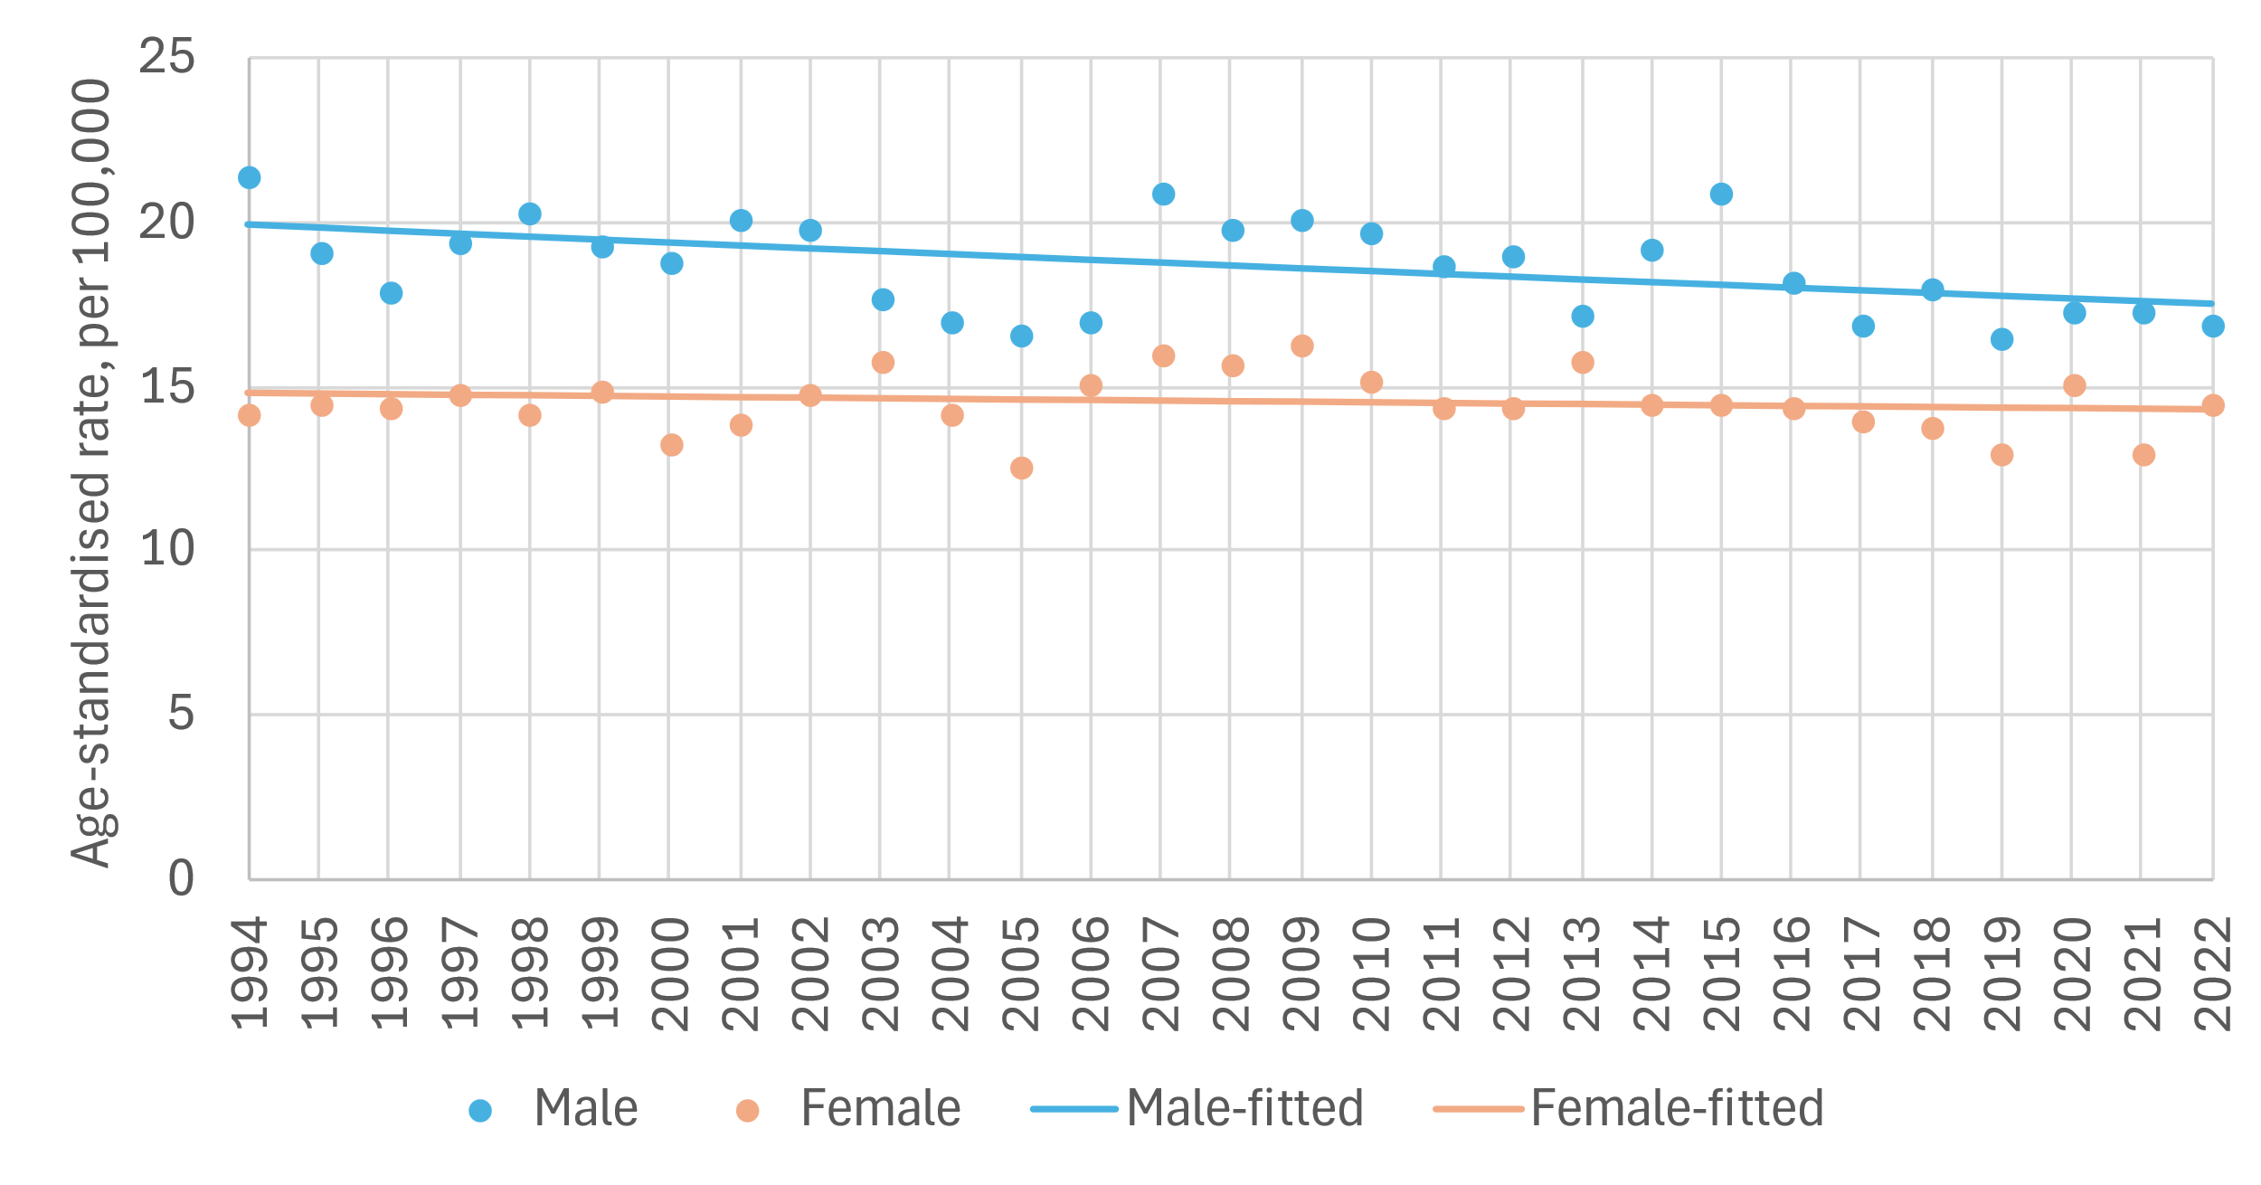
sex | period | APC% | 95%CI | trend | Sex | period | APC% | 95%CI | trend
M | 1994-2022 | -0.5 | -0.8, -0.1 | down | F | 1994-2022 | -0.1 | -0.4, 0.2 | flat

APC%: average annual percentage change in rate over period and 95% confidence interval (95%CI) based on annual data points fitted with Joinpoint regression. Trend: ‘up’=significant increase, ‘down’=significant decrease, ‘flat’=no change (static), at the 95% level.

Survival
Overall, 5-year net survival was 15% for cases diagnosed during 2019-2022 (Figure 12.6). Five-year net survival for 2019-2022 was higher for females (17%) than for males (13%). This was in line with the survival rates seen in the 2014-2018 and 2009-2013 periods.

Figure 12.6: Age-standardised 5-year net survival (%) for pancreatic cancer over six consecutive diagnosis periods
Total | Males | Females
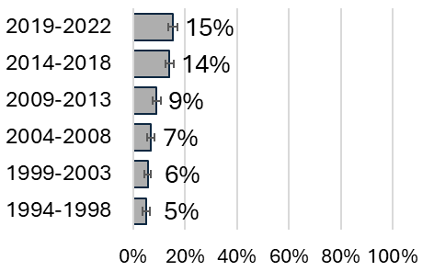 | 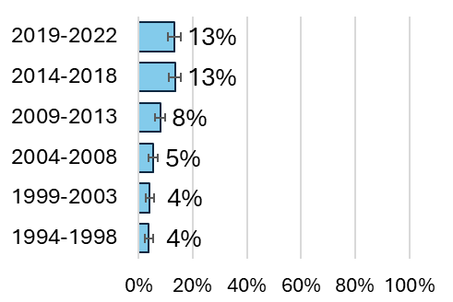 | 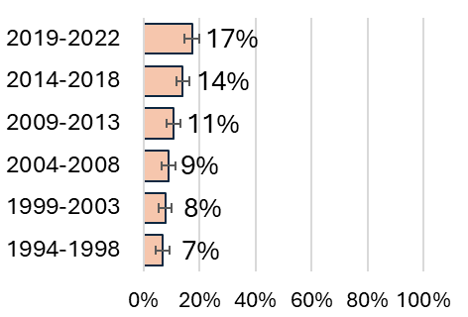

Population Attributable Fraction
In 2022, 628 cases of pancreatic cancer were recorded (326 males, 302 females). The estimated total number of cases attributable to smoking in Ireland in 2022 was 156 (PAF 24.9%). Table 12.1 presents the difference between male and female pancreatic cancer incidence related to smoking. Males had a higher PAF than females (26.3% vs 23.4 %).

Table 12.1: Population attributable fraction and attributable cases for pancreatic cancer in 2022
 | Total | Males | Females
PAF (%) | 24.9 | 26.3 | 23.4
Total cases | 628 | 326 | 302
Attributable cases | 156 | 86 | 70

Sino-nasal C30-31
Key points
Incidence
- There were no significant trends observed in incidence rates from 1994-2022 among males or females.
- Incidence rates in the diagnosis period 2014-2018 were similar across deprivation quintiles.
Mortality
- Age-standardised mortality rates for males decreased from 1994 to 2022.
- Case numbers among females were too few to calculate a reliable trend over time.
Survival
- 5-year net survival was 61% for cases diagnosed during 2019-2022.
Population attributable fraction
- In 2022, the estimated total number of cases of sinonasal cancer attributable to smoking in Ireland was 6 (PAF 26%).

Incidence
Between1994-2022,729 cases of sinonasal cancer were recorded (424 males, 305 females). Median age at diagnosis was 65 years (IQR: 54-74.5) for males and 67 (IQR:51-76) for females. On average during the period 1994-2022 the age-standardised incidence rate of sinonasal cancer was 1.0 case per 100,000 males and 0.6 cases per 100,000 females per year. Figure 13.1 presents incidence between 1994-2022 by age group and sex.

Figure 13.1: Incidence rate (per 100,000) for sinonasal cancer by age group,1994-2022
Total | Males | Females
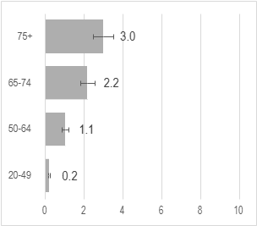 | 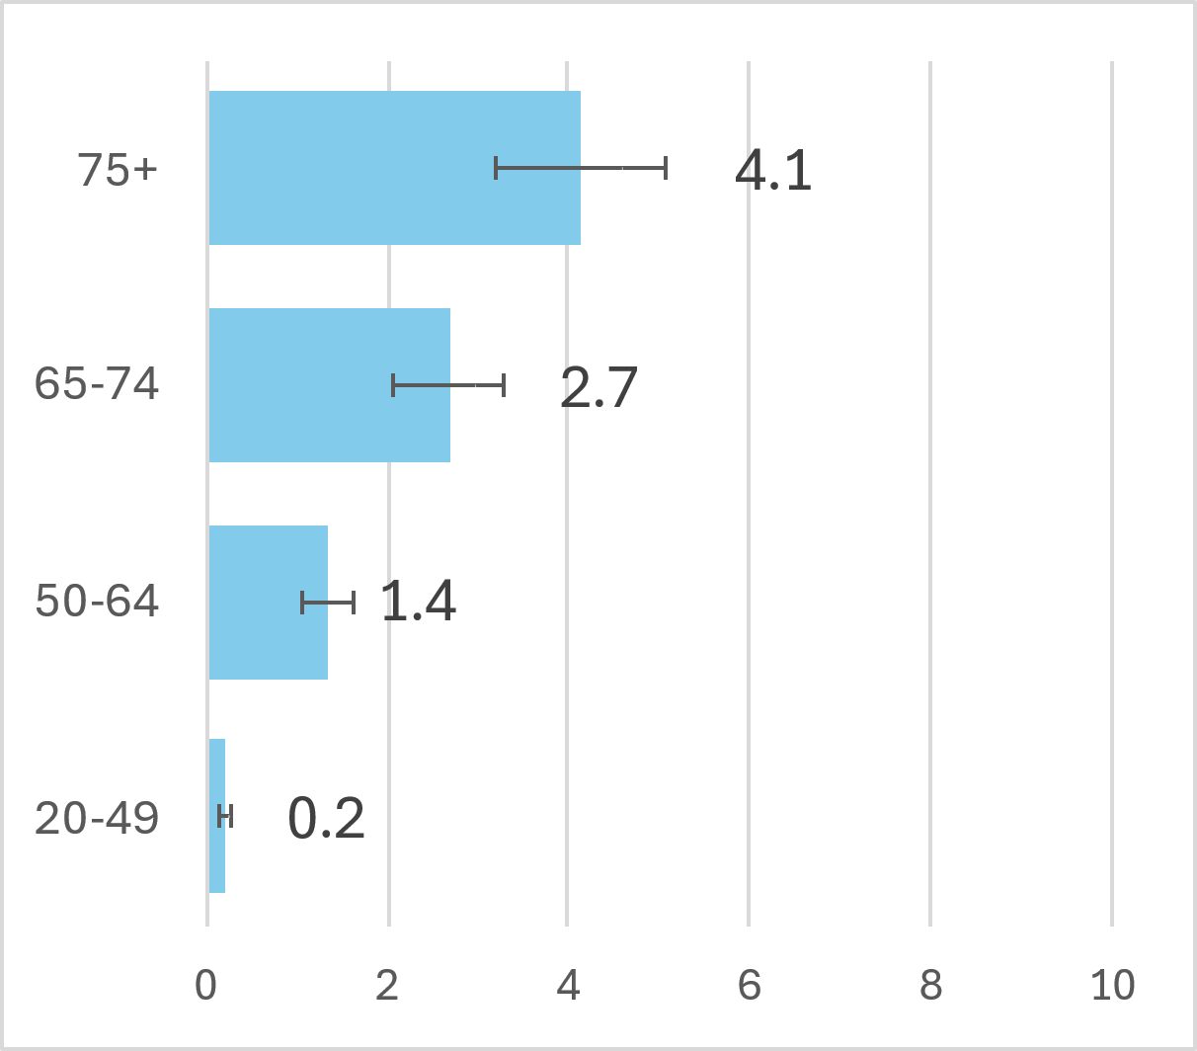 | 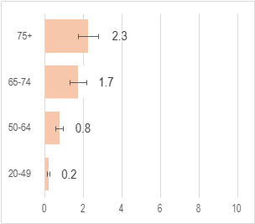

Trends over time
Figure 13.2 shows the incidence of sinonasal cancer from 1994 to 2022. Overall, there was no change in incidence over time among males or females.

Figure 13.2: Age-standardised incidence rate 1994-2022, sinonasal cancer
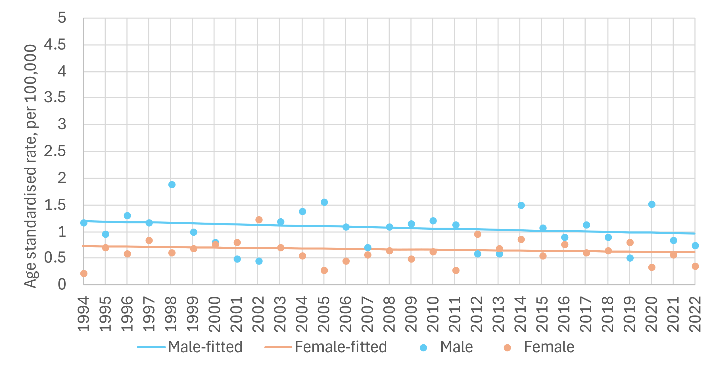

sex | period | APC% | 95%CI | trend | Sex | period | APC% | 95%CI | trend
M | 1994-2022 | -0.8 | -2.2,0.7 | flat | F | 1994-2022 | -0.6 | -2.2,1.0 | flat

APC%: average annual percentage change in rate over period and 95% confidence interval (95%CI) based on annual data points fitted with Joinpoint regression. Trend: ‘up’=significant increase, ‘down’=significant decrease, ‘flat’=no change (static), at the 95% level.

Variation by deprivation
Age-standardised incidence rate of sinonasal cancer in 2014-2018 was1.0 case per 100,000 in the least deprived quintile and 1.0 case per 100,000 in the most deprived quintile. (Figure 13.3). There was no difference in rates of sinonasal cancer between the most and least deprived quintiles among either males or females.

Figure 13.3: Incidence rate (per 100,000) for sinonasal cancer by deprivation quintile, 2014-2018
Total | Males | Females
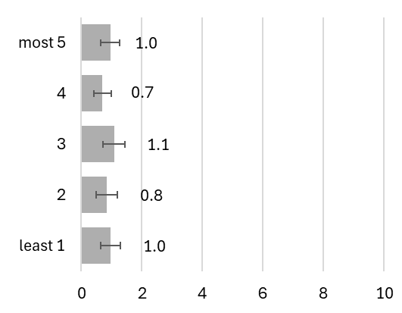 | 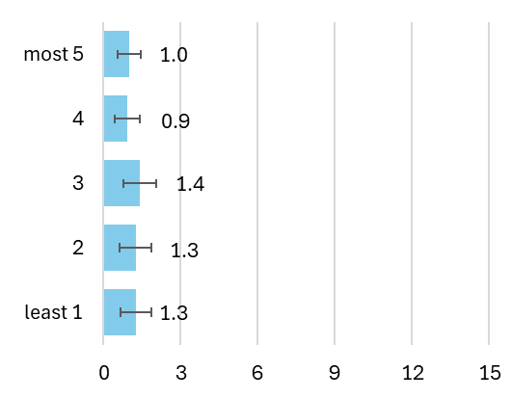 | 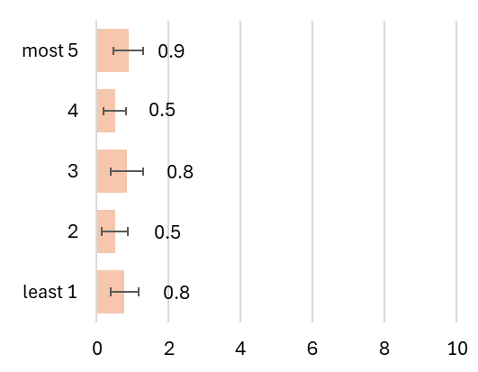

Mortality
Age-standardised mortality rates for sinonasal cancer during the period 1994-2022 were 0.4 deaths per 100,000 males and 0.2 deaths per 100,000 females per year. Figure 13.4 displays mortality according to age group and sex. The mortality rate increased with increasing age among both males and females.

Figure 13.4: Mortality rate (per 100,000) for sinonasal cancer by age group, 1994-2022
Total | Males | Females
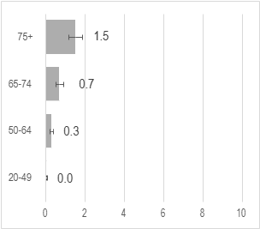 | 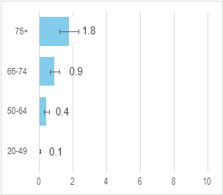 | 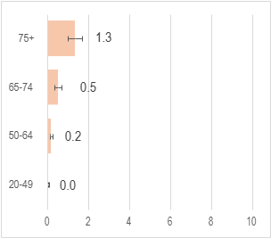

Trends over time
Figure 13.5 displays age-standardised mortality rates for sinonasal cancer 1994 to 2022 for males and females. Overall trends in males indicate a decrease in mortality over time (-2.0% per year (95% CI: -3.9; -0.1)). Cases among females were too few to calculate a reliable trend.

Figure 13.5: Age-standardised mortality rate 1994-2022, sinonasal cancer
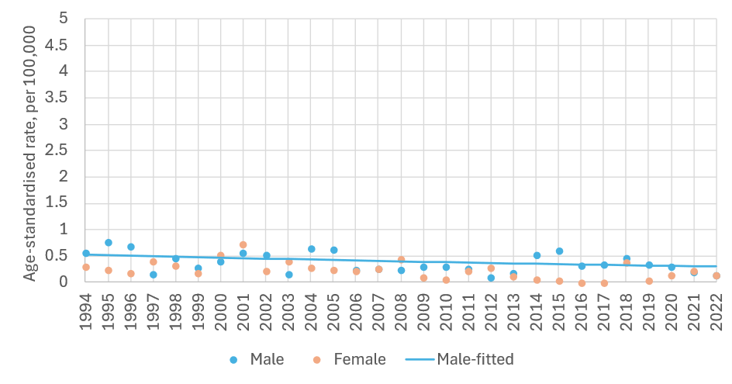
sex | period | APC% | 95%CI | trend | sex | period | APC% | 95%CI | trend
M | 1994-2022 | -2 | -3.9, -0.1 | down | F | 1994-2022 | NA | NA | NA

APC%: average annual percentage change in rate over period and 95% confidence interval (95%CI) based on annual data points fitted with Joinpoint regression. Trend: ‘up’=significant increase, ‘down’=significant decrease, ‘flat’=no change (static), at the 95% level.

Survival
For sinonasal cancer overall 5-year net survival was 61% for cases diagnosed during 2019-2022 (Figure 13.6). Female 5-year net survival for 2019-2022 was slightly higher (62%) than for males (61%). In general, survival improved across periods for both males and females.

Figure 13.6: Age-standardised 5-year net survival (%) for sinonasal cancer over six consecutive diagnosis periods
Total | Males | Females
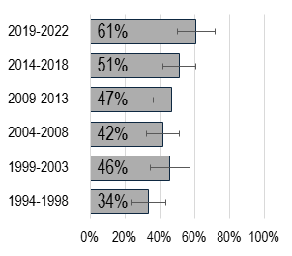 | 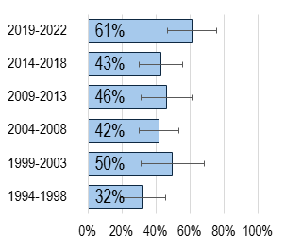 | 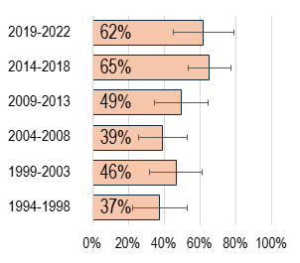

Population Attributable Fraction
In 2022, 24 cases of sinonasal cancer were recorded (16 males, 8 females). The estimated total number of sinonasal cancer cases attributable to smoking in Ireland in 2022 was 6 (PAF 26%). Table 13.1 presents the sinonasal cases in male and females attributable to smoking. Males had a higher PAF than females (27% vs 24%).

Table 13.1: Population attributable fraction and attributable cases for sinonasal cancer in 2022
 | Total | Males | Females
PAF (%) | 26.0 | 27.0 | 24.0
Total cases | 24 | 16 | 8
Attributable cases | 6 | 4 | 2

Larynx C32
Key points
Incidence
- No significant changes in incidence rates were observed between 1994 and 2022 in males or females.
- Incidence rates in the diagnosis period 2014-2018 were lowest in the least deprived population quintile and highest in the most deprived quintile with clear evidence of a socioeconomic gradient.
Mortality
- Age-standardised mortality rates for both males and females decreased from 1994 to 2022
Survival
- 5-year net survival was 64% for cases diagnosed during 2019-2022.
Population attributable fraction
- In 2022, the estimated total number of cases of laryngeal cancer attributable to smoking in Ireland was 121 (PAF 65.9%).

Incidence
Between 1994-2022, 4,326 cases of laryngeal cancer were recorded (3,646 in males, 680 in females). Median age at diagnosis was 65 years (IQR: 58-73) for males and 65 years (IQR: 58-74) for females. On average during the period 1994-2022 the age-standardised incidence rate of laryngeal cancer was 8.8 cases per 100,000 males and 1.5 cases per 100,000 females per year. Figure 14.1 presents incidence from 1994-2022 by age group and sex.

Figure 14.1: Incidence rate (per 100,000) for laryngeal cancer by age group,1994-2022
Total | Males | Females
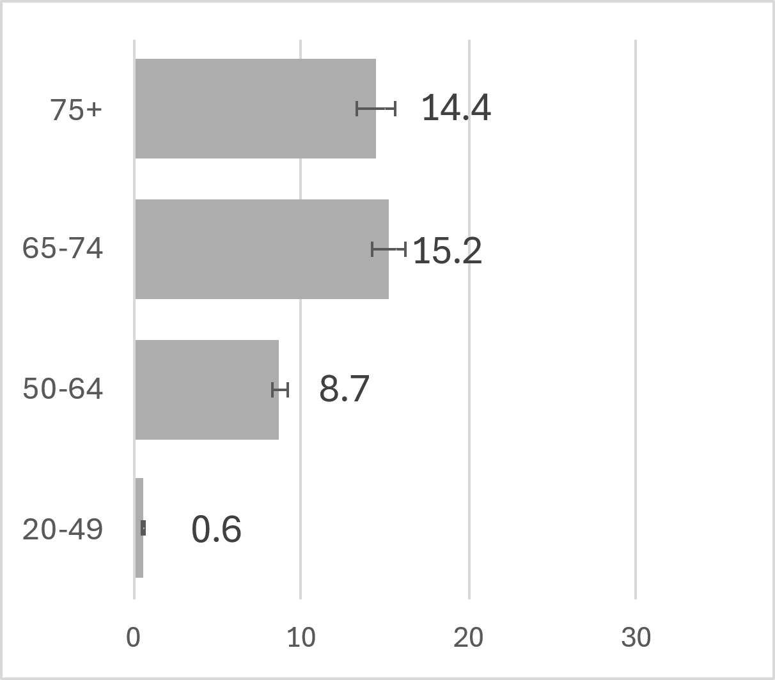 | 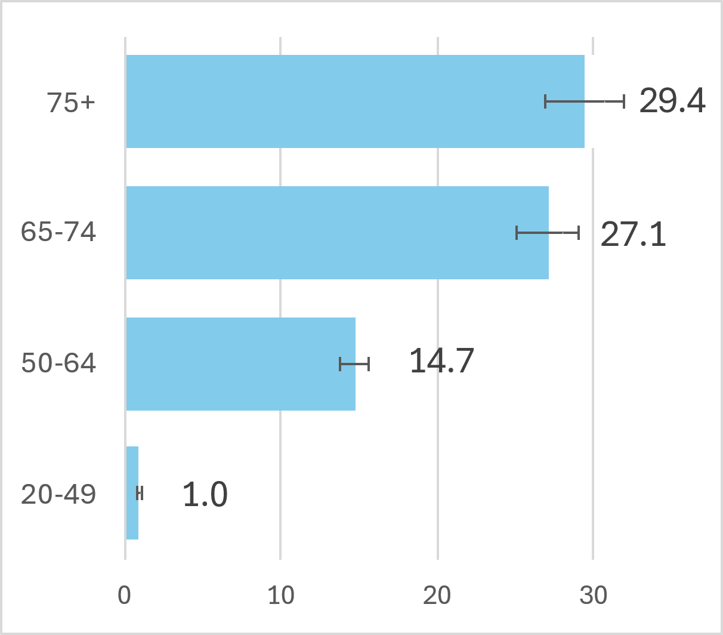 | 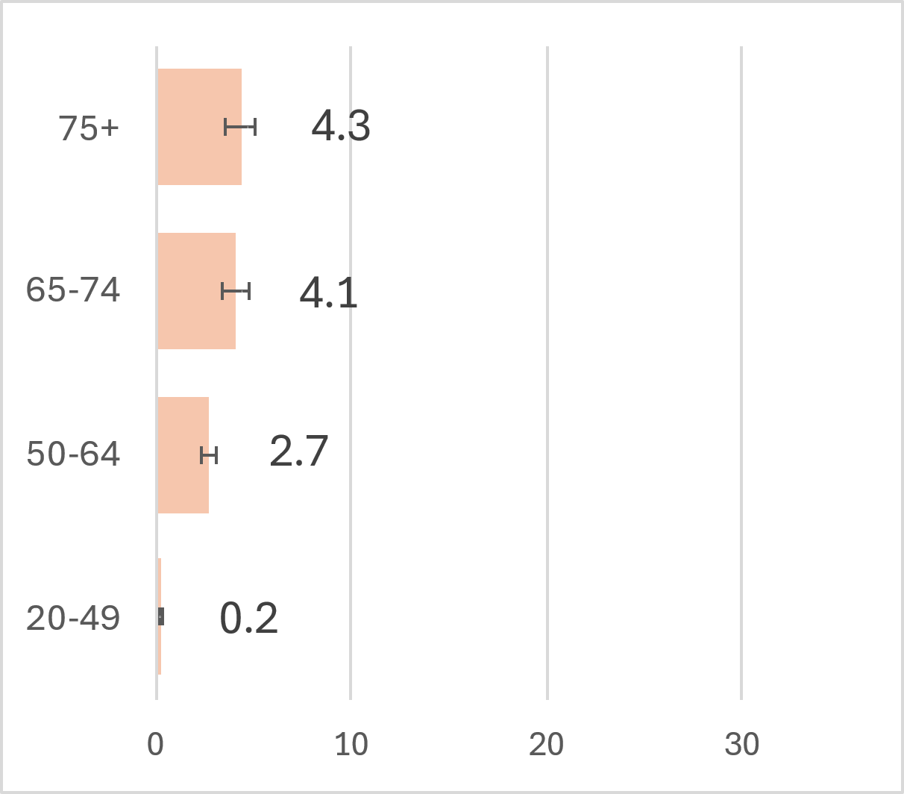

Trends over time
Figure 14.2 shows the incidence of laryngeal cancer from 1994 to 2022. Over this period incidence rates were consistently higher among males than females with rates stable in both sexes over time.

Figure 14.2: Age-standardised incidence rate 1994-2022, C32 laryngeal cancer
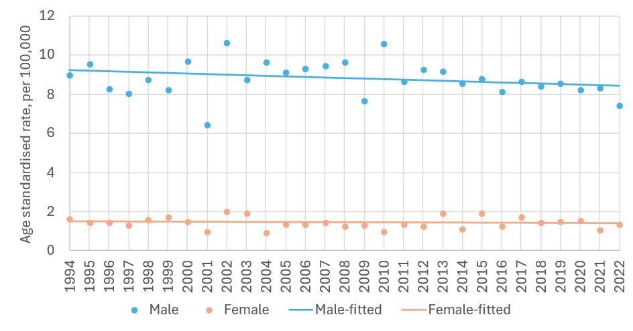
sex | period | APC% | 95%CI | trend | sex | period | APC% | 95%CI | trend
M | 1994-2022 | -0.3 | -0.8,0.1 | flat | F | 1994-2022 | -0.2 | -1.1,0.7 | flat

APC%: average annual percentage change in rate over period and 95% confidence interval (95%CI) based on annual data points fitted with Joinpoint regression. Trend: ‘up’=significant increase, ‘down’=significant decrease, ‘flat’=no change (static), at the 95% level.

Variation in incidence by deprivation quintile
Age-standardised incidence rates of laryngeal cancer in 2014-2018 ranged from 3.3 to 7.1 cases per 100,000 population in the least deprived quintile to the most deprived quintiles respectively (Figure 14.3). A difference in rates of laryngeal cancer among males between the most and least deprived quintiles was observed (6.6 for least deprived and 12.4 for most deprived). Incidence was lower overall in females compared to males, but a difference in rates between the most and least deprived quintiles was still evident (0.5 for least deprived and 2.4 for most deprived).

Figure 14.3: Incidence rate (per 100,000) for laryngeal cancer by deprivation quintile, 2014-2018
Total | Males | Females
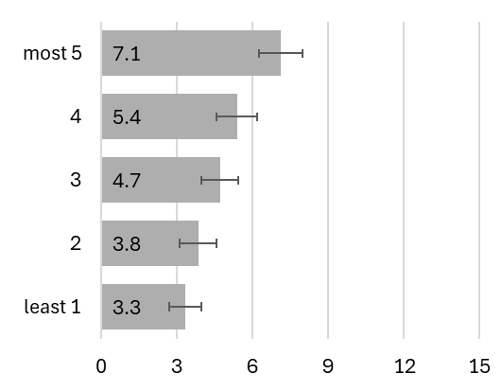 | 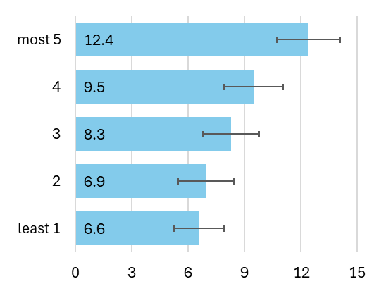 | 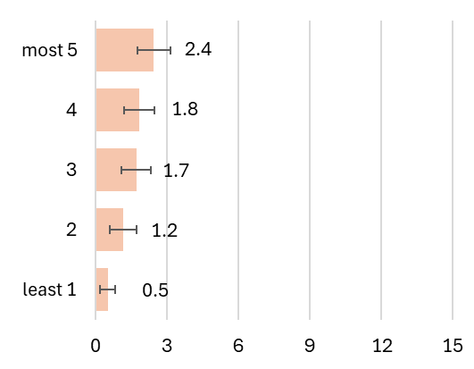

Mortality
Age-standardised mortality rates of laryngeal cancer during the period1994-2022 were 4.2 deaths per 100,000 males and 0.7 deaths per 100,000 females per year. Figure 14.4 provides data on mortality by sex and age group. Mortality rates were higher among males than females across all age groups, and higher among older age groups in both sexes.

Figure 14.4: Mortality rate (per 100,000) for laryngeal cancer by age group, 1994-2022
Total | Males | Females
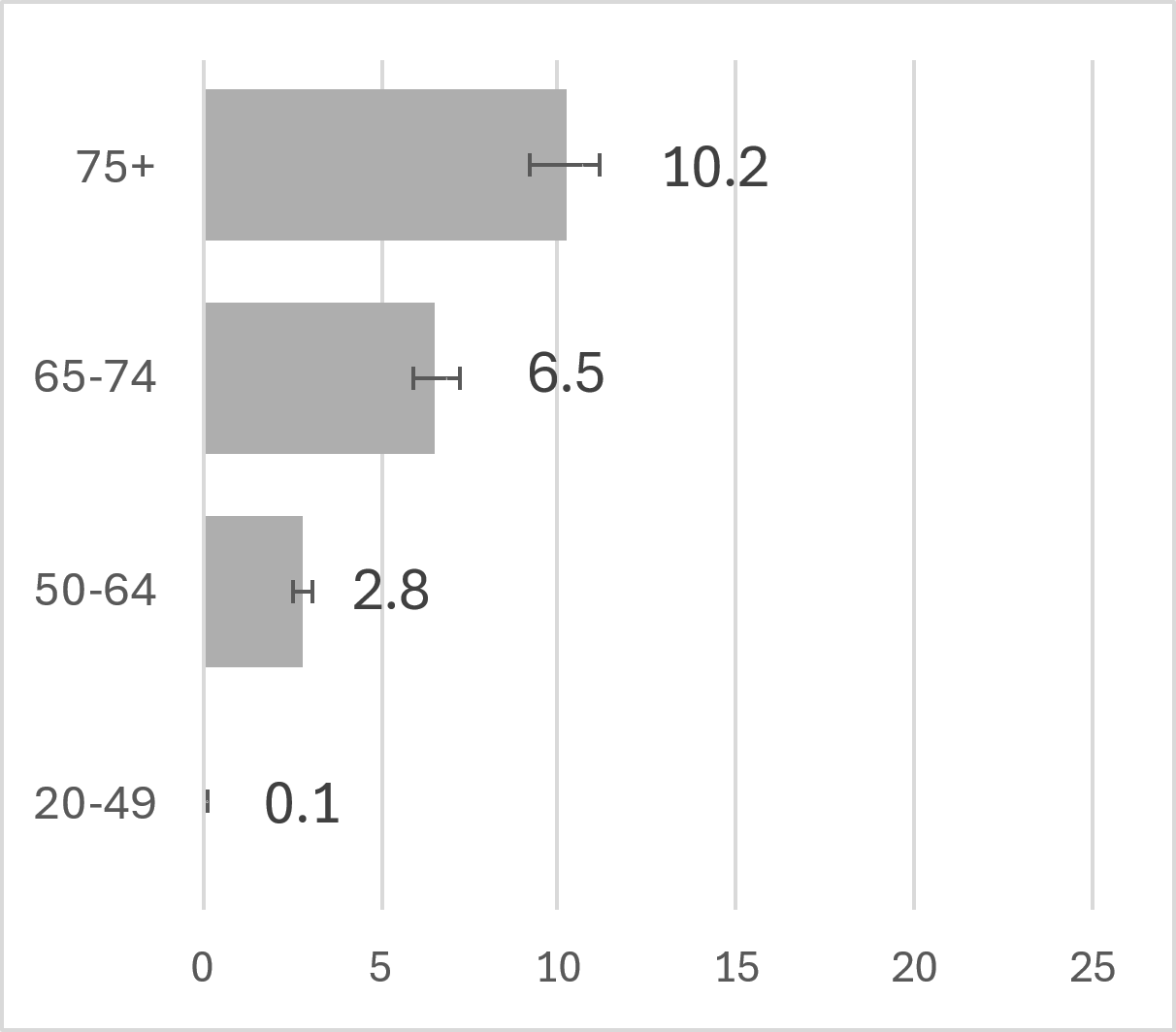 | 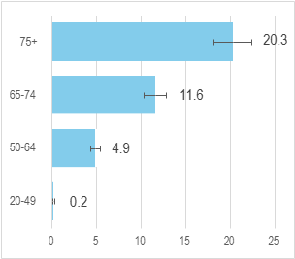 | 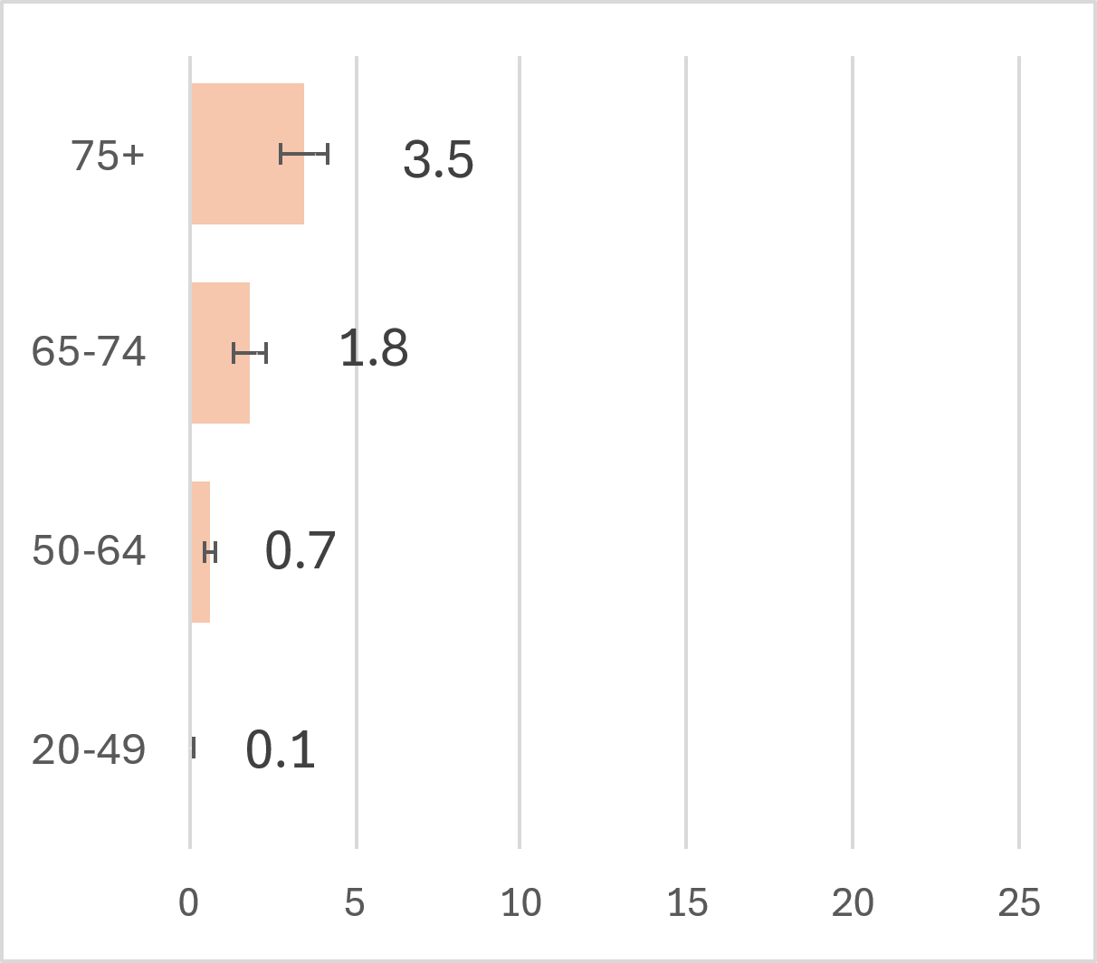

Trends over time
Figure 14.5 shows age-standardised mortality rates for laryngeal cancer from 1994 to 2022 for males and females. There was a decrease in mortality among males by -1.6% per year (95% CI: -2.4; -0.8) and a decrease in mortality for females by -2.4% per year (95% CI: -3.7; -1.1).

Figure 14.5: Age-standardised mortality rate 1994-2022, C32 laryngeal cancer
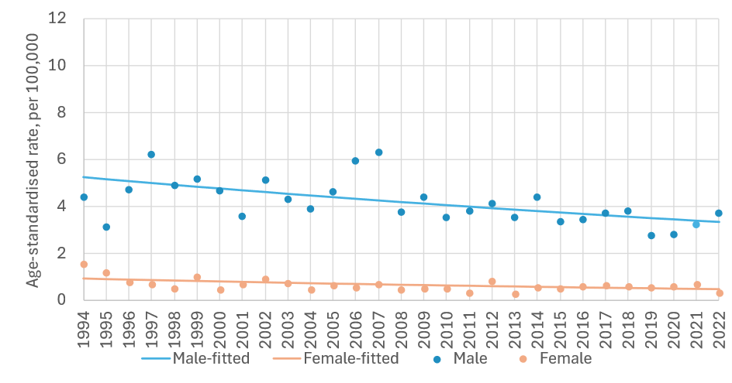
sex | period | APC% | 95%CI | trend | sex | period | APC% | 95%CI | trend
M | 1994-2022 | -1.6 | -2.4, -0.8 | down | F | 1994-2022 | -2.4 | -3.7, -1.1 | down

APC%: average annual percentage change in rate over period and 95% confidence interval (95%CI) based on annual data points fitted with Joinpoint regression. Trend: ‘up’=significant increase, ‘down’=significant decrease, ‘flat’=no change (static), at the 95% level.

Survival
For laryngeal cancer in Ireland overall 5-year net survival was 64% for cases diagnosed during 2019-2022 (Figure 14.6). 5-year net survival for 2019-2022 was the same for males and females. There was greater variability in survival estimates for females over time likely reflecting fewer cases of laryngeal cancer in females.

Figure 14.6: Age-standardised 5-year net survival (%) for laryngeal cancer over six consecutive diagnosis periods
Total | Males | Females
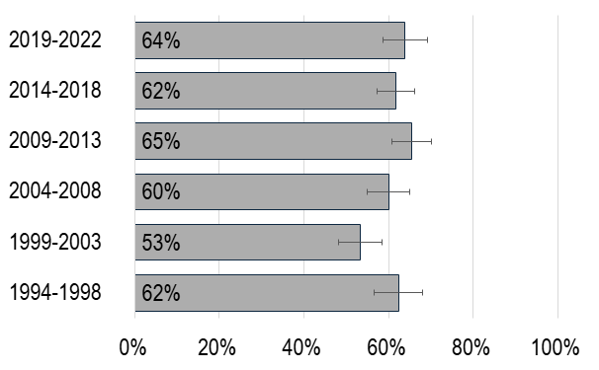 | 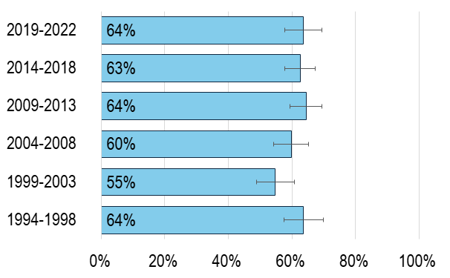 | 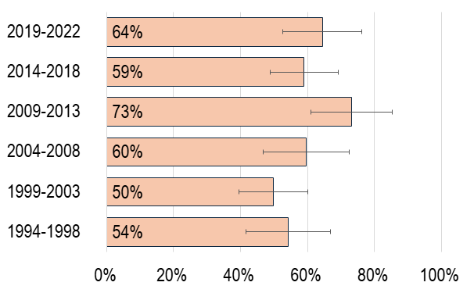

Population Attributable Fraction
In 2022, 184 cases of laryngeal cancer were recorded (153 males, 31 females). The estimated total number of laryngeal cancer cases attributable to smoking in Ireland in 2022 was 121 (PAF 65.9%). Table 14.1 presents the difference between male and female laryngeal cancer incidence related to smoking. Males had a higher PAF than females, 66.5% vs 62.9%.

Table 14.1: Population attributable fraction and attributable cases for larynx cancer in 2022
 | Total | Males | Females
PAF (%) | 65.9 | 66.5 | 62.9
Total cases | 184 | 153 | 31
Attributable cases | 121 | 102 | 20

Lung C33-34
  - Key points
  - Incidence
- Incidence rates among males decreased from 1994 to 2022.
- Incidence rates among females only started to decline from 2015.
- Incidence rates in the diagnosis period 2014-2018 were lowest in the least deprived population quintile and highest in the most deprived quintile with clear evidence of a socioeconomic gradient.
Mortality
- Age-standardised mortality rates decreased between 1994 and 2022 among males.
- Mortality rates among females only started to decline from 2016.
Survival
- 5-year net survival was 25% for cases diagnosed during 2019-2022.
Population attributable fraction
- In 2022 the estimated total number of cases of lung cancer attributable to smoking in Ireland was 2,010 (PAF 73.3%).

Incidence
Between 1994 and 2022, 60,635 cases of lung cancer were recorded (35,042 in males, 25,593 in females). Median age at diagnosis was 71 years (IQR: 63-77) for males and 71 years (IQR: 63-78) for females. On average between 1994-2022 the age-standardised incidence rate of lung cancer during the period 1994-2022 was 94.9 cases per 100,000 males and 55.6 cases per 100,000 females per year. Figure 15.1 breaks this down further by sex and age group.

Figure 15.1: Incidence rate (per 100,000) for lung cancer by age group,1994-2022
Total | Males | Females
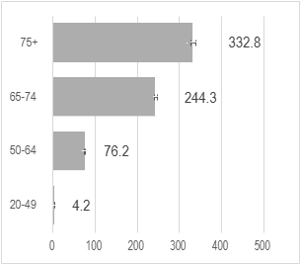 | 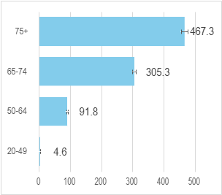 | 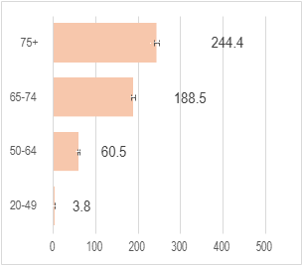

Trends over time
Figure 15.2 shows the incidence of lung cancer from 1994 to 2022. Age-standardised lung cancer incidence rates in males decreased significantly at -0.6% per year (95%CI: -0.8, -0.4) during 1994-2017 subsequently declining at –4.8% per year during 2017-2022 (95%CI: -6.6, -3.0). By contrast, age-standardised lung cancer incidence in females increased at 2.3% per year (95%CI: 2.1, 2.5) during 1994-2015 then declined by -1.8% per year (95%CI: -2.7; -1.0) from 2015-2022.

Figure 15.2: Age-standardised incidence rate 1994-2022, lung cancer
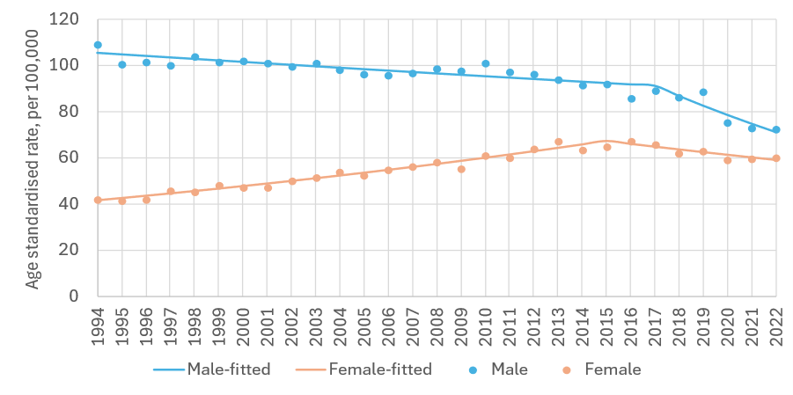
sex | period | APC% | 95%CI | trend | sex | period | APC% | 95%CI | trend
M | 1994-2017 | -0.6 | -0.8, -0.4 | down | F | 1994-2015 | 2.3 | 2.1, 2.5 | up
 | 2017-2022 | -4.8 | -6.6, -3.0 | down |  | 2015-2022 | -1.8 | -2.7, -1.0 | down

APC%: average annual percentage change in rate over period and 95% confidence interval (95%CI) based on annual data points fitted with Joinpoint regression. Trend: ‘up’=significant increase, ‘down’=significant decrease, ‘flat’=no change (static), at the 95% level.

Variation by deprivation quintile
Age-standardised incidence rates of lung cancer in 2014-2018 ranged 62.6 to 99.2 cases per 100,000 in the least deprived to the most deprived quintiles respectively (Figure 15.3). There was a significant difference in rates of lung cancer between the most and least deprived quintiles for males (75.4 for least deprived and 116.2 for most deprived). A difference in rates between the most and least deprived quintiles was also seen in females (54.3 for least deprived and 87.5 for most deprived).

Figure 15.3: Incidence rate (per 100,000) for lung cancer by deprivation quintile, 2014-2018
Total | Males | Females
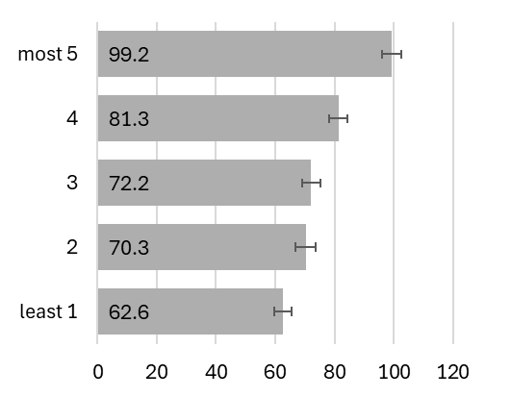 | 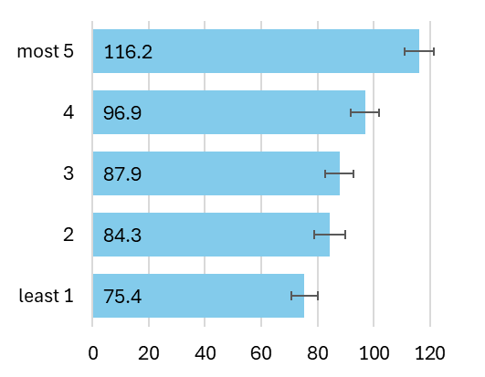 | 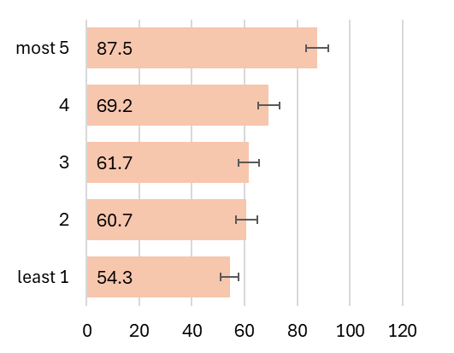

Mortality
Age-standardised mortality rates for lung cancer during the period 1994-2022 were 83.2 deaths per 100,000 males and 44.7 deaths per 100,000 females per year. Figure 15.4 breaks this down further by sex and age group. Mortality rates increased with increasing age and were higher among males than females across age groups.

Figure 15.4: Mortality rate (per 100,000) for lung cancer by age group, 1994-2022
Total | Males | Females
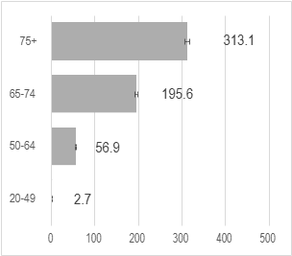 | 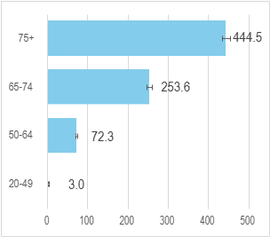 | 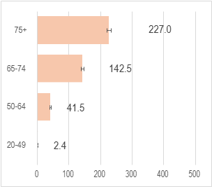

Trends over time
Figure 15.5 shows age-standardised mortality rates for lung cancer 1994 to 2022 for males and females. Mortality rates in males declined at -1.5% per year (95% CI: -1.8; -1.2) from 1994-2013 and at -3.6% (-4.4; -2.7) per year during 2013-2022. Mortality rates increased in females by 0.6% per year (95%CI: 0.3;1.0) from 1994-2016 before starting to decline at -2.8% per year (95% CI: -4.7;1.0) from 2016.

Figure 15.5: Age-standardised mortality rate 1994-2022, lung cancer
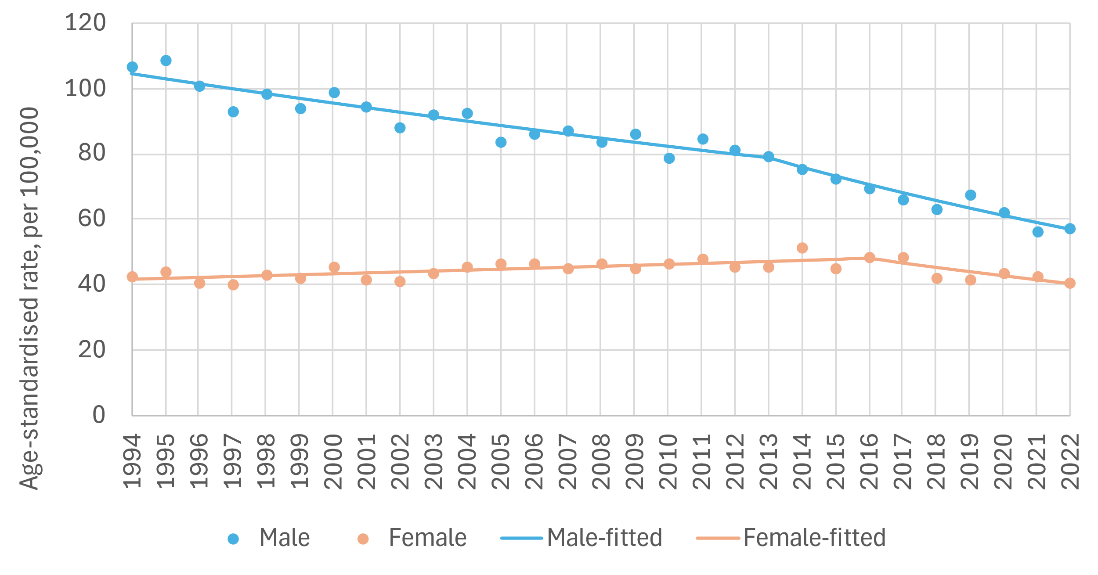
sex | period | APC% | 95%CI | trend | sex | period | APC% | 95%CI | trend
M | 1994-2013 | -1.5 | -1.8, -1.2 | down | F | 1994-2016 | 0.6 | 0.3, 1.0 | up
 | 2013-2022 | -3.6 | -4.4, -2.7 | down |  | 2016-2022 | -2.8 | -4.7, -1.0 | down

APC%: average annual percentage change in rate over period and 95% confidence interval (95%CI) based on annual data points fitted with Joinpoint regression. Trend: ‘up’=significant increase, ‘down’=significant decrease, ‘flat’=no change (static), at the 95% level.

Survival
Lung cancer 5-year net survival was 25% for cases diagnosed during 2019-2022 (Figure 15.6). Five-year net survival for 2019-2022 was 30% for females but only 20% for males. There have been large improvements in survival for both males and females compared to earlier periods. By comparison, 5-year net survival for 1994-1998 was 10% for females and 8% for males.

Figure 15.6: Age-standardised 5-year net survival (%) for lung cancer over six consecutive diagnosis periods
Total | Males | Females
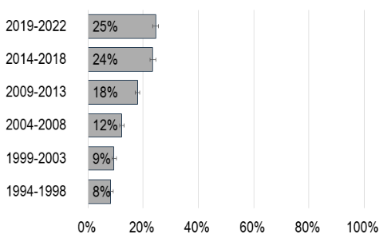 | 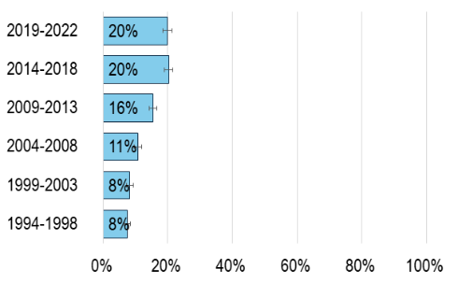 | 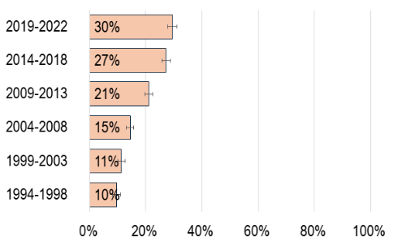

Population Attributable Fraction
In 2022, 2,742 cases of lung cancer were recorded (1,426 in males, 1,316 in females). The estimated total number of lung cancer cases attributable to smoking in Ireland in 2022 was 2,010 (PAF 73.3%). The estimated number of lung cancer cases attributable to second-hand smoke in Ireland in 2022 was 12 (PAF 4.8%). Table 15.1 presents the difference between male and female lung cancer incidence related to smoking. Males had a higher PAF for smoking than females (74.8% vs 71.7%) but a smaller PAF for second hand smoke (4.2% vs 5.3%)

Table 15.1: Population attributable fraction and attributable cases for lung cancer in 2022
 | Smoking |  |  | Second hand smoke
 | Total | Males | Females |  | Total | Males | Females
PAF (%) | 73.3 | 74.8 | 71.7 | PAF (%) | 4.8 | 4.2 | 5.3
Total cases | 2,742 | 1,426 | 1,316 | Non-smoker burden | 249 | 114 | 135
Attributable cases | 2,010 | 1,066 | 944 | Attributable cases | 12 | 5 | 7

Breast (Female Breast Cancer) C50
Key points
Incidence
- Age-standardised incidence rates increased for female breast cancer from 1994-2022.
- Age-standardised incidence rates in the diagnosis period 2014-2018 ranged from 181.5 to 164.8 cases per 100,000 in the least deprived to the most deprived quintiles respectively.
Mortality
- Age-standardised mortality rates decreased from 1994 to 2022.
Survival
- 5-year net survival was 87% for cases diagnosed during 2019-2022.
Population attributable fraction
- In 2022 the estimated total number of cases of breast cancer attributable to smoking in Ireland was 147 (PAF 3.6%).

Incidence
Between 1994-2022, 75,090 cases of breast cancer were recorded. Median age at diagnosis was 59 years (IQR: 50-71). On average during the period 1994-2022 the age-standardised incidence rate of breast cancer in 1994-2022 was 148.5 cases per 100,000 females per year. Figure 16.1 breaks this down further by age group.

Figure 16.1: Incidence rate (per 100,000) for female breast cancer by age group,1994-2022
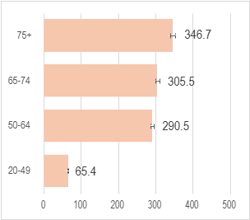

Trends over time
Figure 16.2 shows the incidence of breast cancer from 1994 to 2022. The age-standardised incidence rate for female breast cancer increased significantly at 1.0% (95% CI: -0.8, -0.4) per year from 1994 -2022.

Figure 16.2: Age-standardised incidence rate 1994-2022, female breast cancer
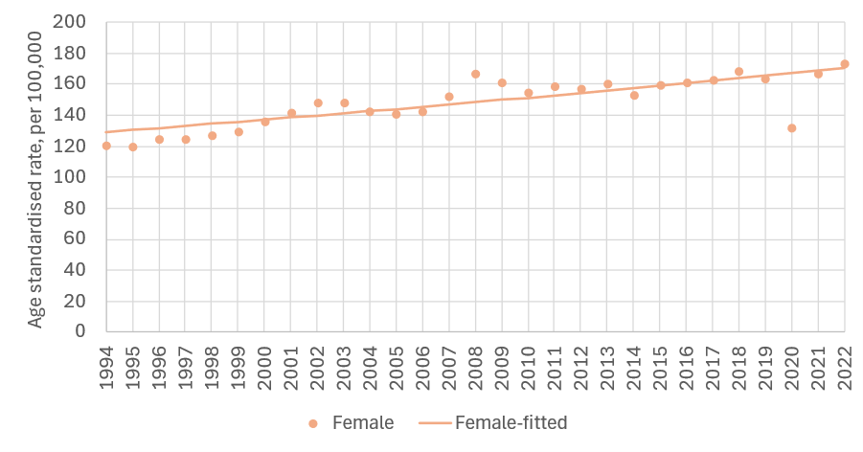
sex | period | APC% | 95%CI | trend
F | 1994-2022 | 1.0 | 0.7,1.3 | up

APC%: average annual percentage change in rate over period and 95% confidence interval (95%CI) based on annual data points fitted with Joinpoint regression. Trend: ‘up’=significant increase, ‘down’=significant decrease, ‘flat’=no change (static), at the 95% level.

Variation by deprivation quintile
Age-standardised incidence rates of breast cancer in 2014-2018 ranged from 181.2 to 164.8 cases per 100,000 in the least deprived to the most deprived quintiles respectively (Figure 16.3).

Figure 16.3: Incidence rate (per 100,000) for female breast cancer by deprivation quintile, 2014-2018
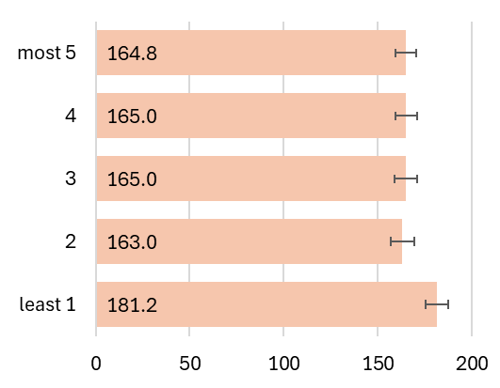

Mortality
The age-standardised mortality rate for female breast cancer during the period 1994-2022 was 43.5 deaths per 100,000 females per year. Figure 16.4 breaks this down further by sex and age group. Females aged 75+ years had the highest mortality rate.

Figure 16.4: Mortality rate (per 100,000) for female breast cancer by age group, 1994-2022
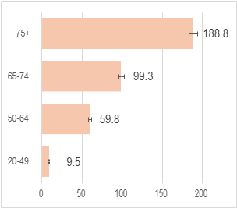

Trends over time
Figure 16.5 presents age-standardised mortality rates for female breast cancer from 1994 to 2022. There was a decline in mortality from breast cancer from 1994 to 2022 (-1.4% per year (95%CI -1.6; -1.2)).

Figure 16.5: Age-standardised mortality rate 1994-2022, female breast cancer
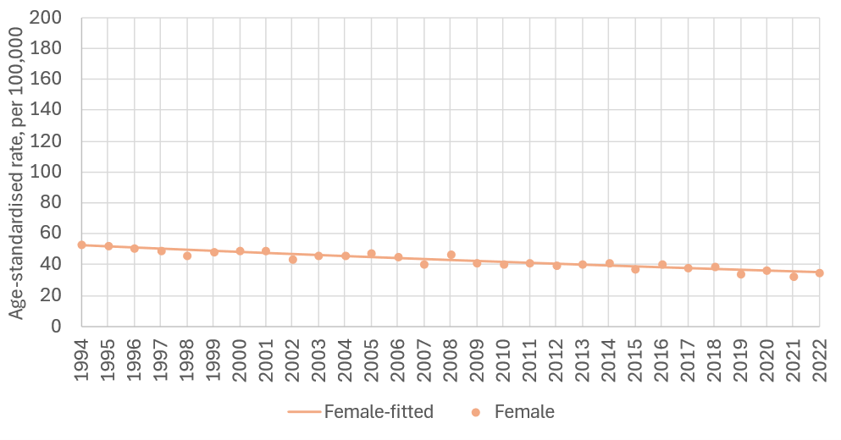
sex | period | APC% | 95%CI | trend
F | 1994-2022 | -1.4 | -1.6, -1.2 | down

APC%: average annual percentage change in rate over period and 95% confidence interval (95%CI) based on annual data points fitted with Joinpoint regression. Trend: ‘up’=significant increase, ‘down’=significant decrease, ‘flat’=no change (static), at the 95% level.

Survival
For female breast cancer overall 5-year net survival was 87% for cases diagnosed during 2019-2022 (Figure 16.6). This was unchanged from the survival estimate in the 2014-2018 period. Female 5-year net survival improved by 16 percentage points compared to 1994-1998 when 5-year net survival was 71%.

Figure 16.6: Age-standardised 5-year net survival (%) for female breast cancer over six consecutive diagnosis periods
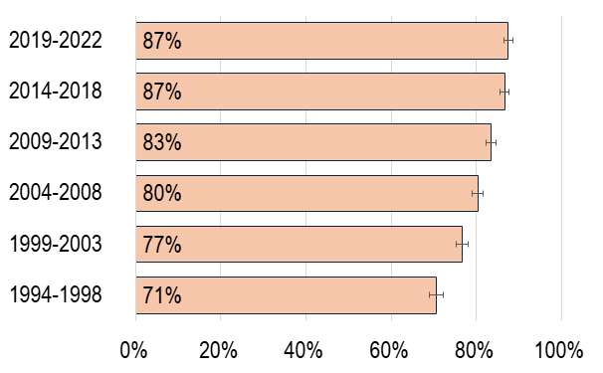

Population Attributable Fraction
In 2022, 4,072 cases of female breast cancer were recorded. The estimated total number of breast cancer cases attributable to smoking in Ireland in 2022 was 147 (PAF 3.6%). Table 16.1 presents breast cancer incidence related to smoking. The PAF for breast cancer among females was 3.6%.

Table 16.1: Population attributable fraction and attributable cases for breast cancer in 2022
 | Females
PAF (%) | 3.6
Total cases | 4,072
Attributable cases | 147

Cervix C53
Key points
Incidence
- Age-standardised incidence rates increased from 1994-2010 before subsequently decreasing from 2010-2022.
- Incidence rates in the diagnosis period 2014-2018 were lowest in the least deprived population quintile and higher in more deprived quintiles with clear evidence of a socioeconomic gradient.
Mortality
- Age-standardised mortality rates decreased from 1994 to 2022.
Survival
- 5-year net survival was 65% for cases diagnosed during 2019-2022.
Population attributable fraction
- In 2022, the estimated total number of cases of cervical cancer attributable to smoking in Ireland was 52 (PAF 20.3%).

Incidence
Between 1994-2022, 7,170 cases of cervical cancer were recorded. Median age at diagnosis was 45 years (IQR: 37-58). On average during the period 1994-2022 the age-standardised incidence rate of cervical cancer was 12.4 cases per 100,000 females per year. Figure 17.1 breaks this down further by age group.

Figure 17.1: Incidence rate (per 100,000) for cervical cancer by age group,1994-2022
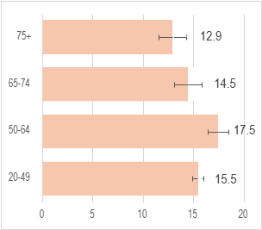

Trends over time
Figure 17.2 shows the incidence of cervical cancer from 1994 to 2022. Incidence increased from 1994 until 2010 (2.0% per year (95%CI: 0.6;3.5)) followed by a subsequent steep decline in incidence from 2010 to 2022 (-3.1% per year (95% CI: -4.9; -1.2)).

Figure 17.2: Age-standardised incidence rate 1994-2022, cervical cancer
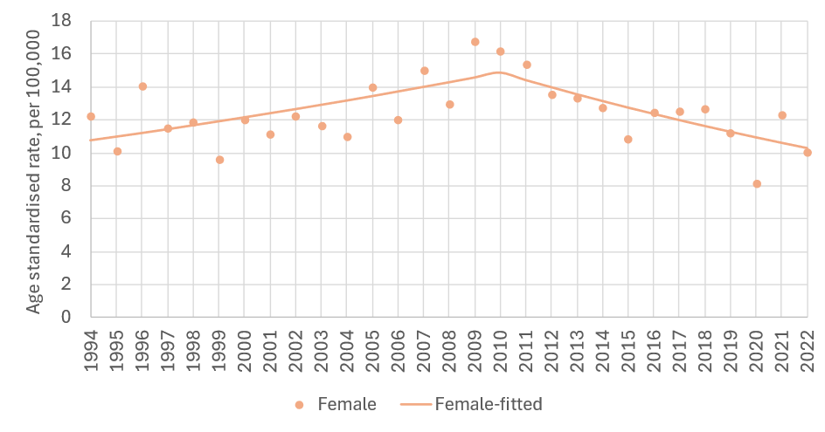
sex |  | period | APC% | 95%CI | trend
F |  | 1994-2010 | 2.0 | 0.6,3.5 | up
 |  | 2010-2022 | -3.1 | -4.8, -1.2 | down

APC%: average annual percentage change in rate over period and 95% confidence interval (95%CI) based on annual data points fitted with Joinpoint regression. Trend: ‘up’=significant increase, ‘down’=significant decrease, ‘flat’=no change (static), at the 95% level.

Variation by deprivation quintile
Age-standardised incidence rates of cervical cancer in 2014-2018 ranged from 9.7 to 17.3 cases per 100,000 in the least deprived to the most deprived quintiles respectively (Figure 17.3).

Figure 17.3: Incidence rate (per 100,000) for cervical cancer by deprivation quintile, 2014-2018
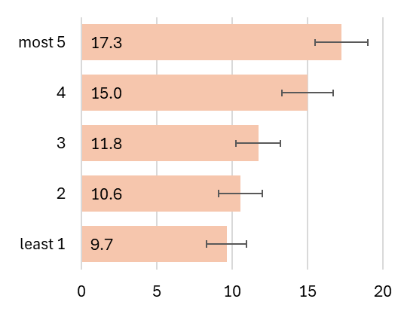

Mortality
Age-standardised mortality rates of cervical cancer during the period 1994-2022 were 4.8 deaths per 100,000 females per year. Figure 17.4 breaks this down further by age group, with rates increasing with increasing age.

Figure 17.4: Mortality rate (per 100,000) for cervical cancer by age group, 1994-2022
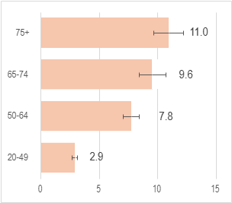

Trends over time
Figure 17.5 shows age-standardised mortality rates for cervical cancer from 1994 to 2010. Mortality rates decreased by -1.3% per year from 1994 -2022 (95%CI: -1.8; -0.7)).

Figure 17.5 Age-standardised mortality rate 1994-2022, cervical cancer
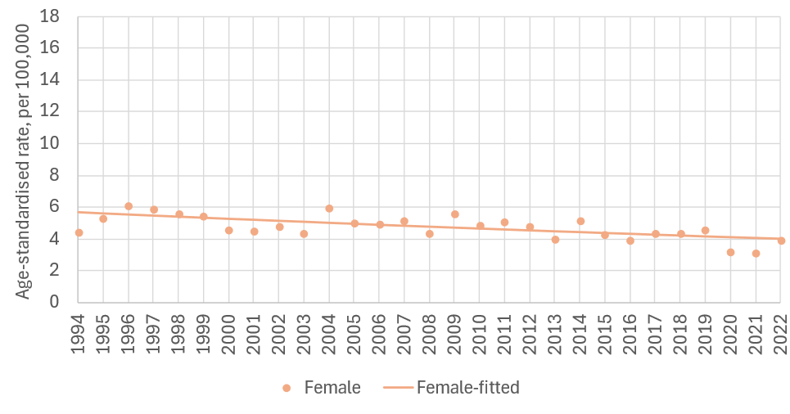
sex | period | APC% | 95%CI | trend
F | 1994-2022 | -1.3 | -1.8, -0.7 | down

APC%: average annual percentage change in rate over period and 95% confidence interval (95%CI) based on annual data points fitted with Joinpoint regression. Trend: ‘up’=significant increase, ‘down’=significant decrease, ‘flat’=no change (static), at the 95% level.

Survival
For cervical cancer 5-year net survival was 65% for cases diagnosed during 2019-2022 (Figure 17.6); this was unchanged from the estimate for the 2014-2018 period.

Figure 17.6: Age-standardised 5-year net survival (%) for cervical cancer over six consecutive diagnosis periods
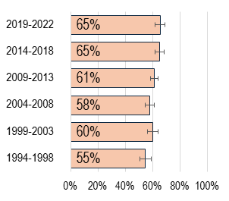

Population Attributable Fraction
In 2022, 257 cases of cervical cancer were recorded. The estimated total number of cervical cancer cases attributable to smoking in Ireland in 2022 was 52 (PAF 20.3%). Table 17.1 presents the cervical cancer incidence related to smoking. The PAF for cervical cancer among females was 20.3%

Table 17.1: Population attributable fraction and attributable cases for cervical cancer in 2022
 | Females
PAF (%) | 20.3
Total cases | 257
Attributable cases | 52

Ovary (mucinous) C56-57, C48
Key points
Incidence
- Age-standardised incidence rates increased from 1998-2022.
- Age-standardised incidence rates for mucinous ovarian cancer in 2014-2018 were similar across quintiles of deprivation.
Mortality
- CSO mortality data does not provide mortality figures at the tumour morphological level therefore mortality trends are not presented.
Survival
- 5-year net survival was 70% for cases diagnosed during 2019-2022.
Population attributable fraction
- In 2022, the estimated total number of cases of ovarian (mucinous) cancer attributable to smoking in Ireland was 5 (PAF 20.3%).

Incidence
Between1994-2022, 431 cases of mucinous ovarian cancer were recorded. Median age at diagnosis was 55 years (IQR: 43-67). On average during the period 1994-2022 the age-standardised incidence rate of ovarian cancer was 0.8 cases per 100,000 females. Figure 18.1 breaks this down further by age group.

Figure 18.1: Incidence rate (per 100,000) for mucinous ovarian cancer by age group,1994-2022
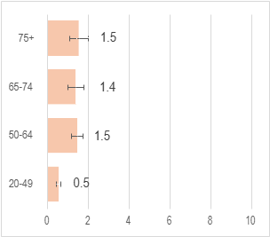

Trends over time
Figure 18.2 shows the incidence of mucinous ovarian cancer from 1994 to 2022. Incidence rates increased by 3.4% (95%CI 1.9; 4.8) per year from 1998-2022.

Figure 18.2: Age-standardised incidence rate 1994-2022, ovarian (mucinous) cancer
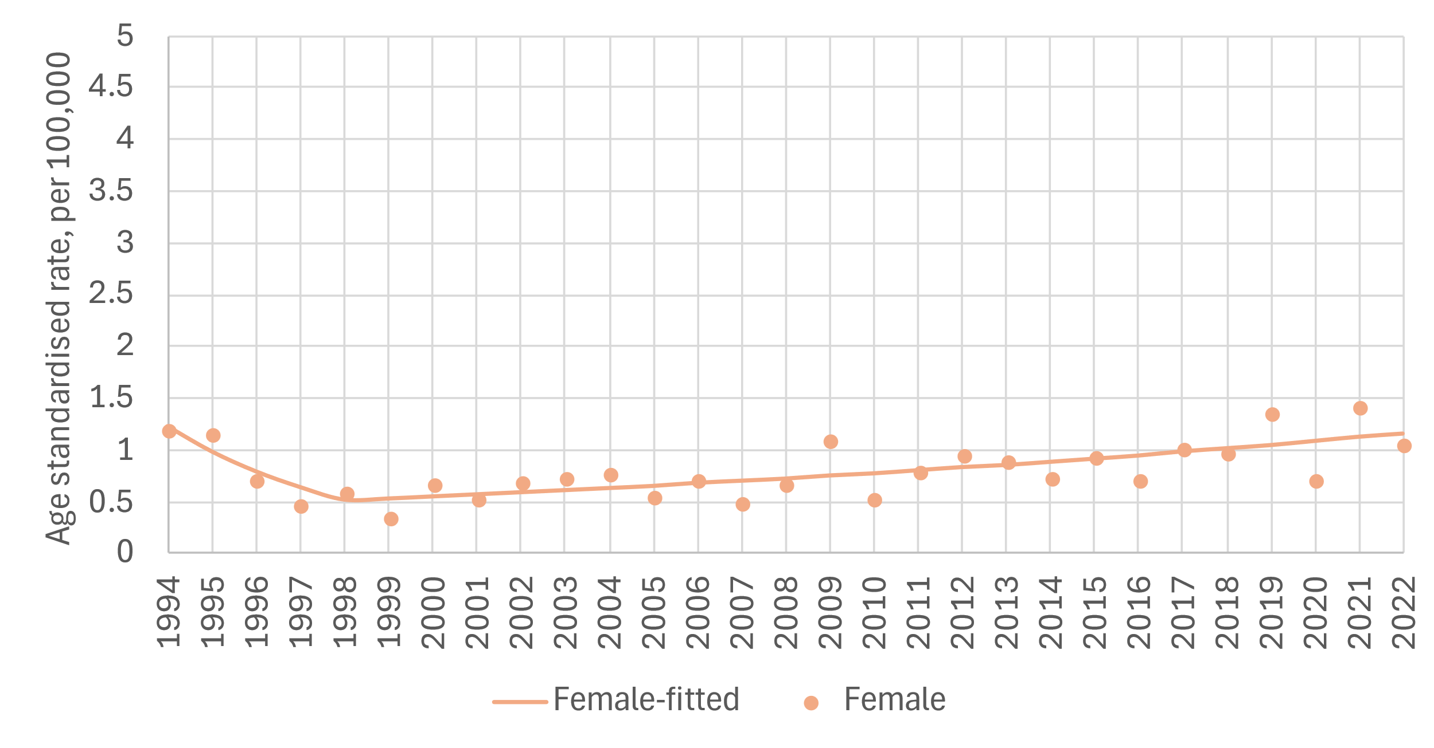
sex | period | APC% | 95%CI | trend
F | 1994-1998 | -19.1 | -37.5, 4.8 | flat
F | 1998-2022 | 3.4 | 1.9, 4.8 | up

APC%: average annual percentage change in rate over period and 95% confidence interval (95%CI) based on annual data points fitted with Joinpoint regression. Trend: ‘up’=significant increase, ‘down’=significant decrease, ‘flat’=no change (static), at the 95% level.

Variation by Deprivation
Age-standardised incidence rates for mucinous ovarian cancer in 2014-2018 were similar across quintiles of deprivation: 0.7 cases per 100,000 females in the least deprived quintile and 1.0 case per 100,000 females in the most deprived (Figure 18.3).

Figure 18.3: Incidence rate (per 100,000) for ovarian (mucinous) cancer by deprivation quintile, 2014-2018
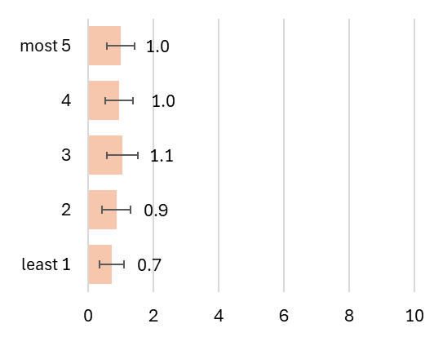

Mortality
CSO mortality data does not provide mortality figures at the tumour morphological level therefore mortality trends are not presented.

Survival
For mucinous ovarian cancer in Ireland overall 5-year net survival was 70% for cases diagnosed during 2019-2022 (Figure 18.4).

Figure 18.4: Age-standardised 5-year net survival (%) for ovarian (mucinous) cancer over six consecutive diagnosis periods
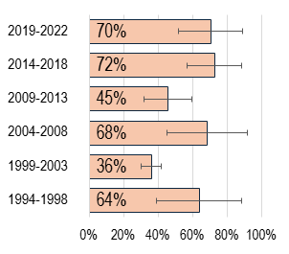

Population Attributable Fraction
In 2022, 25 cases of mucinous ovarian cancer were recorded. The estimated total number of mucinous ovarian cancer cases attributable to smoking in Ireland in 2022 was 5 (PAF 20.3%). Table 18.1 presents cancer incidence related to smoking. The PAF for mucinous ovarian cancer among females was 20.3%.

Table 18.1: Population attributable fraction and attributable cases for ovarian (mucinous) cancer in 2022
 | Females
PAF (%) | 20.3
Total cases | 25
Attributable cases | 5

Kidney C64-66, C68
Key points Kidney
Incidence
- Age-standardised incidence rates in both sexes increased from 1994-2016 and subsequently declined from 2016-2022.
- Incidence rates in the diagnosis period 2014-2018 were lowest in the least deprived population quintile.
Mortality
Age-standardised mortality rates increased from 1994-2022 in males and females.
Survival
- 5-year net survival was 69% for cases diagnosed during 2019-2022.
Population attributable fraction
- In 2022 the estimated total number of cases of kidney cancer attributable to smoking in Ireland was 105 (PAF 13.2%).

Incidence
Between 1994-2022, 15,079 cases of kidney cancer were recorded (9,622 males, 5,457 females). Median age at diagnosis was 66 years (IQR: 56-75) for males and 68 (IQR: 57-77) for females. On average during the period 1994-2022 the age-standardised incidence rate of kidney cancer was 22.7 cases per 100,000 males and 11.2 cases per 100,000 females per year. Figure 19.1 breaks this down further by sex and age group.

Figure 19.1: Incidence rate (per 100,000) for kidney cancer by age group,1994-2022
Total | Males | Females
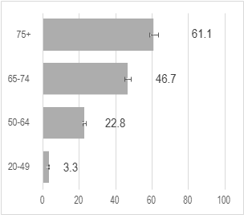 | 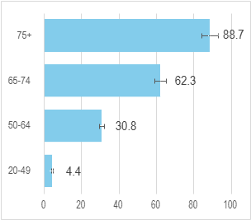 | 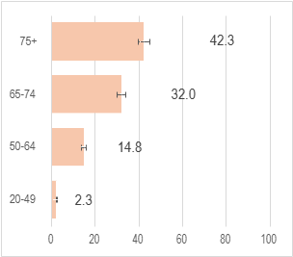

Trends over time
Figure 19.2 shows age-standardised incidence of kidney cancer from 1994 to 2022. In females there was an increase in incidence from 1994 to 2016 (3.1% per year (2.6;3.7)) followed by a decrease from 2016 to 2022 (-3.2% (-6.0; -0.4). Similarly, among males there was an increase in incidence from 1994 to 2016 (2.7% per year (2.1;3.3)) followed by a decrease from 2016 to 2022 (-3.9% (-6.9; -0.9)).

Figure 19.2: Age-standardised incidence rate 1994-2022, kidney cancer
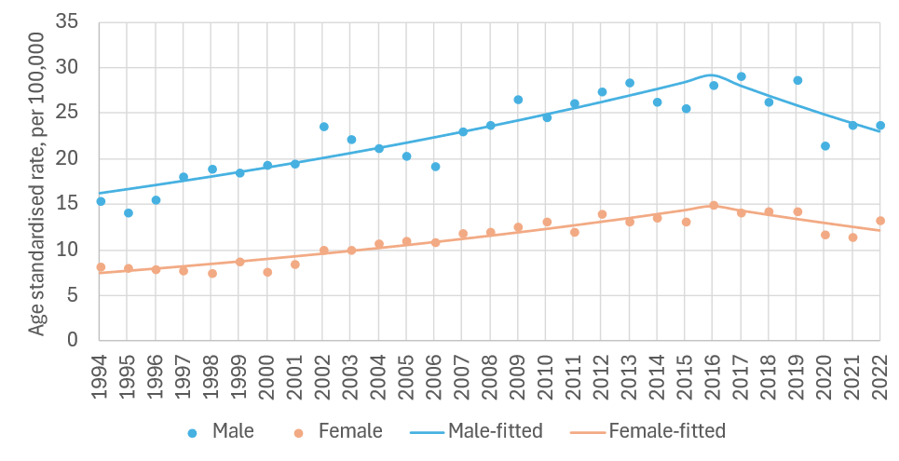
sex | period | APC% | 95%CI | trend | sex | period | APC% | 95%CI | trend
M | 1994-2016 | 2.7 | 2.1, 3.3 | up | F | 1994-2016 | 3.1 | 2.6, 3.7 | up
M | 2016-2022 | -3.9 | -6.8, -0.9 | down | F | 2016-2022 | -3.2 | -6.0, -0.4 | down

APC%: average annual percentage change in rate over period and 95% confidence interval (95%CI) based on annual data points fitted with Joinpoint regression. Trend: ‘up’=significant increase, ‘down’=significant decrease, ‘flat’=no change (static), at the 95% level.

Variation by deprivation quintile
Age-standardised incidence rates of kidney cancer in 2014-2018 were lowest in the least deprived quintile (19.0 cases per 100,000) and higher in the intermediate quintile (21.5 cases per 100,000) (Figure 19.3) with little clear evidence for a socioeconomic gradient in incidence.

Figure 19.3: Incidence rate (per 100,000) for kidney cancer by deprivation quintile, 2014-2018
Total | Males | Females
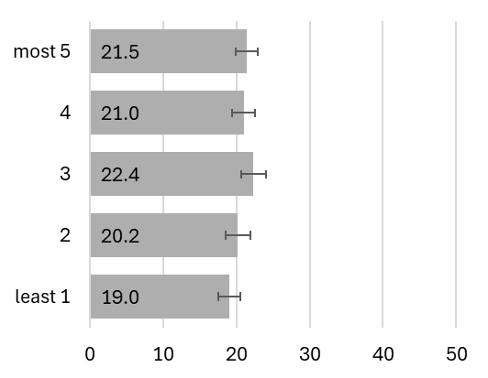 | 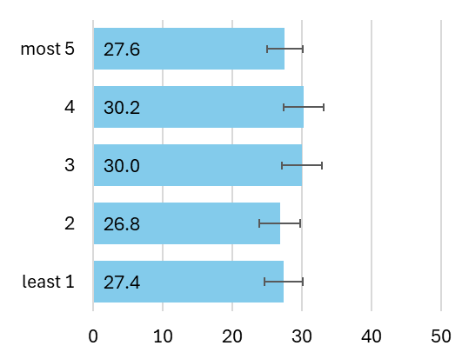 | 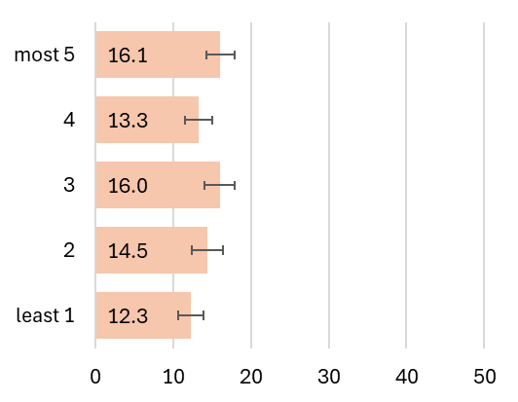

Mortality
Age-standardised mortality rates of kidney cancer during the period 1994-2022 were 10.5 deaths per 100,000 males and 4.5 deaths per 100,000 females per year. Figure 19.4 breaks this down further by sex and age group. Mortality rates increased with increasing age and mortality rates were higher among males compared with females across age groups.

Figure 19.4: Mortality rate (per 100,000) for kidney cancer by age group, 1994-2022
Total | Males | Females
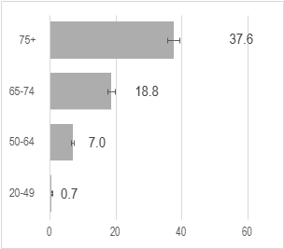 | 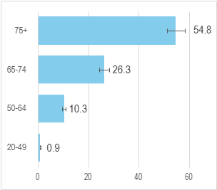 | 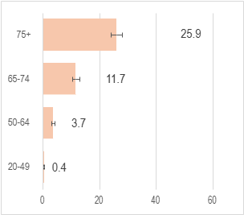

Trends over time
Figure 19.5 shows age-standardised mortality rates for kidney cancer from1994 to 2022. In males there was an increase in mortality from 1994 to 2022 (0.7% per year (0.2;1.3)). Similarly, among females there was an increase in mortality from 1994 to 2022 (0.7% per year (0.1;1.4)).

Figure 19.5: Age-standardised mortality rate 1994-2022, kidney cancer
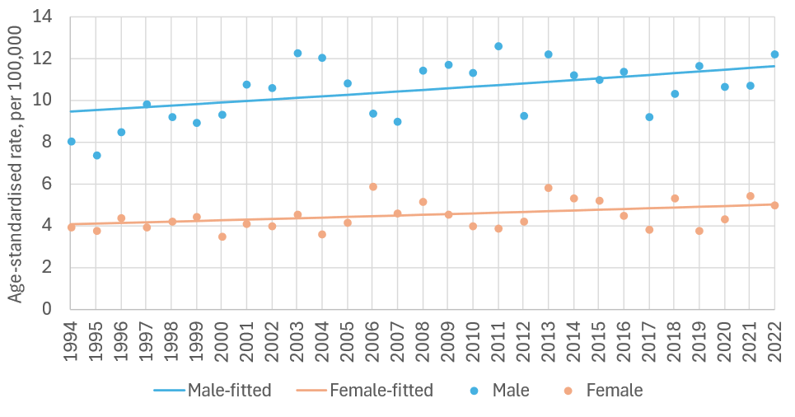
sex | period | APC% | 95%CI | trend | sex | period | APC% | 95%CI | trend
M | 1994-2022 | 0.7 | 0.2, 1.3 | up | F | 1994-2022 | 0.7 | 0.1, 1.4 | up

APC%: average annual percentage change in rate over period and 95% confidence interval (95%CI) based on annual data points fitted with Joinpoint regression. Trend: ‘up’=significant increase, ‘down’=significant decrease, ‘flat’=no change (static), at the 95% level.

Survival
Overall, 5-year net survival for kidney cancer was 69% for cases diagnosed during 2019-2022 (Figure 19.6). Five-year net survival for 2019-2022 was higher (71%) among females than for males (68%). Survival improved steadily across periods in both sexes.

Figure 19.6: Age-standardised 5-year net survival (%) for kidney cancer over six consecutive diagnosis periods
Total | Males | Females
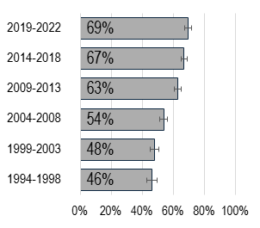 | 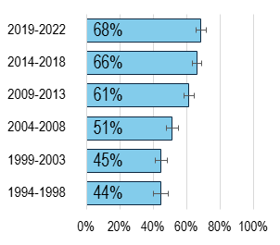 | 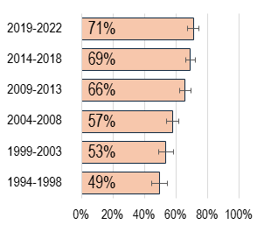

Population Attributable Fraction
In 2022, 798 cases of kidney cancer were reported (498 males, 300 females). The estimated total number of kidney cancer cases attributable to smoking in Ireland in 2022 was 105 (PAF 13.2%). Table 19.7 presents the difference between male and female kidney cancer incidence related to smoking. Males had a higher PAF than females, 13.8% vs 12.1%.

Table 19.7: Population attributable fraction and attributable cases for kidney cancer in 2022
 | Total | Males | Females
PAF (%) | 13.2 | 13.8 | 12.1
Total cases | 798 | 498 | 300
Attributable cases | 105 | 69 | 36

Bladder & Non-Muscle Invasive Bladder Cancer (C67, D090, D414)
Key points
Incidence
- There was no evidence of a significant change in incidence rates in males or females from 1994-2022.
- There was little evidence for significant variation in incidence rates across population quintiles according to deprivation in the diagnosis period 2014-2018.
Mortality
- Age-standardised mortality rates decreased from 1994-2022 in males but were stable in females over the same period.
Survival
- 5-year net survival was 75% for cases diagnosed during 2019-2022.
Population attributable fraction
- In 2022 the estimated total number of cases of bladder cancer attributable to smoking in Ireland was 456 (PAF 47.5%).

Incidence
Between 1994-2022, 19,524 cases of bladder cancer and non-muscle invasive bladder cancer (NMIBC) were recorded (14,102 males, 5,422 females). Median age at diagnosis was 72 years (IQR 63-79) for males and 72 (62-80) for females. On average during the period 1994-2022 the age-standardised incidence rate of bladder cancer in 1994-2022 was 38.4 cases per 100,000 males and 11.2 cases per 100,000 females per year. Figure 20.1 breaks this down further by sex and age group.

Figure 20.1: Incidence rate (per 100,000) for bladder cancer & NMIBC by age group,1994-2022
Total | Male | Females
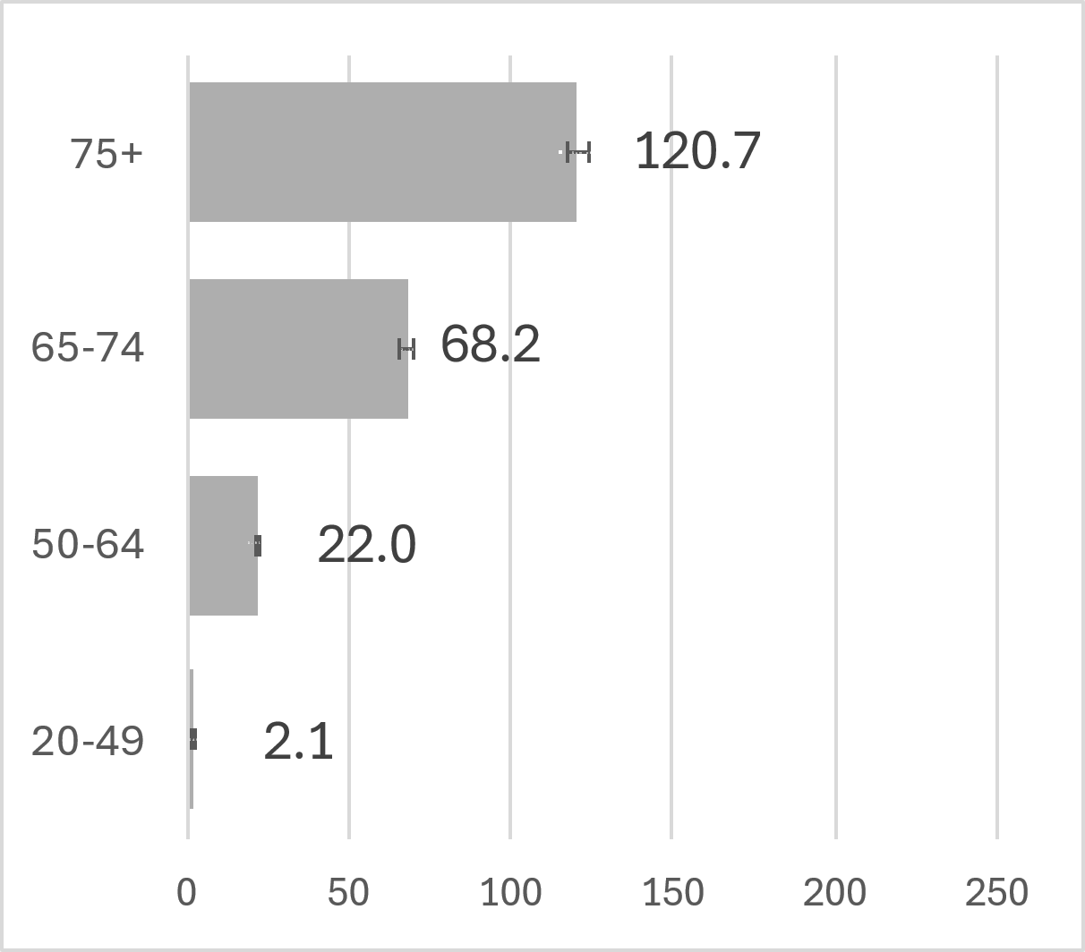 | 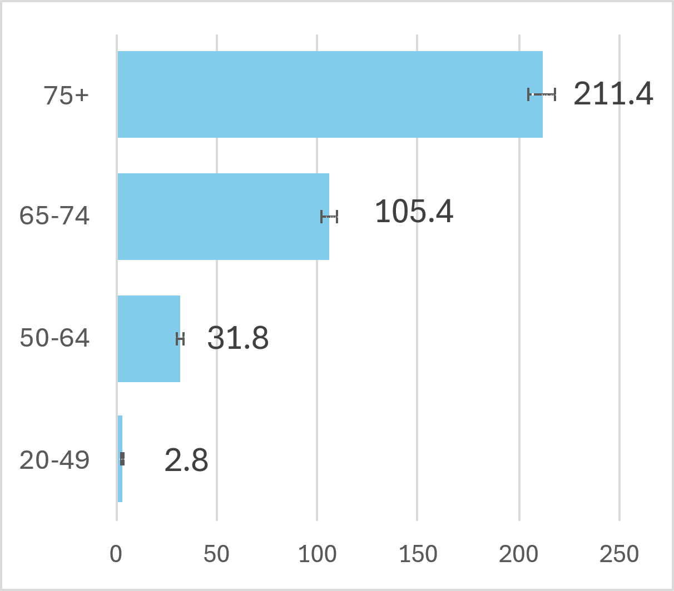 | 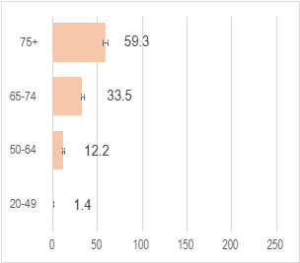

Trends over time
Figure 20.2 shows the incidence of bladder cancer and NMIBC from 1994 to 2022.
Incidence rates were stable from 1994 to 2022 in both males and females.

Figure 20.2: Age-standardised incidence rate 1994-2022, bladder cancer & NMIBC
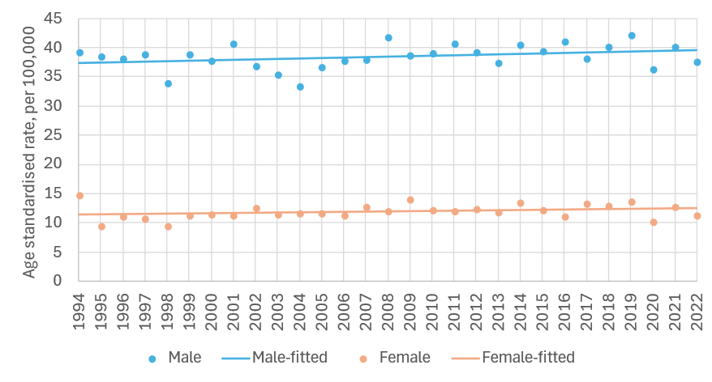
sex | period | APC% | 95%CI | trend | sex | period | APC% | 95%CI | trend
M | 1994-2022 | 0.2 | 0.0, 0.4 | flat | F | 1994-2022 | 0.3 | -0.1, 0.8 | flat

APC%: average annual percentage change in rate over period and 95% confidence interval (95%CI) based on annual data points fitted with Joinpoint regression. Trend: ‘up’=significant increase, ‘down’=significant decrease, ‘flat’=no change (static), at the 95% level.

Variation by deprivation quintile
Age-standardised incidence rates of bladder cancer and NMIBC in 2014-2018 are presented from the least to the most deprived quintiles in Figure 20.3. Incidence rates in the diagnosis period 2014-2018 were lower in the least deprived population quintile (24.8 cases per 100,000 for the least deprived quintile) and higher in the most deprived (27.5 cases per 100,000) but overall, there was little evidence of significant variation across quintiles.

Figure 20.3: Incidence rate (per 100,000) for bladder cancer & NMIBC by deprivation quintile, 2014-2018
Total | Males | Females
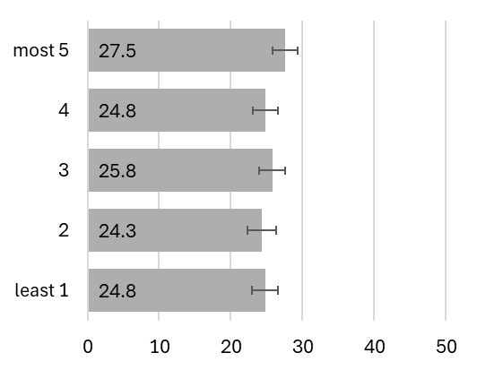 | 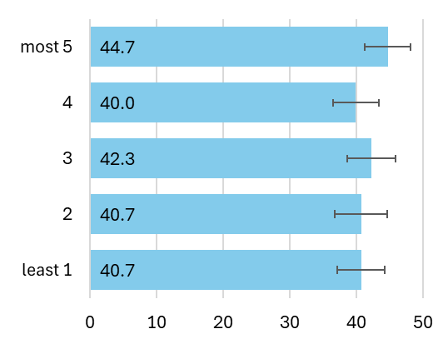 | 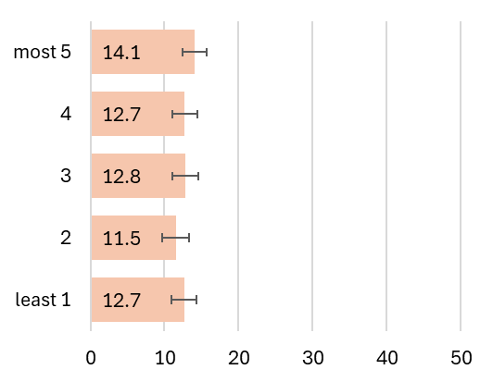

Mortality
Age-standardised mortality rates for bladder cancer during the period 1994-2022 were 12.4 deaths per 100,000 males and 4.2 deaths per 100,000 females per year. Figure 20.4 breaks this down further by sex and age group. Mortality rates were higher among older age groups and among males compared to females.

Figure 20.4: Mortality rate (per 100,000) for bladder cancer by age group, 1994-2022
Total | Males | Females
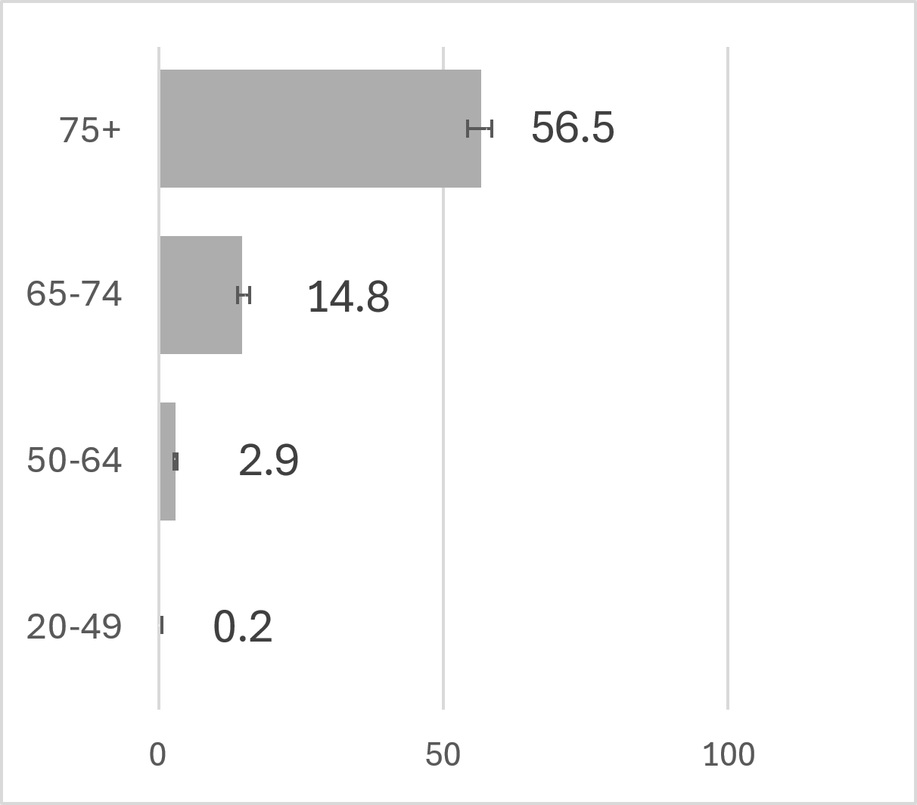 | 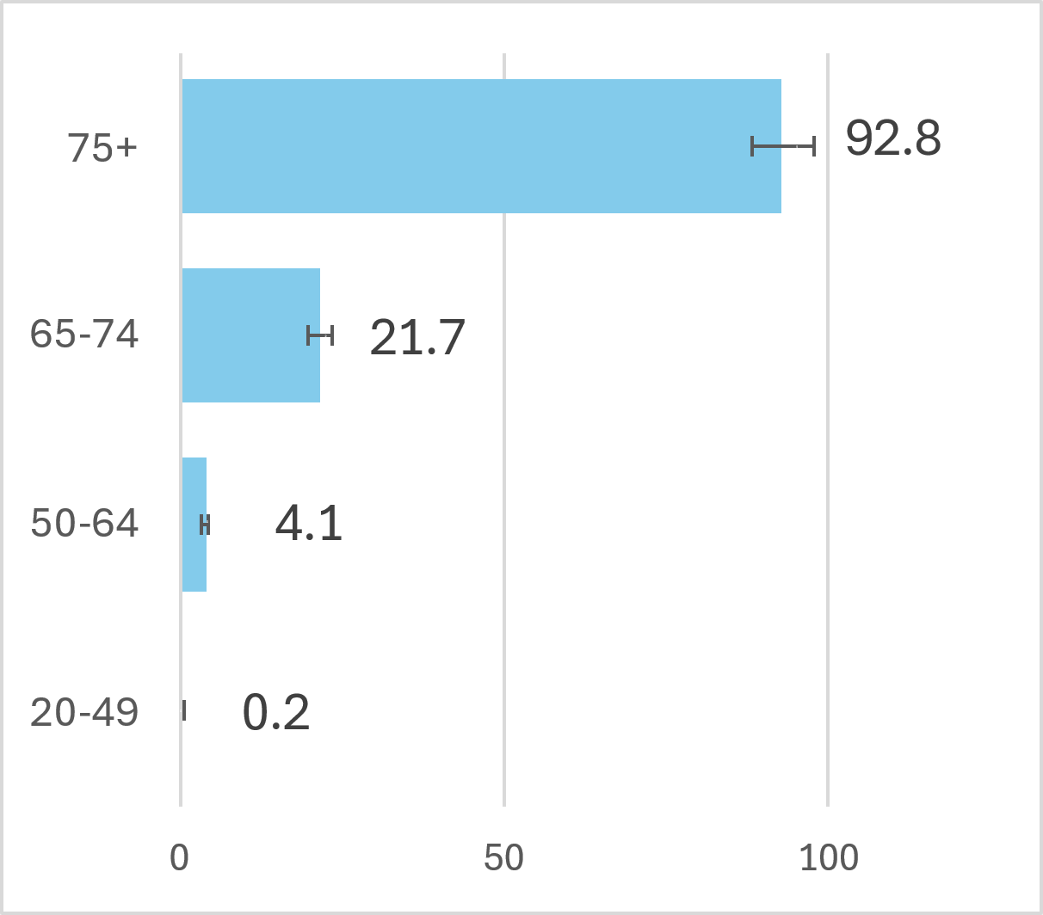 | 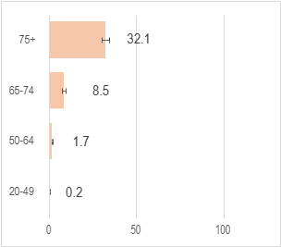

Trends over time
Figure 20.5 shows age-standardised mortality rates for bladder cancer from 1994 to 2022 for males and females. In males there was a decline in mortality rates (APC) from 1994 to 2022 (-1.0% per year (95%CI –1.4; -0.5)). Among females there was no significant change in mortality over time.

Figure 20.5: Age-standardised mortality rate 1994-2022, bladder cancer
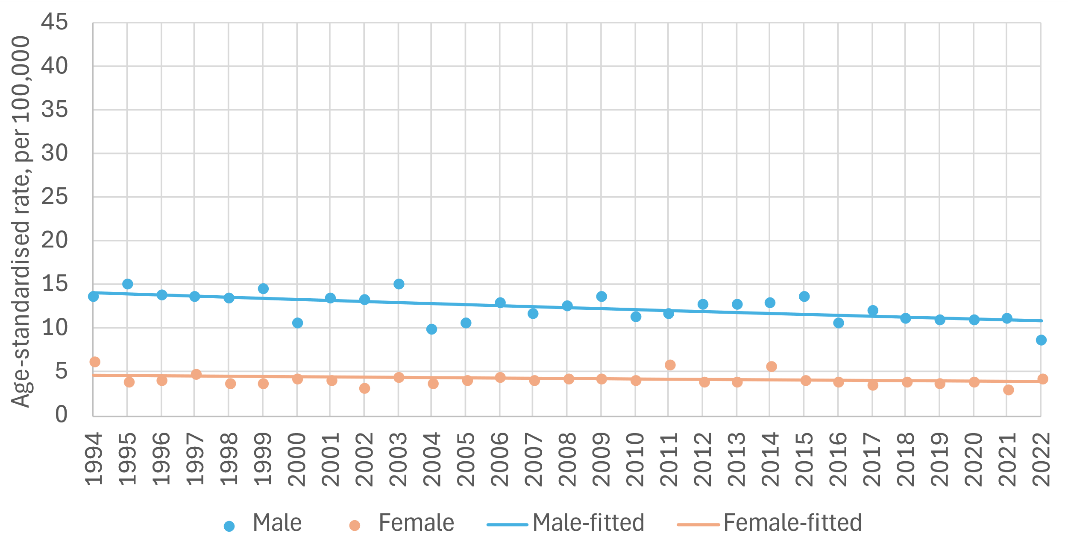
sex | period | APC% | 95%CI | trend | sex | period | APC% | 95%CI | trend
M | 1994-2022 | -1.0 | -1.4, -0.5 | down | F | 1994-2022 | -0.5 | -1.2, 0.2 | flat

APC%: average annual percentage change in rate over period and 95% confidence interval (95%CI) based on annual data points fitted with Joinpoint regression. Trend: ‘up’=significant increase, ‘down’=significant decrease, ‘flat’=no change (static), at the 95% level.

Survival
For bladder cancer & NMIBC in Ireland overall 5-year net survival was 75% for cases diagnosed during 2019-2022 (Figure 20.6). Five-year net survival for 2019-2023 was higher for males (77%) than for females (70%) with survival estimates tending to improve across time periods although the estimate for 2019-2022 was slightly lower than that for the 2014-2018 period.

Figure 20.6: Age-standardised 5-year net survival (%) for bladder cancer & NMIBC over six consecutive diagnosis periods
Total | Males | Females
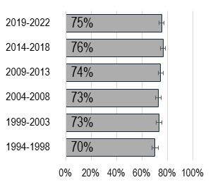 | 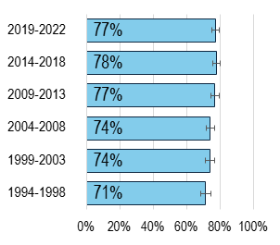 | 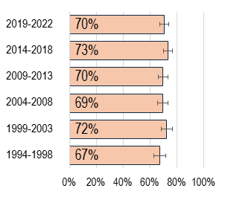

Population Attributable Fraction
In 2022, 962 cases of bladder cancer & NMIBC were reported (714 males, 248 females). The estimated total number of bladder cancer & NMIBC cases attributable to smoking in Ireland in 2022 was 456 (PAF 47.5%). Table 20.1 presents the difference between male and female bladder cancer & NMIBC incidence related to smoking. Males had a higher PAF than females, 48.0% vs 45.9%.

Table 20.1: Population attributable fraction and attributable cases for bladder cancer & NMIBC in 2022
 | Total | Males | Females
PAF (%) | 47.5 | 48.0 | 45.9
Total cases | 962 | 714 | 248
Attributable cases | 456 | 343 | 114

Acute myeloid leukaemia C92.0, C92.4-C92.6, C92.8, C93.0, C94.0, C94.2

Key points
Incidence
- Incidence rates increased among males but were stable in females from 1994-2022.
- Incidence rates in the diagnosis period 2014-2018 were lowest in the intermediate population quintile of deprivation.
Mortality
- It was not possible to generate data on mortality rates nor trends over time for AML. AML is defined by its morphology type i.e. it is a subset of ICD10 C92. The CSO does not quote mortality figures for AML as a single entity.
Survival
- 5-year net survival was 32% for cases diagnosed during 2019-2022.
Population attributable fraction
- In 2022 the estimated total number of cases of AML attributable to smoking in Ireland was 29 (PAF 20.7%).

Incidence
From 1994-2022, 3,181 cases of acute myeloid leukaemia (AML) were recorded (1,768 males, 1,413 females). Median age at diagnosis was 66 years (IQR: 51-76) for males and 63 (IQR: 43-76) for females. On average during the period 1994-2022 the age-standardised incidence rate of AML in 1994-2022 was 4.2 cases per 100,000 males and 2.8 cases per 100,000 females per year. Figure 21.1 breaks this down further by sex and age group.

Figure 21.1: Incidence rate (per 100,000) for Acute Myeloid Leukaemia by age group,1994-2022
Total | Males | Females
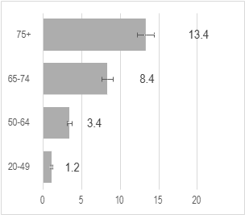 | 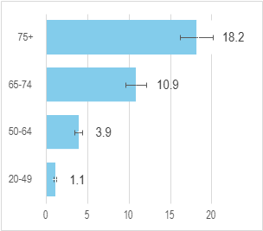 | 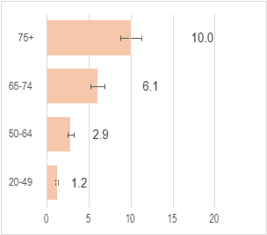

Trends over time
Figure 21.2 shows the incidence of AML cancer from 1994 to 2022. Incidence increased for males from 1994 to 2022 (0.7 % increase per year (95%CI 0.2; 1.3)). Among females, incidence rates remained static.

Figure 21.2: Age-standardised incidence rate 1994-2022, Acute Myeloid Leukaemia
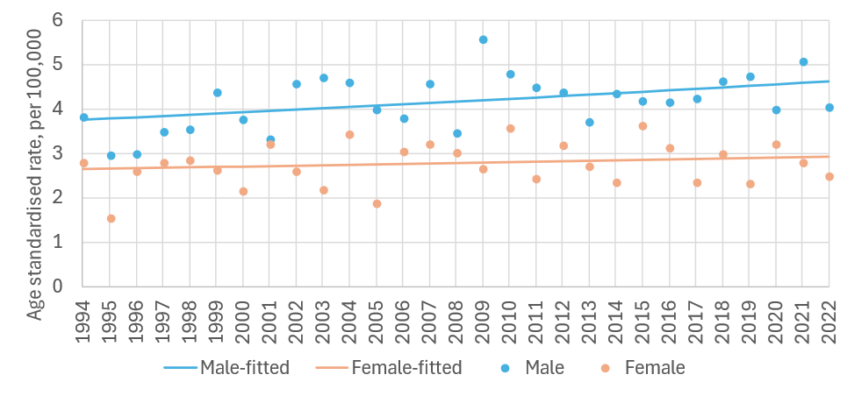
sex | period | APC% | 95%CI | trend | sex | period | APC% | 95%CI | trend
M | 1994-2022 | 0.7 | 0.2, 1.3 | up | F | 1994-2022 | 0.4 | -0.5, 1.2 | flat

APC%: average annual percentage change in rate over period and 95% confidence interval (95%CI) based on annual data points fitted with Joinpoint regression. Trend: ‘up’=significant increase, ‘down’=significant decrease, ‘flat’=no change (static), at the 95% level.

Variation by deprivation quintile
Age-standardised incidence rates of AML in 2014-2018 were 4.1 per 100,000 in the least deprived quintile and 3.9 in the most deprived quintile with the lowest prevalence in the intermediate quintile (2.9 per 100,000). Overall incidence rates were similar across quintiles with similar patterns evident among males and females (Figure 21.3).

Figure 21.3: Incidence rate (per 100,000) for Acute Myeloid Leukaemia by deprivation quintile, 2014-2018
Total | Males | Females
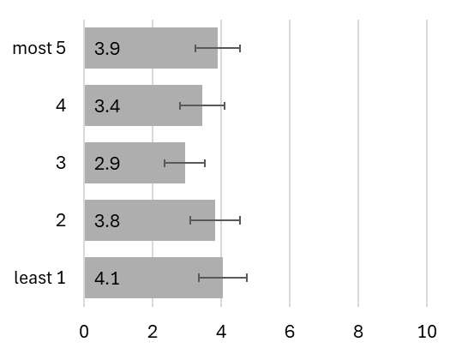 | 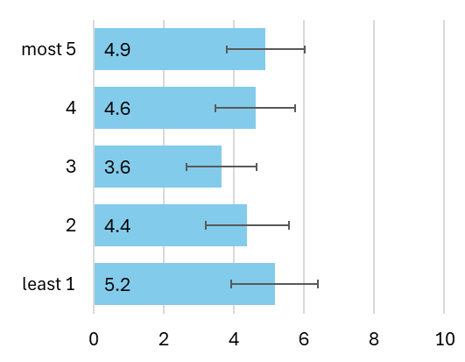 | 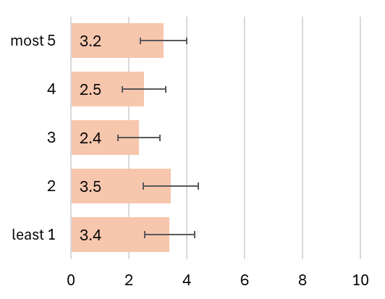

Mortality
It was not possible to generate data on mortality rates nor trends over time for AML. AML is defined by its morphology type i.e. it is a subset of ICD10 C92. The CSO does not quote mortality figures for AML as a single entity.

Survival
For AML cancer in Ireland overall 5-year net survival was 32% for cases diagnosed during 2019-2022 (Figure 21.4). This estimate was five percentage points higher than the survival rates seen in 2014-2018 period. 5-year net survival for 2019-2023 was higher for females (37%) than for males (28%).

Figure 21.4: Age-standardised 5-year net survival (%) for Acute Myeloid Leukaemia over six consecutive diagnosis periods
Total | Males | Females
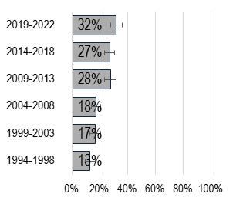 | 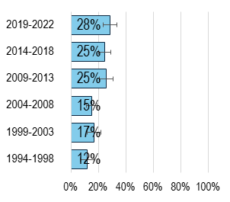 | 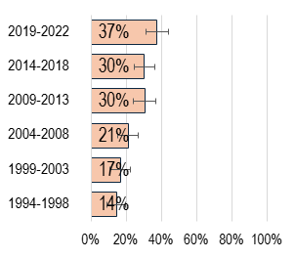

Population Attributable Fraction
In 2022, 140 cases of AML were reported (83 males, 57 females). The estimated total number of AML cases attributable to smoking in Ireland in 2022 was 29 (PAF 20.7%). Table 20.1 presents the difference between male and female AML incidence related to smoking. Males had a higher PAF than females, 21.8% vs 19.2%.

Table 21.1: Population attributable fraction and attributable cases for AML in 2022
 | Total | Males | Females
PAF (%) | 20.7 | 21.8 | 19.2
Total cases | 140 | 83 | 57
Attributable cases | 29 | 18 | 11

Discussion
This is the first report to comprehensively examine the burden of tobacco-related cancers in Ireland. This report shows that despite declines in smoking prevalence, tobacco use remains a major cause of cancer in Ireland. There is a lag between changes in smoking prevalence and changes in tobacco-related cancer incidence and mortality. Ireland has a rapidly growing and ageing population. Projections indicate that the number of people aged 65+ years will double to 1.6 million by 2051(59) while cancer incidence rates will double by 2045.(60,61) These trends further underscore the importance of advancing progress on control of modifiable risk factors for cancer, including tobacco-smoking, to achieve cancer control in Ireland.

This report found that trends in age-standardised incidence and mortality rates for most tobacco-related cancers were declining or stable. Five-year net survival improved across most cancer types examined. However, even though these trends are moving in a positive direction, the effects of historically high smoking prevalence will continue to be observed for some time as health impacts often take years to manifest. This ongoing impact was evident in the number and proportion of new cancers attributable to tobacco smoking in 2022. An estimated 3,756 cases, or 14.7% of new invasive cancer cases, could have been prevented in 2022 in the absence of tobacco-smoking. This burden is not borne equally with evidence of socioeconomic and gender disparities in cancer incidence. The findings of this report have important implications for cancer and tobacco control policies in Ireland.

Incidence and Mortality
We examined trends in tobacco-related cancers from 1994 to 2022 during which 305,914 cases of tobacco-related cancers were diagnosed and 160,952 deaths from tobacco-related cancers were recorded. While trends in age-standardised incidence and mortality for most tobacco-related cancers were declining or stable, this group of malignancies continue to pose a major public health burden. Tobacco-related cancers include those with high annual incidence (e.g. head and neck cancer in men), high mortality (e.g. oesophageal cancer and pancreatic cancer) or both (e.g. lung cancer, colorectal cancer, female breast cancer).(62) Across these cancers, reducing tobacco smoking at population level must remain a key primary prevention measure.(63)

Lung cancer
Lung cancer remains the leading cause of cancer mortality among men and women in Ireland, responsible for approximately one in five cancer deaths on average between 2020 and 2022.(62) Lung cancer incidence and mortality decreased across the entire period examined for males, but both incidence and mortality increased among females until 2015 and 2016 respectively, before the onset of a decline. These findings align with the ‘Lopez curve’ which is used internationally to describe the stages of the tobacco epidemic.(13) Differing trends according to sex likely reflect a cohort effect i.e. peak uptake of tobacco smoking among women followed decades after peak uptake among men, therefore the peak in tobacco-related female morbidity and mortality (in this case from lung cancer) also occurs decades later than for males.(13) These findings are similar to those recently described in the UK where age-standardised lung cancer incidence among women is beginning to plateau while corresponding mortality trends are only recently starting to decline.(64)

Head and Neck Cancers
Cancers of the head and neck are the fifth most common cancer type among men in Ireland.(62) Of the six head and neck cancers, five are tobacco related. Incidence rates increased for cancers of the oral cavity and pharynx, with an upward trend also observed for nasopharyngeal cancer in women. In contrast, incidence rates were stable for sinonasal cancer, laryngeal cancer and nasopharyngeal cancer in men. Internationally incidence of cancers of the head and neck is increasing – a trend largely driven by increases in oropharyngeal cancer.(65) Across cancers of the head and neck, risk factors are similar but the magnitude of risk associated with tobacco smoking varies – being greatest for laryngeal cancer.(65) Alcohol consumption and high-risk HPV infection are major additional risk factors for oropharyngeal cancer.(65) In males decreasing trends in incidence for oral cavity cancer and pharyngeal cancer were seen from 1994 until the early 2000s before a significant increase. The initial decline and subsequent increase in incidence of pharyngeal cancer may reflect differential exposures according to birth cohort as has been described in the UK – with decreasing exposure to tobacco and increased exposure to HPV in later born cohorts.(66) While trends in incidence of the tobacco-related head and neck cancers tend to mirror those seen internationally, declining or stable mortality rates in Ireland contrast with UK and global trends of increasing mortality.(65)

Gastrointestinal cancers
Five major types of gastrointestinal cancer are tobacco-related: colorectal, oesophageal, pancreatic, stomach and liver cancer.(63) Incidence rates were stable or decreasing across cancer types except for liver cancer and oesophageal adenocarcinoma in women. Where mortality trends could be calculated, trends were downward or stable except for liver cancer. Globally liver cancer incidence and mortality are increasing. In general, Irish trends are in line with global trends whereby the incidence of some types of gastrointestinal cancer has decreased.(63) However, this group of malignancies continues to pose an important public health challenge. The importance of primary prevention measures to control these malignancies including reducing tobacco use has been emphasised.(63)

Cervical Cancer
Cervical cancer incidence rates increased until 2010 followed by a period of steep decline after the introduction of the national cervical cancer screening programme in 2008. Mortality rates decreased for cervical cancer across the period examined. These trends are in line with those previously described in Ireland(67,68) and in keeping with expected trends where a screening programme is in place.(67) Tobacco smoking may increase the risk of acquisition and/or persistence of HPV infection(28) which is the cause of most cervical cancer. Notably, the WHO recommends that as part of a comprehensive elimination strategy primary prevention strategies should include a focus on smoking cessation.(69) Ireland has committed to the WHO goal of cervical cancer elimination by 2040, to be achieved via promotion of high uptake of cervical screening, HPV vaccination in adolescence and improved cervical cancer diagnosis and treatment.(70)

Variation in incidence according to deprivation
Tobacco use is a strong indicator of health inequality and has been estimated to account for up to half of the socioeconomic gradient in health.(12,14) There was a clear socioeconomic gradient in the incidence of tobacco-related cancers combined. Those living in the most deprived areas had higher incidence rates of tobacco-related cancers compared with those living in the least deprived areas. Considering individual cancer types, there was a clear socioeconomic gradient in incidence with increasing rates among more disadvantaged groups, most notably for lung, laryngeal and cervical cancer. For example, lung cancer incidence rates varied from 62.6 to 99.2 cancer cases per 100,000 in the least deprived to most deprived quintiles respectively. This gradient was even more pronounced for males among whom rates varied from 75.4 per 100,000 in the least deprived to 116.2 in the most deprived. Though less steep, the gradient was also present among females. These findings add to those of the 2023 NCRI report which highlighted similar variation across quintiles.(71) Similar inequalities in tobacco-related cancers according to socioeconomic indicators have also been described in England,(72) Scotland(73) and the US.(74) In England and Scotland, the socioeconomic gradient in incidence was also greatest in cancers of the lung and larynx.(72,73) Some cancer types however, showed less variation in incidence by deprivation while the highest incidence of breast cancer was seen in the least deprived.(71)

Survival
In general, five-year net survival has improved since the 1990s across most tobacco-related cancers. The cancers with the highest five-year net survival were breast cancer (87%) and mucinous ovarian cancer (70%) followed by kidney cancer (69%). It is notable however, that tobacco-related cancers include several cancer types for which there is generally poor five-year net survival including lung cancer (25%), oesophageal cancer (oesophageal squamous cell carcinoma (22%) and oesophageal adenocarcinoma (25%)), liver cancer (16%) and pancreatic cancer (15%). Smoking after a cancer diagnosis can significantly worsen survival outcomes, increase risk of mortality and raise the likelihood of developing a secondary cancer.(27) In contrast, quitting smoking at the time of, or soon after, diagnosis has been demonstrated to improve survival including for mucinous ovarian and lung cancer, as well as for cancers of the head and neck.(27,75)

The most recent comprehensive international survival comparisons were provided by the international consortium CONCORD for the diagnostic period 2010 to 2014.(76,77) Among the four tobacco-related tumour types for which Ireland did not rank in the top half of European countries surveyed (colon, breast, cervical, ovarian), survival rates have since improved. Lung cancer survival – the cancer associated with the highest number of cancer deaths – has increased to 25% in the most recent period. This compares favourably to recent estimates of 21% from England in 2016 to 2020.(78)

Sex
Similar to trends seen internationally,(79) the greatest burden of smoking-related cancers in Ireland was observed in males, as evidenced by higher incidence and mortality rates across most cancer types examined. For example, for tobacco-related cancers of the head and neck, newly diagnosed cases in males tended to outnumber those in females by a ratio of approximately 3 to 1. While in general cancer incidence and mortality rates in tobacco-related cancers are higher among males, smoking increases the risk of three sex-specific cancers in females i.e. female breast, ovarian (mucinous) and cervical cancers. Although the relative increased risk associated with smoking is modest for each of the female specific cancers, this risk is in addition to the risk of developing the other tobacco-related cancers and to other gender-specific health effects of tobacco-smoking such as those on reproductive health. Further, the median age at diagnosis for these cancers is substantially lower than those for the other cancer types examined in females.

Population attributable fraction
This report provides evidence that a large burden of cancer in Ireland could be avoided if tobacco use was eliminated. In 2022, 3,756 or 14.7% of new invasive cancer cases in Ireland were attributable to tobacco smoking. Lung cancer accounted for the highest number of smoking-attributable cases in both men and women, with 74.8% of cases in men (1,066/1,426) and 71.7% in women (944/1,316) linked to smoking. Similarly, high proportions of invasive cancers were attributable to tobacco smoking for bladder cancer (48% for males (343/714) and 45.9% females (114/248)) and laryngeal cancer (26.3% for males (86/326) and 23.4% for females (71/302)).

The estimates for the total PAF for tobacco-smoking in Ireland are in line with other recent international estimates.(53,54,73,80,81) For example, the PAF for incident cancer cases for Norway between 2016-2020 was 16.6% (20.3 % for men and 13.1% for women).(53) In Denmark the equivalent estimate for 2018 was 14.6% (16% for men and 13.1% for women).(54) The proportion of cases attributable to smoking in Switzerland on average between 2015-2019 was 14.1% (17.1% for males and 10.9% for females).(80) With respect to individual cancer types similar proportions have also been reported internationally, for example for Scotland the overall PAF for smoking for lung cancer was 75% between 2015-2019 (76% male and 74% females).(73)

The estimate for the PAF for tobacco smoking was slightly higher than the estimate for 2016 (14.7% in 2022 relative to 13% in 2016).(33) Differing estimates may be due to methodological variations for example the inclusion of breast cancer as a tobacco-related cancer, in addition to differing sources of estimates of relative risks and morphological codes employed.(81,82)

Strengths and limitations
In any report examining trends in cancer across extended time periods, it is important to be cognisant of the potential impact of changes in coding and reporting practices over time.
The estimates of PAF provided should be considered conservative. While the methods to estimate the PAF are in line with previous studies both nationally and internationally, more advanced methods which additionally consider smoking initiation, intensity and duration may have produced less conservative estimates of PAF.(29,79) However, consistency in methodological approaches with prior reports facilitates comparison with earlier Irish estimates and with European counterparts. Recently groups from Switzerland, Norway, and Denmark have published using similar methods.(53,54,80)

Further, this report has focused on tobacco-smoking. It has not considered risk associated with use of other tobacco product types (e.g. smokeless tobacco)(83) or considered the impact on cancer incidence associated with other modifiable risk factors – which in some cases may be synergistic with tobacco smoking.(33) Additionally, we used area-level measures in considering variation in incidence according to deprivation. Using individual-level socioeconomic indicators may produce different findings.(71)

Individual-level smoking data is not available in the NCRI dataset. The estimates of smoking exposure were from the nationally representative Healthy Ireland 2015 survey leaving a seven-year lag from exposure to incidence. In general, the literature suggests the use of a 10-year lag.(52,58) However, where exposure data are not available at a ten-year interval, the most recent reliable and representative exposure estimates are generally used.(33,54) Where smoking prevalence is decreasing, as in the case of Ireland, use of exposure data with a shorter lag will likely underestimate the impact of tobacco-smoking on cancer incidence.(54) Therefore, these estimates are likely to be conservative.

The known impact of the COVID-19 pandemic on cancer case counts may have affected estimates of trends in incidence and it is important to continue monitoring these trends in coming years. It should be noted however, that the estimates presented herein were derived using conservative methods less likely to be influenced by pandemic variation.

Strengths of this study include the comprehensive nature of the report. This is the first report to systematically examine tobacco-related cancers in Ireland across a range of key indicators of cancer control at population-level including incidence, mortality and survival. Additionally, this report describes tobacco-related cancers according to key indicators of equity including sex and area-level deprivation. This reports also expands information available on population-level control of less common cancers. Key strengths include use of exposure data from a nationally representative survey with high participation rates, and complete and high-quality cancer data from the NCRI.

Policy implications
This report has shown that a large burden of cancer in Ireland could be avoided if smoking was eliminated. Ireland was one of the first countries in the world to set a tobacco endgame goal to reduce smoking prevalence to <5% by 2025 thereby effectively aiming to eliminate tobacco use.(46) Overall, however, progress towards achieving this target has slowed with smoking prevalence stalled at 17%. Failure to meet the endgame goal is important as many new cancer cases would have been prevented over the coming decades if the targeted reductions in the prevalence of tobacco smoking were achieved.(5,84) A 2020 NCRI report estimated that if the endgame goal were to have been achieved by 2025 this would have resulted in 1,097 fewer cancers in 2035.(33)

Tobacco Control
Despite having had an endgame target in place since 2013, a recent international analysis suggested that with smoking prevalence above 15% and as yet still incomplete implementation of the recommendations of the WHO Framework Convention on Tobacco Control (FCTC) Ireland should be considered as part of a group of countries which are ‘almost’ endgame ready.(85) Ireland ranked behind countries such as the UK and Brazil in endgame measures.(85) While the prevalence of smoking has decreased in recent decades, due to population growth the absolute number of people who smoke remains high. The WHO emphasises the need for stronger action to combat the tobacco epidemic. Without such action, the burden of tobacco-related cancer will continue to be substantial in the coming decades, reflecting the latency between tobacco-smoking and cancer.

The WHO provide clear, evidence-based policies which set out effective user-focused, product-focused and supply-focused measures to better enable tobacco-control.(43,86) Further innovative ‘endgame’ measures including reducing tobacco product nicotine content and phasing out tobacco sales have high levels of support among the Irish population.(87) If implemented, such measures would build on important legislative change such as increasing the age limit for sale of tobacco to 21.(88)

Cancer Control
The findings of this report underscore the centrality of tobacco-control to cancer control in Ireland. The current National Cancer Strategy published in 2017 committed to the tobacco endgame target. This target was endorsed at European level in 2021 as part of Europe’s Beating Cancer Plan. The development of any new national cancer strategy must be used to commit to accelerating efforts to achieve the tobacco endgame in Ireland. Further, service measures such as improving provision and uptake of existing evidence‐based smoking cessation support (and ensuring these are responsive to the needs of vulnerable populations) should be a focus of investment.

Tackling health inequalities
This report highlights inequalities in tobacco-related cancer incidence by sex and area-level socioeconomic deprivation. These disparities generally mirror disparities in cigarette smoking prevalence by gender and socioeconomic position. The National Cancer Strategy placed tackling inequalities in incidence and survival at the heart of cancer control policy. Such inequalities may also be effectively targeted through accelerated efforts to advance tobacco control. The evidence base supports a pro-equity effect for price increases on tobacco products and targeted smoking cessation support.(89) Further, inequalities in tobacco-smoking and cancer incidence by sex highlight the need for gender-specific – and indeed ‘gender responsive’ - smoking prevention and smoking cessation strategies as advocated for in the European region by the WHO.(12,13)

Conclusion
In common with other high-income settings, the findings of this report underscore the extent to which tobacco remains the leading preventable cause of cancer incidence in Ireland. These results highlight the primacy of continued, and accelerated, efforts to reduce tobacco smoking in Ireland to achieve cancer control in Ireland.

References
1. World Cancer Day: know the facts – tobacco and alcohol both cause cancer [Internet]. [cited 2025 Apr 30]. Available from: https://www.who.int/europe/news/item/03-02-2021-world-cancer-day-know-the-facts-tobacco-and-alcohol-both-cause-cancer
2. gov.ie [Internet]. [cited 2025 Apr 30]. Healthy Ireland Survey 2024. Available from: https://gov.ie/en/healthy-ireland/publications/healthy-ireland-survey-2024/
3. Smoking Prevalence and Cigarette Consumption in 187 Countries, 1980-2012 | Tobacco and e-Cigarettes | JAMA | JAMA Network [Internet]. [cited 2025 Apr 30]. Available from: https://jamanetwork.com/journals/jama/fullarticle/1812960
4. Healthy Ireland survey 2023 - summary report. [Internet]. Dublin: Healthy Ireland, Department of Health; 2023 Nov [cited 2025 Apr 30]. Available from: https://www.drugsandalcohol.ie/39977/
5. OECD [Internet]. 2025 [cited 2025 Apr 29]. EU Country Cancer Profile: Ireland 2025. Available from: https://www.oecd.org/en/publications/eu-country-cancer-profile-ireland-2025_7d8d0798-en.html
6. Tobacco consumption statistics [Internet]. [cited 2025 Apr 30]. Available from: https://ec.europa.eu/eurostat/statistics-explained/index.php?title=Tobacco_consumption_statistics
7. Cancer Incidence Projections for Ireland 2020-2045 | National Cancer Registry Ireland [Internet]. 2019 [cited 2025 Jun 22]. Available from: https://www.ncri.ie/en/reports-publications/reports/cancer-incidence-projections-for-ireland-2020-2045
8. Society Measuring Ireland’s Progress 2023 - Central Statistics Office [Internet]. CSO; 2025 [cited 2025 Jun 22]. Available from: https://www.cso.ie/en/releasesandpublications/ep/p-mip/measuringirelandsprogress2023/society/
9. Global Burden of Disease Collaborative Network. Global Burden of Disease Study 2019 (GBD 2019) Smoking Tobacco Use Prevalence 1990-2019 [Internet]. Institute for Health Metrics and Evaluation (IHME); 2021 [cited 2025 Apr 30]. Available from: http://ghdx.healthdata.org/record/ihme-data/gbd-2019-smoking-tobacco-use-prevalence-1990-2019
10. Healthy Ireland survey 2019 summary of findings. [Internet]. Dublin: Government Publications; 2019 Nov [cited 2025 Jun 5]. Available from: https://www.drugsandalcohol.ie/31349/
11. Freedman ND, Thun MJ, Phillips DH, Sauvaget C. Tobacco products. In: World Cancer Report: Cancer research for cancer prevention [Internet]. International Agency for Research on Cancer; 2020 [cited 2025 Apr 30]. Available from: https://www.ncbi.nlm.nih.gov/books/NBK606465/
12. HSE.ie [Internet]. [cited 2025 Apr 30]. Tobacco Free Ireland Programme. Available from: https://www.hse.ie/eng/about/who/tobaccocontrol/tobaccocontrolprogramme.html
13. WHO. Through a gender lens: women and tobacco in the WHO European Region [Internet]. 2021 [cited 2025 Apr 30]. Available from: https://www.who.int/europe/publications/i/item/WHO-EURO-2021-1847-41598-56811
14. Smoking Profile - Smoking and inequalities | Fingertips | Department of Health and Social Care [Internet]. [cited 2025 Jun 4]. Available from: https://fingertips.phe.org.uk/profile/tobacco-control/supporting-information/smokingandinequalities
15. Valentelyte G, Sheridan A, Kavanagh P, Doyle F, Sorensen J. Socioeconomic Variation in Tobacco Smoking Among the Adult Population in Ireland. Nicotine Tob Res. 2024 Nov 21;ntae245.
16. McEvoy O, Layte R. Bringing the group back in: Social class and resistance in adolescent smoking. Sociol Health Illn [Internet]. 2025 Feb [cited 2025 Apr 30];47(2). Available from: https://onlinelibrary.wiley.com/doi/10.1111/1467-9566.13858
17. Currie C, Molcho M, Boyce W, Holstein B, Torsheim T, Richter M. Researching health inequalities in adolescents: the development of the Health Behaviour in School-Aged Children (HBSC) family affluence scale. Soc Sci Med 1982. 2008 Mar;66(6):1429–36.
18. gov.ie [Internet]. [cited 2025 Jun 5]. Healthy Ireland Survey 2023. Available from: https://gov.ie/en/healthy-ireland/publications/healthy-ireland-survey-2023/
19. Generation Vape? E-cigarette use among children on the island of Ireland – insights from official data | Institute of Public Health [Internet]. [cited 2025 Jun 5]. Available from: https://www.publichealth.ie/blog/generation-vape-e-cigarette-use-among-children-island-ireland-insights-official-data
20. Tobacco: E-cigarettes [Internet]. [cited 2025 Jun 5]. Available from: https://www.who.int/news-room/questions-and-answers/item/tobacco-e-cigarettes
21. Braillon A, Lang AE. The International Agency for Research on Cancer and e-cigarette carcinogenicity: time for an evaluation. Eur J Epidemiol. 2023 Apr;38(4):391.
22. Kosmider L, Cox S, Zaciera M, Kurek J, Goniewicz ML, McRobbie H, et al. Daily exposure to formaldehyde and acetaldehyde and potential health risk associated with use of high and low nicotine e-liquid concentrations. Sci Rep. 2020 Apr 16;10(1):6546.
23. Bowe AK, Doyle F, Stanistreet D, O’Connell E, Durcan M, Major E, et al. E-Cigarette-Only and Dual Use among Adolescents in Ireland: Emerging Behaviours with Different Risk Profiles. Int J Environ Res Public Health. 2021 Jan 5;18(1):332.
24. Larsson SC, Burgess S. Appraising the causal role of smoking in multiple diseases: A systematic review and meta-analysis of Mendelian randomization studies. EBioMedicine [Internet]. 2022 [cited 2025 Apr 30];82. Available from: https://www.thelancet.com/journals/ebiom/article/PIIS2352-3964(22)00335-8/fulltext
25. Hecht SS, Hatsukami DK. Smokeless tobacco and cigarette smoking: chemical mechanisms and cancer prevention. Nat Rev Cancer. 2022;22(3):143–55.
26. Hecht SS, DeMarini DM. Tobacco smoke and its constituents. In: Baan RA, Stewart BW, Straif K, editors. Tumour Site Concordance and Mechanisms of Carcinogenesis [Internet]. Lyon (FR): International Agency for Research on Cancer; 2019 [cited 2025 Apr 30]. (IARC Scientific Publications). Available from: http://www.ncbi.nlm.nih.gov/books/NBK570328/
27. Lushniak BD, Samet JM, Pechacek TF, Norman LA, Taylor PA. The health consequences of smoking—50 years of progress: A report of the surgeon general. 2014 [cited 2025 Apr 30]; Available from: https://stacks.cdc.gov/view/cdc/21569
28. Humans IWG on the E of CR to. Personal Habits and Indoor Combustions. International Agency for Research on Cancer; 2012.
29. Collaborators G 2019 T. Spatial, temporal, and demographic patterns in prevalence of smoking tobacco use and attributable disease burden in 204 countries and territories, 1990–2019: a systematic analysis from the Global Burden of Disease Study 2019. Lancet Lond Engl. 2021;397(10292):2337.
30. The global burden of cancer attributable to risk factors, 2010–19: a systematic analysis for the Global Burden of Disease Study 2019 - The Lancet [Internet]. [cited 2025 Apr 30]. Available from: https://www.thelancet.com/journals/lancet/article/PIIS0140-6736(22)01438-6/fulltext?rss=yes&fbclid=IwAR2KDpBYEg-eCLbhblAnv1aLJa3t_4mcGZbrz7zdGf5_kbnc5Mzkw1T5IXc
31. World Cancer Research Fund [Internet]. [cited 2025 Apr 30]. Smoking and cancer. Available from: https://www.wcrf.org/preventing-cancer/topics/smoking-and-cancer/
32. Betts K. Cancer Research UK - Cancer News. 2024 [cited 2025 Apr 30]. Breast cancer and smoking: What is the link? Available from: https://news.cancerresearchuk.org/2024/07/09/breast-cancer-smoking-link/
33. Modifiable risk factors and cancer in Ireland | National Cancer Registry Ireland [Internet]. [cited 2025 Apr 30]. Available from: https://www.ncri.ie/publications/statistical-reports/modifiable-risk-factors-and-cancer-ireland
34. Annual report | National Cancer Registry Ireland [Internet]. [cited 2025 Apr 30]. Available from: https://www.ncri.ie/tags/annual-report
35. National Cancer Control Programme. National Survey on Cancer Awareness and Attitudes [Internet]. 2022 [cited 2025 Apr 30]. Available from: https://www.hse.ie/eng/services/list/5/cancer/prevention/nccp-national-survey-on-cancer-awareness-and-attitudes-report.pdf
36. Layte R, Whelan CT. Explaining Social Class Inequalities in Smoking: The Role of Education, Self-Efficacy, and Deprivation. Eur Sociol Rev. 2009 Aug 1;25(4):399–410.
37. Gredner T, Mons U, Niedermaier T, Brenner H, Soerjomataram I. Impact of tobacco control policies implementation on future lung cancer incidence in Europe: an international, population-based modeling study. Lancet Reg Heal [Internet]. 2021 [cited 2025 Apr 30];4. Available from: https://www.thelancet.com/journals/lanepe/article/PIIS2666-7762(21)00051-X/fulltext
38. Madathil S, Rousseau MC, Joseph L, Coutlée F, Schlecht NF, Franco E, et al. Latency of tobacco smoking for head and neck cancer among HPV-positive and HPV-negative individuals. Int J Cancer. 2020;147(1):56–64.
39. Chen J. A Comparative Analysis of Lung Cancer Incidence and Tobacco Consumption in Canada, Norway and Sweden: A Population-Based Study. Int J Environ Res Public Health. 2023 Oct 17;20(20):6930.
40. Collatuzzo G, Malvezzi M, Mangiaterra S, Di Maso M, Turati F, Parazzini F, et al. Cancers attributable to tobacco smoking in Italy in 2020. Cancer Epidemiol. 2024 Oct 1;92:102623.
41. La Vecchia C, Negri E, Carioli G. Progress in cancer epidemiology: avoided deaths in Europe over the last three decades. Eur J Cancer Prev. 2022 Jul;31(4):388–92.
42. Allwright S. Republic of Ireland’s indoor workplace smoking ban. Br J Gen Pract. 2004 Nov 1;54(508):811–2.
43. WHO Framework Convention on Tobacco Control (WHO FCTC) [Internet]. [cited 2025 May 7]. Available from: https://www.who.int/europe/teams/tobacco/who-framework-convention-on-tobacco-control-(who-fctc)
44. Currie LM, Blackman K, Clancy L, Levy DT. The effect of tobacco control policies on smoking prevalence and smoking-attributable deaths in Ireland using the IrelandSS simulation model. Tob Control. 2013 May;22(e1):e25-32.
45. Thomson G, Edwards R, Wilson N, Blakely T. What are the elements of the tobacco endgame? Tob Control. 2012 Mar 1;21(2):293–5.
46. Ollila H, Ruokolainen O, Laatikainen T, Koprivnikar H, and JATC-2 WP9 co-authors. Tobacco endgame goals and measures in Europe: current status and future directions. Tob Control. 2024 Jun 17;tc-2024-058606.
47. gov.ie [Internet]. [cited 2025 Apr 30]. Tobacco Free Ireland. Available from: https://gov.ie/en/department-of-health/publications/tobacco-free-ireland/
48. gov.ie [Internet]. [cited 2025 Apr 30]. National Cancer Strategy 2017 - 2026. Available from: https://gov.ie/en/department-of-health/publications/national-cancer-strategy-2017-2026/
49. Bray F, Soerjomataram I. Population attributable fractions continue to unmask the power of prevention. Br J Cancer. 2018;118(8):1031–2.
50. Databases - CSO - Central Statistics Office [Internet]. CSO; [cited 2025 Jun 22]. Available from: https://www.cso.ie/en/databases/
51. Haase T, Pratschke J. The 2016 Pobal HP deprivation index for small areas (SA). 2017. 2020.
52. Brown KF, Rumgay H, Dunlop C, Ryan M, Quartly F, Cox A, et al. The fraction of cancer attributable to modifiable risk factors in England, Wales, Scotland, Northern Ireland, and the United Kingdom in 2015. Br J Cancer. 2018 Apr;118(8):1130–41.
53. Berstad P, Haugan K, Knudsen MD, Nygård M, Ghiasvand R, Robsahm TE. Cancers attributed to modifiable factors in Norway 2016-2020. Eur J Cancer Oxf Engl 1990. 2025 Feb 25;217:115232.
54. Tybjerg AJ, Friis S, Brown K, Nilbert MC, Morch L, Køster B. Updated fraction of cancer attributable to lifestyle and environmental factors in Denmark in 2018. Sci Rep. 2022 Jan 11;12(1):549.
55. Hiding in plain sight: Treating tobacco dependency in the NHS [Internet]. [cited 2025 Jun 5]. Available from: https://www.rcp.ac.uk/improving-care/resources/hiding-in-plain-sight-treating-tobacco-dependency-in-the-nhs/
56. Cancer Research UK [Internet]. 2015 [cited 2025 Jun 5]. Tobacco statistics. Available from: https://www.cancerresearchuk.org/health-professional/cancer-statistics/risk/tobacco
57. Colamesta V, D’Aguanno S, Breccia M, Bruffa S, Cartoni C, La Torre G. Do the smoking intensity and duration, the years since quitting, the methodological quality and the year of publication of the studies affect the results of the meta-analysis on cigarette smoking and Acute Myeloid Leukemia (AML) in adults? Crit Rev Oncol Hematol. 2016 Mar 1;99:376–88.
58. Parkin DM, Boyd L, Walker LC. 16. The fraction of cancer attributable to lifestyle and environmental factors in the UK in 2010: Summary and conclusions. Br J Cancer. 2011 Dec;105(S2):S77–81.
59. Press Statement Older Persons Information Hub 2024 - CSO - Central Statistics Office [Internet]. CSO; 2024 [cited 2025 Jun 5]. Available from: https://www.cso.ie/en/csolatestnews/pressreleases/2024pressreleases/pressstatementolderpersonsinformationhub2024/
60. Cancer in Ireland 1994-2017 with estimates for 2017-2019: Annual Report of the National Cancer Registry | National Cancer Registry Ireland [Internet]. 2019 [cited 2025 Jun 5]. Available from: https://www.ncri.ie/en/reports-publications/reports/cancer-in-ireland-1994-2017-with-estimates-for-2017-2019-annual-report
61. Society Measuring Ireland’s Progress 2023 - Central Statistics Office [Internet]. CSO; 2025 [cited 2025 Jun 5]. Available from: https://www.cso.ie/en/releasesandpublications/ep/p-mip/measuringirelandsprogress2023/society/
62. Cancer in Ireland 1994-2022: Annual statistical report of the National Cancer Registry (2024) | National Cancer Registry Ireland [Internet]. 2024 [cited 2025 Jun 5]. Available from: https://www.ncri.ie/en/reports-publications/reports/cancer-in-ireland-1994-2022-annual-statistical-report-of-the-national
63. Arnold M, Abnet CC, Neale RE, Vignat J, Giovannucci EL, McGlynn KA, et al. Global Burden of 5 Major Types of Gastrointestinal Cancer. Gastroenterology. 2020 Jul 1;159(1):335-349.e15.
64. Bray F. Cancer trends in the UK. 2024 Mar 13 [cited 2025 Apr 30]; Available from: https://www.bmj.com/content/384/bmj.q504
65. Gormley M, Creaney G, Schache A, Ingarfield K, Conway DI. Reviewing the epidemiology of head and neck cancer: definitions, trends and risk factors. Br Dent J. 2022 Nov;233(9):780–6.
66. Cancer Research UK [Internet]. 2017 [cited 2025 May 8]. Head and neck cancers incidence statistics. Available from: https://www.cancerresearchuk.org/health-professional/cancer-statistics/statistics-by-cancer-type/head-and-neck-cancers/incidence
67. Cancer Trends 38 - Breast, cervical and colorectal cancer 1994-2019 | National Cancer Registry Ireland [Internet]. [cited 2025 May 7]. Available from: https://www.ncri.ie/publications/cancer-trends-and-projections/cancer-trends-38-breast-cervical-and-colorectal-cancer
68. Cancer Trends 40 - HPV Associated Cancers | National Cancer Registry Ireland [Internet]. [cited 2025 May 7]. Available from: https://www.ncri.ie/publications/cancer-trends-and-projections/cancer-trends-40-hpv-associated-cancers
69. Global strategy to accelerate the elimination of cervical cancer as a public health problem [Internet]. [cited 2025 May 6]. Available from: https://www.who.int/publications/i/item/9789240014107
70. Corporate [Internet]. [cited 2025 May 7]. Cervical Cancer Elimination. Available from: https://www2.healthservice.hse.ie/organisation/nss/cervical-cancer-elimination/
71. Cancer inequalities in Ireland by deprivation, 2004-2018 | National Cancer Registry Ireland [Internet]. [cited 2025 May 7]. Available from: https://www.ncri.ie/publications/statistical-reports/cancer-inequalities-ireland-deprivation-2004-2018
72. Webster L, Angus C, Brennan A, Gillespie D. Smoking attributable fractions for adult diseases in England. 2019 Jun 4 [cited 2025 May 7]; Available from: https://orda.shef.ac.uk/articles/journal_contribution/Smoking_attributable_fractions_for_adult_diseases_in_England/8181524/1
73. Leeming G, Angus C, Gillespie D. Alcohol and Tobacco Attributable Fractions for Scotland [Internet]. The University of Sheffield; 2023 Nov [cited 2025 May 7]. Available from: https://orda.shef.ac.uk/articles/report/_b_Alcohol_and_Tobacco_Attributable_Fractions_for_Scotland_b_/24543343/1
74. Henley SJ. Vital Signs: Disparities in Tobacco-Related Cancer Incidence and Mortality — United States, 2004–2013. MMWR Morb Mortal Wkly Rep [Internet]. 2016 [cited 2025 May 7];65. Available from: https://www.cdc.gov/mmwr/volumes/65/wr/mm6544a3.htm
75. Cinciripini PM, Kypriotakis G, Blalock JA, Karam-Hage M, Beneventi DM, Robinson JD, et al. Survival Outcomes of an Early Intervention Smoking Cessation Treatment After a Cancer Diagnosis. JAMA Oncol. 2024 Dec 1;10(12):1689–96.
76. Allemani C, Matsuda T, Di Carlo V, Harewood R, Matz M, Nikšić M, et al. Global surveillance of trends in cancer survival 2000-14 (CONCORD-3): analysis of individual records for 37 513 025 patients diagnosed with one of 18 cancers from 322 population-based registries in 71 countries. Lancet Lond Engl. 2018 Mar 17;391(10125):1023–75.
77. Cancer in Ireland 1994-2018 with Estimates for 2018-2020: Annual Report of the National Cancer Registry | National Cancer Registry Ireland [Internet]. [cited 2025 May 7]. Available from: https://www.ncri.ie/publications/statistical-reports/cancer-ireland-1994-2018-estimates-2018-2020-annual-report-national
78. NHS England Digital [Internet]. [cited 2025 May 7]. Cancer Survival in England. Available from: https://digital.nhs.uk/data-and-information/publications/statistical/cancer-survival-in-england
79. Safiri S, Nejadghaderi SA, Abdollahi M, Carson‐Chahhoud K, Kaufman JS, Bragazzi NL, et al. Global, regional, and national burden of cancers attributable to tobacco smoking in 204 countries and territories, 1990–2019. Cancer Med. 2022 May 27;11(13):2662–78.
80. Jiang X, Pestoni G, Vinci L, Suter F, Lorez M, Rohrmann S, et al. Cancer cases attributable to modifiable lifestyle risk factors in Switzerland between 2015 and 2019. Int J Cancer. 2024 Apr 1;154(7):1221–34.
81. Islami F, Marlow EC, Thomson B, McCullough ML, Rumgay H, Gapstur SM, et al. Proportion and number of cancer cases and deaths attributable to potentially modifiable risk factors in the United States, 2019. CA Cancer J Clin. 2024;74(5):405–32.
82. Islami F, Goding Sauer A, Miller KD, Siegel RL, Fedewa SA, Jacobs EJ, et al. Proportion and number of cancer cases and deaths attributable to potentially modifiable risk factors in the United States. CA Cancer J Clin. 2018 Jan;68(1):31–54.
83. H R, St N, R S, J V, O AY, P C, et al. Global burden of oral cancer in 2022 attributable to smokeless tobacco and areca nut consumption: a population attributable fraction analysis. Lancet Oncol [Internet]. 2024 Nov [cited 2025 Jun 5];25(11). Available from: https://pubmed.ncbi.nlm.nih.gov/39393386/
84. GBD 2021 Tobacco Forecasting Collaborators. Forecasting the effects of smoking prevalence scenarios on years of life lost and life expectancy from 2022 to 2050: a systematic analysis for the Global Burden of Disease Study 2021. Lancet Public Health. 2024 Oct;9(10):e729–44.
85. Selvan ST, Yeo XX, Eijk Y van der. Which countries are ready for a tobacco endgame? A scoping review and cluster analysis. Lancet Glob Health. 2024 Jun 1;12(6):e1049–58.
86. MPOWER [Internet]. [cited 2025 May 7]. Available from: https://www.who.int/initiatives/mpower
87. Cosgrave EJ, Blake M, Murphy E, Sheridan A, Doyle F, Kavanagh P. Is the public ready for a tobacco-free Ireland? A national survey of public knowledge and attitudes to tobacco endgame in Ireland. Tob Control. 2024 Oct 19;33(6):807–12.
88. gov.ie [Internet]. [cited 2025 May 7]. Government approves legislation to increase the minimum legal age of sale of tobacco products to 21. Available from: https://gov.ie/en/department-of-health/press-releases/government-approves-legislation-to-increase-the-minimum-legal-age-of-sale-of-tobacco-products-to-21/
89. Smith CE, Hill SE, Amos A. Impact of population tobacco control interventions on socioeconomic inequalities in smoking: a systematic review and appraisal of future research directions. Tob Control. 2020 Sep 29;30(e2):e87-95.

Appendix 1
Table A.1: Cases numbers by sex for 5-year time periods
Cancer type | Overall |  |  | 1994-1998 |  |  | 1999-2003 |  |  | 2004-2008 |  |  | 2009-2013 |  |  | 2014-2018 |  |  | 2019-2022
Cancer type | Total | Male | Female | Total | Male | Female | Total | Male | Female | Total | Male | Female | Total | Male | Female | Total | Male | Female | Total | Male | Female
All tobacco-related | 305914 | 136268 | 169646 | 37578 | 17711 | 19867 | 41870 | 18822 | 23048 | 48860 | 21573 | 27287 | 57748 | 25549 | 32199 | 64710 | 28615 | 36095 | 55148 | 23998 | 31150
C00-06 oral cavity | 6078 | 4163 | 1915 | 845 | 641 | 204 | 699 | 494 | 205 | 873 | 577 | 296 | 1141 | 738 | 403 | 1321 | 908 | 413 | 1199 | 805 | 394
C09-10, C12-14 pharynx | 3512 | 2691 | 821 | 391 | 288 | 103 | 362 | 266 | 96 | 461 | 359 | 102 | 660 | 514 | 146 | 838 | 638 | 200 | 800 | 626 | 174
C11 nasopharynx | 468 | 355 | 113 | 63 | 54 | 9 | 66 | 51 | 15 | 71 | 58 | 13 | 90 | 66 | 24 | 99 | 68 | 31 | 79 | 58 | 21
C15 oesophagus adenocarcinoma | 5212 | 4152 | 1060 | 510 | 389 | 121 | 661 | 520 | 141 | 845 | 668 | 177 | 951 | 758 | 193 | 1122 | 895 | 227 | 1123 | 922 | 201
C15 squamous cell carcinoma | 4467 | 2227 | 2240 | 669 | 329 | 340 | 655 | 312 | 343 | 730 | 350 | 380 | 768 | 388 | 380 | 852 | 426 | 426 | 793 | 422 | 371
C16 stomach | 15068 | 9486 | 5582 | 2441 | 1524 | 917 | 2309 | 1397 | 912 | 2413 | 1527 | 886 | 2738 | 1734 | 1004 | 2844 | 1840 | 1004 | 2323 | 1464 | 859
C18-19 colon & rectosigmoid junction | 47422 | 25884 | 21538 | 6458 | 3415 | 3043 | 6774 | 3581 | 3193 | 8039 | 4401 | 3638 | 8970 | 4980 | 3990 | 9634 | 5376 | 4258 | 7547 | 4131 | 3416
C20 rectum | 18150 | 11857 | 6293 | 2477 | 1595 | 882 | 2795 | 1841 | 954 | 3019 | 1943 | 1076 | 3364 | 2236 | 1128 | 3506 | 2320 | 1186 | 2989 | 1922 | 1067
C22 liver | 5701 | 3867 | 1834 | 318 | 207 | 111 | 500 | 332 | 168 | 789 | 511 | 278 | 1148 | 791 | 357 | 1600 | 1121 | 479 | 1346 | 905 | 441
C25 pancreas | 13671 | 6982 | 6689 | 1699 | 841 | 858 | 1881 | 939 | 942 | 2193 | 1090 | 1103 | 2470 | 1283 | 1187 | 2890 | 1517 | 1373 | 2538 | 1312 | 1226
C30-31 sino-nasal | 729 | 424 | 305 | 107 | 68 | 39 | 105 | 46 | 59 | 114 | 72 | 42 | 122 | 68 | 54 | 163 | 96 | 67 | 118 | 74 | 44
C32 larynx | 4326 | 3646 | 680 | 554 | 461 | 93 | 619 | 511 | 108 | 713 | 615 | 98 | 808 | 691 | 117 | 875 | 731 | 144 | 757 | 637 | 120
C33-34 lung | 60635 | 35042 | 25593 | 7759 | 5074 | 2685 | 8423 | 5229 | 3194 | 9575 | 5628 | 3947 | 11365 | 6458 | 4907 | 12818 | 6974 | 5844 | 10695 | 5679 | 5016
C50 breast | 75090 |  | 75090 | 8136 |  | 8136 | 10154 |  | 10154 | 12002 |  | 12002 | 14263 |  | 14263 | 16188 |  | 16188 | 14347 |  | 14347
C53 cervix | 7170 |  | 7170 | 906 |  | 906 | 949 |  | 949 | 1249 |  | 1249 | 1617 |  | 1617 | 1421 |  | 1421 | 1028 |  | 1028
C56-57, C48 ovary-mucinous | 431 |  | 431 | 55 |  | 55 | 44 |  | 44 | 55 |  | 55 | 79 |  | 79 | 93 |  | 93 | 105 |  | 105
C64-66, C68 kidney | 15079 | 9622 | 5457 | 1367 | 865 | 502 | 1768 | 1150 | 618 | 2245 | 1396 | 849 | 3066 | 1980 | 1086 | 3625 | 2310 | 1315 | 3008 | 1921 | 1087
C67, D090, D414 bladder & NMIBC | 19524 | 14102 | 5422 | 2438 | 1759 | 679 | 2652 | 1895 | 757 | 2956 | 2104 | 852 | 3526 | 2528 | 998 | 4177 | 3035 | 1142 | 3775 | 2781 | 994
C920, C924-C926, C928, C930, C940, C942 AML | 3181 | 1768 | 1413 | 385 | 201 | 184 | 454 | 258 | 196 | 518 | 274 | 244 | 602 | 336 | 266 | 644 | 360 | 284 | 578 | 339 | 239

Mortality data from the CSO Ireland was only available for rectal cancer for 2007-2022 because in ICD9 (pre-2007), deaths due to cancer of the rectum (C20) could not be distinguished from deaths due to rectosigmoid junction (C19) or rectal cancer (C20). Rectal cancer mortality was coded as an individual term in ICD10 after 2007 and therefore only post 2007 mortality data after the implementation of ICD10 are available.

